Bayesian optimization for parameter estimation of a local particle filter

Shoichi AKAMI¹

Graduate School of Life and Environmental Sciences, University of Tsukuba, Tsukuba, Japan

Meteorological Research Institute, Japan Meteorological Agency, Tsukuba, Japan

and

Keiichi KONDO

Meteorological Research Institute, Japan Meteorological Agency, Tsukuba, Japan

and

Hiroshi L. TANAKA

Organization of Volcanic Disaster Mitigation, Shinjuku, Japan

and

Mizuo KAJINO

Meteorological Research Institute, Japan Meteorological Agency, Tsukuba, Japan

Faculty of Life and Environmental Sciences, University of Tsukuba, Tsukuba, Japan

August 9th, 2025

------------------------------------
1) Corresponding author: Shoichi AKAMI, Graduate School of Life and Environmental Sciences, University of Tsukuba, 1-1, Tennoudai, Tsukuba, Ibaraki, Japan, 305-8572.
Email: akami@mri-jma.go.jp
Tel: +81-29-853-8695

Abstract
Particle filter (PF) is a powerful data assimilation method that does not assume the linearity in the time evolution of errors or Gaussian error distributions. However, the number of particles required increases exponentially with the dimensions of the dynamical system, which is a bottleneck when applying the PF to numerical weather prediction (NWP) models. Local particle filter (LPF) realizes the PF in high-dimensional systems by the localization, but it has high parameter sensitivity and is challenging to operate stably. On the other hand, when using a nonlinear observation operator, it is possible to estimate the analysis with higher accuracy than the local ensemble transformation Kalman filter (LETKF) by setting the weight inflation factor, which smooths the weights among particles, and the localization scale, to the optima. Therefore, an efficient parameter estimation method is required.
Bayesian optimization (BO) is a method for efficiently solving optimization problems of black box functions with high computational costs, and is used for parameter optimization of neural networks. Therefore, we estimated the weight inflation factor and localization scale that minimize the root mean square error between the observations and the forecasts (RMSE(o vs. f)) in the LPF using the BO in the Lorenz-96 40-variable model (L96). As a result, the BO was able to model the response surface with high accuracy and estimate the weight inflation factor and localization scale with accuracy equal to or better than random sampling (RS). In addition, this result was robust to changes in the observation set. However, as the number of parameters to be estimated increased, the BO did not always obtain estimations close to the optima, depending on the observation set.
This study has clarified that the BO contributes to improving the practicality of the LPF, and it has also provided suggestions on how the BO should be developed in the future. Since the LPF can estimate high-precision analysis even in strongly nonlinear phenomena, the development of the technology in this study is expected to improve the accuracy of heavy rainfall prediction in the future. The BO will be helpful in atmospheric model experiments for the practical application of the LPF.
Keywords: Local particle filter; Parameter estimation; Bayesian optimization; Gaussian process regression

Introduction
In high-dimensional chaotic dynamical systems, such as numerical weather prediction (NWP) models, even small errors in the initial conditions can develop over time and become large errors. Data assimilation is a technique for estimating the analysis closer to the truth from forecasts and observations, and forecast errors can be improved by using the high-precision analyses as the initial conditions. The ensemble Kalman filter (EnKF; Evensen, 1994) and 4D-Var (Dimet and Talagrand, 1986), which are currently the mainstream data assimilation methods, can estimate the optimum analysis when the errors develop linearly over time and the error distribution follows a Gaussian distribution. On the other hand, when these conditions are not satisfied—around cumulus convection and storm tracks—it may not be possible to estimate the optimum analyses (Kondo and Miyoshi, 2019).
Particle filter (PF; Gordon et al., 1993) does not assume linearity or Gaussianity, and therefore can be an appropriate data assimilation method for dynamical systems with strong nonlinearity. However, the PF obtains the analyses by resampling ensembles (particles) based on weights obtained from the likelihood of observations; therefore, "weight collapse" may occur in high-dimensional systems. The PF requires an exponential increase in the number of particles necessary for the dimensions of the dynamical system (Snyder et al., 2008), and this problem is a bottleneck when applying the PF to the NWP systems.
Local particle filter (LPF; Penny and Miyoshi, 2016; Potthast et al., 2019; Kotsuki et al., 2022) is a method for realizing the PF in high-dimensional systems by reducing the dimensions of the dynamical system through localization. Spatial localization is justified by the fact that long-range correlations are weaker than spurious or nearby correlations (Hamill et al., 2001). In fact, the LPF can estimate the more accurate analyses than the EnKF in cases of non-Gaussian observation errors, nonlinear observation operators, and sparse observation networks (Poterjoy and Anderson, 2016; Poterjoy, 2016; Penny and Miyoshi, 2016). This advantage of the LPF is extremely important for improving the prediction accuracy of heavy rainfall. This is because, for example, radar reflectivity and precipitation intensity have a nonlinear relationship, and when assimilating radar reflectivity, it is necessary to introduce a nonlinear observation operator.
However, in the LPF, it is necessary to set the localization scale and the inflation factor that smooths the weights among particles to the optima. In addition, excessive resampling causes "weight collapse," so adjusting the resampling frequency based on the number of effective particles is also an effective approach. Another method for implementing the PF is to approximate the prior distribution by a combination of Gaussian kernels centered on the values of each particle. In this method, the amplitude of the Gaussian kernel is an important parameter (Stordal et al., 2011). In the LPF, the filter diverges unless these various parameters are optimized (Kotsuki et al., 2022).
With the improvement of methods and the advancement of models applied to the practical implementation of the LPF, the number of parameters to be optimized is expected to increase, and the computational cost of numerical experiments is anticipated to become substantial. The simplest method for searching for the optima of these parameters is grid search (GS), which divides the parameter space into equal parts and comprehensively searches all combinations. The GS always obtains the optima within the set range, but it requires experiments that increase exponentially with the number of parameters. Random sampling (RS) is a method that randomly selects combinations from the parameter space. It works more efficiently than the GS in high-dimensional spaces, but if the number of samples is insufficient, it may not obtain the optima. Therefore, a more efficient optimization method is required.
One method for reducing computational costs is to replace the system response to parameters with a surrogate model (e.g., Sawada, 2020). Bayesian optimization (BO; Mockus, 1989) is a method for estimating parameters that minimize an objective function and is used for parameter optimization of neural networks (Snoek et al., 2012). In this method, Gaussian process regression (GPR) is employed to emulate the objective function. Consequently, even if the shape of the response surface of the input-output data is unknown or the function is a multi-peaked function that cannot be differentiated, it is still possible to efficiently search for a global optimal solution. In addition, the BO and other systems are independent and easy to implement.
The effectiveness of using the BO for parameter estimation within the EnKF framework has already been demonstrated (Lunderman et al., 2021). Therefore, this study builds on this research line to investigate whether parameter estimation using the BO can improve the practicality of the LPF. In addition, since the BO has been used as a tool in previous studies and there is a lack of knowledge that contributes to an essential understanding, we conducted a survey focusing on the GPR prediction distributions and Lipschitz constants to inform future technological developments. This survey was conducted using a data assimilation experiment using the Lorenz-96 40-variable model (L96: Lorenz and Emanuel, 1998).
This paper is organized as follows. Section 2 introduces the methodology, Section 3 describes the experimental setup, Section 4 compares the estimation accuracy of the RS and the BO, and investigates the estimation results of the BO in detail from the perspectives of the GPR prediction distribution and Lipschitz constant. Section 5 presents prospects and conclusions.

Method
- Local particle filter
The PF estimates the posterior distribution using the Monte Carlo method and Bayes’ theorem:
$$\begin{aligned}p\left(x_{t} | y_{1:t}\right)=\frac{p\left(y_{t} | x_{t}\right) p\left(x_{t} | y_{1:t-1}\right)}{p\left(y_{t} | y_{1:t-1}\right)}, \#\left(1\right)\end{aligned}$$
where $p$ represents the probability distribution; $p\left(x_{t} | y_{1:t}\right)$ denotes the posterior distribution of state variable $x$ at time $t (t=1, …, T)$ given all observations $y$ up to time $t;$ $p\left(y_{t} | x_{t}\right)$ is the likelihood of $x$ given $y$; $p(x_{t}|y_{1:t-1})$ is the prior distribution given all $y$ up to one time before analysis time; and $p(y_{t}|y_{1:y-1})$ denotes the marginal likelihood of $y$, which can be expressed as a constant computed by climate data in the NWP. The prior distribution can be approximated using particles (or ensemble members) of the numerical forecast:
$$\begin{aligned}p\left(x_{t} | y_{1:t-1}\right)≈\frac{1}{M}\sum_{m=1}^{M}{δ\left(x_{t}-F\left(x_{t-1}^{m}\right)\right)}, \#\left(2\right)\end{aligned}$$
where the subscripts $m (m=1, …, M)$ denote the indices of the particle, $δ$ is the Dirac delta function, and $F$ is the numerical model. In this study assumes a Gaussian likelihood function, given by
$$\begin{aligned}p\left(y_{t} | x_{t}\right)=\frac{1}{\sqrt{{\left(2π\right)}^{o}\left|R\right|}}\exp\left[-\frac{1}{2}{\left(y_{t}-h\left(x_{t}\right)\right)}^{⊤}R^{-1}\left(y_{t}-h\left(x_{t}\right)\right)\right]. \#\left(3\right)\end{aligned}$$
where $o$ represents the dimension of $y$. In addition, $R$ denotes the observation error covariance matrix, and $|R|$ is its determinant. $h$ denotes the observation operator. The weight of each particle is the normalized likelihood, computed for all particles as follows:
$$\begin{aligned}w_{t}^{m}=\frac{p\left(y_{t} | x_{t}^{m}\right)}{\sum_{m^{'}=1}^{M}{p\left(y_{t} | x_{t}^{m^{'}}\right)}}, \#\left(4\right)\end{aligned}$$
where the subscripts $m^{'}$ denote the indices of the particles for summation. The posterior distribution is obtained by resampling each particle of the prior distribution in proportion to its weight:
$$\begin{aligned}p\left(x_{t} | y_{1:t}\right)≈\sum_{m=1}^{M}{w_{t}^{m}δ\left(x_{t}-F\left(x_{t-1}^{m}\right)\right)}. \#\left(5\right)\end{aligned}$$
The resampling method is also arbitrary. This study defined the analysis particles as the sum of the transformation for perturbations of forecast particles and the mean of the forecast particles:
$$\begin{aligned}X^{a}={\overline{X}}^{f}+δX^{f} T , \#\left(6\right)\end{aligned}$$
where $X^{a}$ denotes the analysis particles; ${\overline{X}}^{f}$ represent the mean of forecast particles; and $δX^{f}$ denotes the perturbation of forecast particles, where the row and column of $X^{a}$, ${\overline{X}}^{f}$, and $δX^{f}$ indicate the particle size and dimension of the NWP model, respectively. $T$ denotes the ensemble transform matrix, defined as a square matrix of order $M$. As resampling is performed using the ensemble transform matrix in the LPF, the matrix markedly affects filter performance (Farchi and Bocquet, 2018; Kotsuki et al., 2022). When the particle size is sufficiently large, the ratio of resampled particle sizes will closely match the ratio of weights; otherwise, the sampling error may become substantial.
In addition, the weights among grid points differ because varying observations are assimilated at each grid point through localization. As the pronounced weight difference may cause spatial discontinuity, the ensemble transform matrix should satisfy a spatially smooth transition. Addressing the smoothing issue presents an interesting challenge. For example, Kotsuki et al. (2022) addressed this problem by sorting the particles and creating an ensemble transform matrix close to an identity matrix (see also Potthast et al., 2019). Our resampling method is based on Algorithm 1 of Kotsuki et al. (2022) and additionally uses stochastic universal resampling (SUR) instead of probabilistic resampling to reduce sampling error. The SUR is implemented as follows. Create a normalized cumulative probability distribution divided by the weight of each particle, and select a random starting point in the range $[0, 1/M]$. Set $M$ pointers at equal intervals between the starting point and $1/M$, and sample the particles corresponding to the cumulative probabilities pointed to by each pointer.
Furthermore, we used localization to limit the impact of observations within the local domain to avoid "weight collapse" (Penny and Miyoshi, 2016; Kotsuki et al., 2022). This localization method is applied by independently computing the analysis at every grid point, similar to the local ensemble transform Kalman filter (LETKF; Hunt et al., 2007). Specifically, it is implemented by computing the product of the inverse of observation error covariance matrix $R$ in Eq. (3) and the inverse of localization function $L(r)$:
$$\begin{aligned}\exp\left[-\frac{1}{2}{\left(y_{t}-h\left(x_{t}\right)\right)}^{⊤}R^{-1}{\left\{L\left(r\right)\right\}}^{-1}\left(y_{t}-h\left(x_{t}\right)\right)\right]. \#\left(7\right)\end{aligned}$$
Here, a Gaussian function with compact support was used as the localization function (Gaspari and Cohn, 1999):
$$\begin{aligned}L\left(r\right)=\left\{\begin{aligned}\exp\left(-\frac{q^{2}}{2r^{2}}\right) if q<2\sqrt{\frac{10}{3}} r \\ 0 else\end{aligned}\right., \#\left(8\right)\end{aligned}$$
where $q$ denotes the distance between the analysis grid point and the observation point and $r$ represents the standard deviation of the Gaussian function, defining the localization scale. Observations beyond the radius of influence where the localization function is zero are not assimilated, while those within the localization scale are weighted based on the localization function. Therefore, $r$ is the parameter that determines the localization scale, and It is necessary to set the appropriate value.
In addition, to avoid filter divergence, it is necessary to maintain particle diversity. Therefore, we smoothed the weights among particles to prevent a few particles from occupying most of the weights. We refer to this approach as weight inflation in this study:
$$\begin{aligned}w_{t}^{m}←τw_{t}^{m}+\frac{1-τ}{M}, \left(0≤τ≤1\right), \#\left(9\right)\end{aligned}$$
where $τ$ represents the inflation factor in the LPF. If $τ$ is not 1, the weights $w_{t}^{m}$ are smoothed, and all particles have equal weights when $τ$ equals 0. On the other hand, if the original weights are used, the LPF tends to diverge due to "weight collapse." As $τ$ becomes smaller, the LPF deviates from the theoretical PF but works stably. Thus, the relationship between mathematical rigor and stability is a trade-off on the inflation factor $τ$. Note that this approach is mathematically equivalent to Eq. (23) in Kotsuki et al. (2022). However, while Kotsuki et al. (2022) smoothed the weights in the time direction, we smoothed the weights among particles.

- Local ensemble transform Kalman filter
The LETKF is a computationally efficient data assimilation method that combines the local ensemble Kalman filter (LEKF; Ott et al., 2004) and the ensemble transform Kalman filter (ETKF, Bishop et al., 2001). The analysis ensemble is obtained by the following equation:
$$\begin{aligned}X^{a}={\overline{X}}^{f}+δX^{f}\left[{\tilde{P}}^{a}{\left(h\left(δX^{f}\right)\right)}^{T}R^{-1}\left(y-h\left({\overline{X}}^{f}\right)\right)+\sqrt{M-1}{\left({\tilde{P}}^{a}\right)}^{\frac{1}{2}}\right]. \#\left(10\right)\end{aligned}$$
Here, ${\tilde{P}}^{a}$ is the analysis error covariance matrix in the ensemble space. It is given by the following equation:
$$\begin{aligned}{\tilde{P}}^{a}={\left[\frac{\left(M-1\right)}{α}I+{\left(h\left(δX^{f}\right)\right)}^{T}R^{-1}\left(h\left(δX^{f}\right)\right)\right]}^{-1}. \#\left(11\right)\end{aligned}$$
Here, $α$ represents the covariance inflation factor in the LETKF, $I$ is the identity matrix. With a finite ensemble size, the forecast error covariance matrix is generally underestimated, which leads to filter divergence due to a decrease in ensemble spread. In multiplicative inflation, the underestimation is prevented by inflating the forecast error covariance matrix by a constant $α$.

- Bayesian optimization
The BO estimates input data that minimizes the objective function by modeling response surface using the GPR and evaluating using an acquisition function. The GPR assumes that a joint distribution $p(g)$ of input data $z=\{z_{1}, z_{2}, …, z_{S}\}$ and corresponding output data $g=\{g\left(z_{1}\right), g\left(z_{2}\right), …, g(z_{S})\}$ follow the multivariate Gaussian distribution $N\left(μ, K\right)$. Here, The input data and output data subscripts $s (s=1, …, S)$ denote the indices of the data. This assumption is written as follows:
$$\begin{aligned}g\sim GP\left(μ\left(z\right), K\left(z, z^{'}\right)\right), \#\left(12\right)\end{aligned}$$
where $z$ are input data that summarizes the inflation factor $τ$ and the localization scale $r$ into a single vector. The superscript $'$ denotes the another data within the data set. In addition, $GP$ denotes the Gaussian process with the mean $μ$ and the covariance matrix $K$ defined as a square matrix of order $S$. The elements of covariance matrix $K_{ij}$ is defined as $k\left(z, z^{'} \right| θ)$. In this study, we used the Gaussian kernel with added white noise as a general choice. Note that the following equation is for the 2-dimensional BO:
$$\begin{aligned}k\left(z, z^{'} | θ\right)=θ_{1}\exp\left(-\frac{{\left(τ-τ^{'}\right)}^{2}}{θ_{2}}-\frac{{\left(r-r^{'}\right)}^{2}}{θ_{3}}\right)+θ_{4}δ\left(z, z^{'}\right). \#\left(13\right)\end{aligned}$$
Here, the kernel function $k(z, z^{'})$ defines the correlation between any two data $z$ and $z^{'}$ in the input data $z$. In addition, $θ=(θ_{1}, θ_{2}, θ_{3}, θ_{4})$ denotes the positive hyper-parameters that define the kernel function, while $δ$ represents the Dirac delta function.
When the amplitude parameter $θ_{1}$ is small, the variation in the GPR prediction distribution is slight. The GPR prediction distribution becomes smoother when the length scale parameters $θ_{2}$ and $θ_{3}$ are large. When the noise parameter $θ_{4}$ is small, the uncertainties in the GPR prediction distribution near the input data are reduced. Note that when there are two types of input data, using two length scale parameters, $θ_{2}$ and $θ_{3}$, allows for more flexible modeling tailored to the characteristics of each input data.
In addition, since $τ$ and $r$ have different scales by a factor of 10, we normalized them to the same scale. Since the Gaussian kernel performs distance-based calculations, the normalization prevents the influence of specific input data from becoming dominant. In our system, this approach markedly contributed to improving the performance of the BO.
When new input data $z^{*}$ is given, the GPR is updated, and the new joint distribution of output data $g^{*}$ is expressed as:
$$\begin{aligned}p\left(g^{*} | z^{*}, D\right)=N\left(k_{*}^{⊤}K^{-1}g, k_{**}-k_{*}^{⊤}K^{-1}k_{*}\right), \#\left(14\right)\end{aligned}$$
where $D=(z, g)$ denotes the accumulated input data, $k_{*}$ is the similarity between the new input data $z^{*}$ and the accumulated input data $D$. $k_{**}$ represents the similarity of the new input data $z^{*}$ to themselves.
$$\begin{aligned}k_{*}={\left(k\left(z^{*}, z_{1}\right), k\left(z^{*}, z_{2}\right), …, k\left(z^{*}, z_{S}\right)\right)}^{⊤}, \#\left(15\right)\end{aligned}$$
$$\begin{aligned}k_{**}=k(z^{*}, z^{*}). \#\left(16\right)\end{aligned}$$
Eq. (14), (17), and (18) are derived under the assumption that $μ\left(z\right)$ in Eq. (12) is zero, but in practice, mathematical rigor can be satisfied by subtracting the average from the input data.
In addition, when the covariance matrix $K$ becomes close to a singular matrix due to redundant exploration of the same input data, it may become impossible to calculate the inverse matrix stably (Rasmussen and Nickisch, 2010). There are several techniques to improve numerical stability, but we followed Rasmussen and Williams (2006) and added jitter to the diagonal components of the covariance matrix. However, as far as we have experimented, this technique alone can prevent errors associated with singular matrices, but cannot prevent the redundant exploration.
The hyper-parameters $θ$ are optimized by maximizing the negative log marginal likelihood, defined as following equation:
$$\begin{aligned}\log{p\left(g | z, θ\right)}=-\frac{S}{2}\log\left(2π\right)-\frac{1}{2}\log\left|K_{θ}\right|-\frac{1}{2}g^{⊤}K_{θ}^{-1}g, \#\left(17\right)\end{aligned}$$
where $K_{θ}$ denotes the covariance matrix that depends on $θ$, with elements determined by the kernel function $k\left(z, z^{'}\right| θ)$, and $\left|K_{θ}\right|$ represents the determinant. The gradient of the negative log marginal likelihood [Eq. (17)] is expressed as follows:
$$\begin{aligned}\frac{∂\log{p\left(g | z, θ\right)}}{∂θ}=-\frac{1}{2}tr\left(K_{θ}^{-1}\frac{∂K_{θ}}{∂θ}\right)+{\left(K_{θ}^{-1}g\right)}^{⊤}\frac{∂K_{θ}}{∂θ}\left(K_{θ}^{-1}g\right), \#\left(18\right)\end{aligned}$$
where $\frac{∂K_{θ}}{∂θ}$ denotes the matrix of the same shape as the covariance matrix $K_{θ}$, and the elements of the matrix are $\frac{∂}{∂θ}k\left(z, z^{'} \right| θ)$, which is each element of the covariance matrix $K_{θ}$ differentiated by the hyper-parameter $θ$. More accurate modeling and evaluation can be expected by optimizing the hyper-parameters in each training cycle where new input data $z^{*}$ is given.
To improve the numerical stability of optimization calculations, our system employs multi-start optimization, which starts optimization calculations from multiple initial values by adding values generated by Latin hyper-cube sampling (LHS; McKay et al., 2000) to the hyper-parameters from the one training cycle ago. In addition, we adopted the L-BFGS-B algorithm (Byrd et al., 1995) as the optimization method.
The modeling of response surfaces using the GPR has been described above. Next, we explain evaluation using an acquisition function. The acquisition function is a combination of the mean $μ$ and covariance matrix $K$ obtained by the GPR. First, following Lunderman et al. (2021), we adopted the EI, defined by the following equation, as the acquisition function:
$$\begin{aligned}EI\left(μ, σ\right)=\left(\hat{g}-μ\right)Φ\left(d\right)+σϕ\left(d\right). \#\left(19\right)\end{aligned}$$
Here, $\hat{g}$ denotes the provisional optimum solution, i.e., the minimum value of the objective function in the previous training cycle. In addition, $σ$ represents the standard deviation, which is the square root of $K$. Furthermore, $d$ denotes the difference between the mean and tentative optimal value normalized by the standard deviation and can be written as $d=(\hat{g}-μ)/σ$. Here, $Φ$ and $ϕ$ are the normal cumulative distribution function and the normal probability density function, respectively. The EI increases when the GPR mean is small or the GPR standard deviation is large.
However, using the EI, the inverse matrix in Eq. (14), (17), and (18) could not be calculated stably due to the redundant exploration of the same input data. Therefore, we then adopted penalized EI. The local penalization method proposed by Gonzalez et al. (2016) is an approach that smoothly decreases the acquisition function value near the input data. This approach assumes that the objective function is a Lipschitz continuous function and prevents the redundant exploration by setting a spherical region centered on the input data and adding a penalty to the acquisition function within that region.
In addition, since the algorithm falls into a local solution of the acquisition function, the next input data cannot be obtained appropriately, so we optimized the acquisition function (see also Shahriari et al., 2016). Additionally, multi-start optimization and the L-BFGS-B algorithm were employed for optimization. To optimize the penalized EI, it is necessary to calculate the penalized EI and its derivative at the input data. The derivative of penalized EI can be described as follows:
$$\begin{aligned}∇\ln{\tilde{EI}}= EI^{-1}∇EI+\sum_{s=1}^{S}{φ{\left(z^{*}, z_{s}\right)}^{-1}∇φ\left(z^{*}, z_{s}\right).} \#\left(20\right)\end{aligned}$$
Here, $\tilde{EI}$ indicates the penalized EI. The next input data is explored after calculating the total penalty at all input data. The penalty function takes the following form:
$$\begin{aligned}φ\left(z^{*}, z_{s}\right)=\frac{1}{2}erfc\left(-u\right), \#\left(21\right)\end{aligned}$$
with
$$u=\frac{1}{\sqrt{2σ^{2}}}\left(L‖z^{*}-z_{s}‖-\hat{g}+μ\right).$$
Here, $erfc$ is the complementary error function, and $L$ is the Lipschitz constant. In the BO using the penalized EI, changing the ratio of "exploration and exploitation" is possible by adjusting the Lipschitz constant. As a rule of thumb, if $L$ is 0.1 or more and less than 0.5, the setting is exploration-oriented; if $L$ is 0.5 or more and less than 2.0, the setting is general; and if $L$ is 2.0 or more and less than 10.0, the setting is exploitation-oriented. The derivative of the penalty function takes the following form:
$$\begin{aligned}∇φ\left(z^{*}, z_{s}\right)=\frac{e^{-u^{2}}}{\sqrt{2πσ^{2}}}\frac{2L}{\left\|z^{*}-z_{s}\right\|}\left(z^{*}-z_{s}\right). \#\left(22\right)\end{aligned}$$
The derivative of the EI can be described as follows:
$$\begin{aligned}∇EI=\frac{dσ}{dz}ϕ\left(d\right)-Φ\left(d\right)\frac{dμ}{dz}. \#\left(23\right)\end{aligned}$$
The derivative of the penalized EI is described above. The penalized EI at an input data is written as follows:
$$\begin{aligned}\ln{\tilde{EI}}=\ln{EI}+\sum_{s=1}^{S}{\ln{φ\left(z^{*}, z_{s}\right)}}. \#\left(24\right)\end{aligned}$$
The local penalization method calculates the total product of the acquisition function and the penalty at each input data and maximizes it. In Eq. (24), the total sum is calculated by applying a logarithmic characteristic.

Experimental Setup
- Lorenz-96 40-variable model
We conducted an observing system simulation experiment (OSSE) using the L96 to investigate whether the BO improves the practicality of the LPF. The L96 is a toy model that simulates atmospheric variables along certain latitudes. The time evolution of the atmospheric variable is expressed as follows:
$$\begin{aligned}\frac{dx_{n}}{dt}=\left(x_{n+1}-x_{n-2}\right)x_{n-1}-x_{n}+F, \#\left(25\right)\end{aligned}$$
where $x$ and $t$ denote the state variables and time, respectively, as described in Section 2a. The subscripts $n (n=1, …, N)$ represent the indices of the grid point. Since the L96 has periodic boundary conditions, the following relationship with respect to state variable at each grid point: $x_{-1}=x_{39}, x_{0}=x_{40} and x_{41}=x_{1}$ are satisfied. Each term on the right side represents the following: the first is advection, the second is diffusion, and the third is forcing $F$. The shift of the grid point in the advection term causes the nonlinearity of the atmosphere. Here, one variable is simulated at each grid point in 40 grid points. The fourth-order Runge–Kutta scheme is used for time integration, where forecast time step $Δt=0.01$.

- Data assimilation method
The LETKF can estimate the optimum analysis when the error distribution of observations and forecasts follows a Gaussian distribution. On the other hand, LPF does not require forecast errors to follow a Gaussian distribution. Therefore, when using a nonlinear observation operator whose the background error distribution does not follow a Gaussian distribution, the LETKF cannot estimate the optimum analysis. In contrast, the LPF can estimate a more accurate analysis by handling observation information more appropriately. Therefore, following Poterjoy (2016), we adopted a nonlinear observation operator that takes the absolute value and logarithm of the state variables,
$$\begin{aligned}h\left(x\right)=\ln\left(\left|x\right|\right).\#\left(26\right)\end{aligned}$$
The root mean square error between the truth and the analysis (RMSE(t vs. a)) and the ensemble spread in the LETKF and the LPF were compared. In addition, the difference of RMSE(t vs. a) was investigated when the inflation factors $α$, $τ$, and the localization scale $r$ were changed. In the LETKF, the covariance inflation factor $α$ was varied in increments of 0.001 in the range of 1.01-1.10, and in the LPF, the weight inflation factor $τ$ was varied in increments of 0.01 in the range of 0.1-1.0. In addition, the localization scale $r$ was varied in increments of 0.1 in the range of 1-10 for both the LETKF and the LPF (i.e., 91 * 91 increments). The observations were generated by applying the nonlinear observation operator to the truth, which is a long-term integration of the L96, and adding Gaussian noise $N(0, 1)$ as observation errors. The observations were collected at all grid points at 0.05 time units. Here, 0.05 time units correspond to 6 Earth hours , which is the error-doubling time for synoptic weather. The observation variables are the same as the model variables, and the observation errors are assumed to be uncorrelated. Furthermore, as a gross error check, if the difference between the forecast and the observation exceeds 10 times the observation error, the observation is rejected.
All observations are assimilated using the LETKF and the LPF for 64 particles over two years. Initial particles are randomly selected from long-term integration using the L96 initialized in a random state.

- Parameter estimation
To confirm the basic behavior of the BO, we estimate one parameter (weight inflation factor $τ$) using the 1-dimensional BO, and then perform the 2-dimensional BO experiment to estimate the optimum values of two parameters ($τ$ and localization scale $r$). In this study, we defined the root mean square error (RMSE(o vs. f)) between the observations and forecasts in the LPF as the objective function, and estimated $τ$ and $r$ that minimize this function using the BO.
$$\begin{aligned}g\left(z\right)=-\frac{1}{T}\sum_{t=1}^{T}{\sqrt{\frac{1}{N}\sum_{n=1}^{N}{{\left(y_{n,t}-h\left({\overline{x}}_{n, t}^{f}\left(z\right)\right)\right)}^{2}}}.}\#\left(27\right)\end{aligned}$$
where $g$ and $z$ denote the RMSE(o vs. f) and the input data, respectively, as described in Section 2b; $y$ and $h$ represent the observation and observation operator, respectively, as outlined in Section 2a; ${\overline{x}}_{n, t}^{f}$ is the mean of the forecast particle at the $n$th grid point and at the $t$th time.
The RMSE (o vs. f) was used because the truth cannot be obtained in the real atmosphere. In addition, the analysis may be too close to the observations and is not always appropriate for error estimation. On the other hand, the observations are perturbed around the truth, and the forecast error is expected to be smaller than the observation error in the first guess and larger than the observation error over time (Otsuka and Miyoshi, 2015). Therefore, we evaluated the forecast accuracy by comparing future observations with extended forecasts. This method is equivalent to indirectly assessing the analysis accuracy. Extended forecasts are conducted for all particles. This assumption holds if the optimal analyses are estimated and outliers of observations are rejected. Although this assumption is valid in the experimental settings of this study, it may not always hold in general.
Unlike an online system, an offline system executes assimilation cycles and training cycles separately, allowing the use of future observations. In addition, considering that the NWP is executed using the optimum of past parameters, our system is reasonable. The length of the extended forecast was set to 2 Earth days, based on the error doubling time.
The offline system of 2-dimensional BO experiment was executed according to the following procedure:
1) Execute the OSSE using the weight inflation factor $τ$ and localization scale $r$ generated by the LHS.
2) Calculate the RMSE(o vs. f)s and provide them as the initial input data to the BO.
3) Estimate the weight inflation factor $τ$ and localization scale $r$ that minimize the RMSE(o vs. f) using the BO.
Here, we show the flowchart of the offline system in Fig. 1. The numbers of each process correspond to the numbers in Fig. 1.
Fig. 1
We provided the initial input data generated by the LHS to the BO, performed the OSSE with the estimated the weight inflation factor $τ$ and localization scale $r$, and repeated the training cycle that estimates $τ$ and $r$, which minimize the RMSE(o vs. f) using the BO. In this experiment, the system was stopped after 20 training cycles, and the weight inflation factor $τ$ and localization scale $r$ with the smallest RMSE(o vs. f) were selected as the estimations by the BO. In our system, we set the number of training cycles to 20 because the GPR prediction distribution hardly changed even when more input data was added. In general, the stopping criterion of the BO is often set based on the amount of computational resources to be invested in advance and the variation of the estimation.
To evaluate the estimation accuracy and convergence rate of the BO, this study compared the estimations of the BO and the RS, following Snoek et al. (2012). In addition, when the RMSE(o vs. f) is defined as the objective function, estimation results of the BO depend on the seed of Gaussian noise used to generate the observation errors. Therefore, we conducted 35 experiments using the Gaussian noise with different seeds to investigate the robustness of the BO to changes in the observation set.
In addition, we investigated how the estimation accuracy changes when the parameters estimated by the BO are increased from 1 dimension ($τ$ only) to 2 dimensions ($τ$, $r$). Moreover, the Lipschitz constant was set to $L$ = 0.5, and the number of initial input data was set to 5 in the 1-dimensional BO. Additionally, in the 2-dimensional BO, the Lipschitz constant was set to $L$ = 2.0, and the number of initial input data was set to 20. We also conducted sensitivity experiments with respect to the Lipschitz constant [Eq. (21)], which determines the ratio of "exploration and exploitation", and the number of initial input data.

Result and Discussion
- Comparison of the LETKF and the LPF
First, we investigated the conditions under which the LPF can estimate more accurate analyses than the LETKF. The GS obtained the following localization scale and inflation factor values. Fig. 2a shows the time series of the RMSE(t vs. a) and the ensemble spread in the LETKF. The localization scale $r$ is 6.5, and the covariance inflation factor $α$ is 1.100. The RMSE(t vs. a) fluctuates within the range of 0.5–5.0, showing significant fluctuations, especially during the first half of the experimental period corresponding to the spin-up period. Additionally, the ensemble spread fluctuated within the range of 0.5-1.0. Fig. 2b shows the time series of the RMSE(t vs. a) and the ensemble spread in the LPF. The localization scale $r$ is 1.9, and the inflation factor $τ$ is 0.53. The RMSE(t vs. a) fluctuated within the range of 0.5-2.5. Additionally, the ensemble spread fluctuated within the range of 0.5-1.5. These results show that when the nonlinear observation operator is used, and the RMSE(t vs. a) of the LPF is smaller than that of the LETKF. The LETKF only handles up to the second moment (variance) in the analysis error covariance matrix and posterior distribution updates, so it cannot consider higher-order moments such as the third (skewness) and fourth (kurtosis) moments. On the other hand, the LPF does not have such restrictions, allowing the LPF to adequately assimilate observations using information from the higher-order moments. The nonlinear observation operator in this study produces observation distributions with large skewness, suggesting that the LPF is able to estimate more accurate analyses than the LETKF.
Fig. 2
Next, we investigated how the RMSE(t vs. a) changes when the inflation factors $α$, $τ$, and localization scale $r$ are varied. Figure 3a shows the response surface of the RMSE(t vs. a) in the LETKF. In the LETKF, the minimum error of 1.024 was obtained when $r$ = 6.5 and $α$ = 1.100. The region of optimal parameters was distributed on the left shoulder in the range of localization scale $r$ = 2-4 and covariance inflation factor $α$ = 1.04-1.10. In addition, except for the region of $r$ = 1-2 and $α$ = 1.05-1.10, the RMSE(t vs. a) tends to increase as alpha decreases.
Fig. 3
Using the nonlinear observation operator forces the forecast error distribution to become non-Gaussian. Using the multiplicative inflation increases the forecast error covariance, which mitigates this negative impact, and therefore, such a tendency is expected to appear. On the other hand, except for the region where $r$ = 1-2 and $α$ = 1.05-1.10, there was also a tendency for the RMSE(t vs. a) to increase as $r$ increases. This result is due to sampling errors being more pronounced in distant observations, where signals are small and cannot be assimilated effectively. If the inflation factor is too large, the forecast error will be large, and the observation error will be relatively underestimated, causing the analysis to be overly contaminated by observation errors. Additionally, if the localization scale is too small, the observations are not sufficiently assimilated, and the correction to the analysis becomes insufficient. Therefore, the RMSE(t vs. a) becomes large in the region where $r$ = 1-2 and $α$ = 1.05-1.10. The minimum error was not included in the region of optimal parameters, and the boundary of the contour is unclear. This feature was not observed in the response surface when $α$ was changed in increments of 0.01 and $r$ was changed in increments of 1 (not shown). In nonlinear dynamical systems, the RMSE(t vs. a) exhibits a nonlinear response to changes in the localization scale and the inflation factor. Therefore, increasing the resolution of the response surface may cause the local optima to appear outside the global optima.
Figure 3b shows the response surface of the RMSE(t vs. a) in the LPF. In the LPF, a minimum error of 0.586 was obtained with the localization scale $r$ = 1.9 and the weight inflation factor $τ$ = 0.53. The region of optimal parameters was elliptically distributed within the ranges of the localization scale $r$ = 1-3 and the weight inflation factor $τ$ = 0.4-0.6. Both excessive and insufficient $τ$ resulted in the large RMSE(t vs. a). This result is because excessive $τ$ prevents assimilation of observations, while insufficient $τ$ causes filter instability. Basically, the RMSE(t vs. a) decreases as $r$ decreases. However, in the region where $r$ = 1-2 and $τ$ = 0.1-0.4, the RMSE(t vs. a) increases as $r$ decreases. This result indicates that when the filter with small $τ$ becomes unstable, the observations are not sufficiently assimilated, resulting in a decrease in the analysis accuracy. The fact that the response to changes in $τ$ is more complex than that to changes in $r$ suggests that $τ$ is a more important parameter for stabilizing the LPF.
Figure 3c shows the response surface of the RMSE(o vs. f) in observation space in the LPF. The minimum error of 1.282 was obtained with the same $r$ = 1.9 and $τ$ = 0.53 as in the RMSE(t vs. a) for the RMSE(o vs. f). From this result, it can be seen that the optima of these parameters can be efficiently estimated by estimating $τ$ and $r$ that minimize the RMSE(o vs. f) using the BO. Compared to the response surface of the RMSE(t vs. a), the overall distribution trend was consistent; however, the RMSE(o vs. f) exhibits a larger minimum value and a smaller maximum value. This result is because applying a nonlinear observation operator reduces the variance of the background error distribution in the observation space.
In summary, when using the nonlinear observation operators, the LPF can estimate more accurate analyses than the LETKF, but $τ$ and $r$ must be set to their optima.

- 1-dimensional BO
Figure 4 is a cross-sectional view of the response surface (Fig. 3b) at the localization scale $r$ = 1.9. In addition, as will be described in detail later, Fig. 6d shows the GPR prediction distribution of the 1-dimensional BO at the 20th training cycle. We compared Fig. 4 and Fig. 6d to verify whether the GPR prediction distribution of the 1-dimensional BO was appropriate. Focusing on the general shape of the GPR mean and GPR standard deviation, the U-shaped distribution was consistent. In addition, the input data were dense around $τ$ = 0.5, which corresponded to the region where the RMSE(t vs. a)s were small in the response surface (Fig. 4). These results show that the 1-dimensional BO can model the response surface with high accuracy.
Fig. 4
The localization scale was fixed at $r$ = 1.9, and only $τ$ was estimated using the BO. The 5 points obtained by LHS are used as initial input data. Fig. 5 shows the time series of the minimum RMSE(o vs. f) from the previous training cycle, estimated by the BO and the RS. Note that for convenience in conducting the OSSE using the BO estimation, the training cycles of $τ$ and the RMSE(o vs. f) are shifted by one cycle. The BO estimation converged at the 8th training cycle, while the RS estimation converged at the 5th training cycle. The estimation accuracy of both methods was equivalent. Although the RS estimation converged in fewer training cycles, the BO was able to estimate a high precision $τ$ from the 1st training cycle. In addition, except for the 6th, 13th, and 19th training cycles, the BO estimation fluctuated within the optimal inflation factor range. In Fig. 5, the parameter with the smallest RMSE(o vs. f) was $τ$ = 0.53 in the 8th training cycle, which was consistent with $τ$ = 0.53, the parameter that minimizes the RMSE(t vs. a) in Fig. 4. This result shows that the 1-dimensional BO can estimate the optima of $τ$.
Fig. 5
The estimation results of the 1-dimensional BO were investigated from the viewpoint of the GPR prediction distribution. Fig. 6a-d show the GPR mean (expected value of the RMSE(o vs. f)), the GPR standard deviation (95% confidence interval) (uncertainty of the RMSE(o vs. f)), the EI, the penalty, the penalized EI, and input data variation corresponding to Fig. 5.
Fig. 6
At the 0th training cycle (Fig. 6a), the RMSE(o vs. f) at $τ$ = 0.5, 0.79, 0.33, 0.14, and 0.97 from the LHS were given as the initial input data. The GPR mean showed a U-shaped distribution with a minimum value around $τ$ = 0.5, indicating that the response surface was modeled with high accuracy at this point. The GPR standard deviation was almost constant regardless of $τ$. Since the EI became large at points where the GPR mean was small, the EI showed a convex distribution with a maximum value around $τ$ = 0.5. The penalty showed a V-shaped distribution with a minimum value around $τ$ = 0.5. Since the penalized EI is calculated as the product of the EI and the penalty, the penalized EI showed a distribution with two connected peaks, with a small value at the point where the penalty was minimum.
At the 13th training cycle (Fig. 6b), as the input data accumulated, the GPR mean increased to around $τ$ = 0.8-0.9, and the shape of the GPR prediction distribution became closer to the response surface. The GPR standard deviation increased to around $τ$ = 0.65 and 0.85, and the GPR standard deviation became more volatile than in the 0th training cycle. From the 0th to the 13th training cycle, the length scale parameter $θ_{2}$ in [Eq. (13)] decreased significantly from 0.292 to 0.071, which is thought to have caused the distribution to become highly volatile. Since the EI became large at points where the GPR standard deviation was large, the EI tended to take the maximum around $τ$ = 0.6. Since the penalty became small at points where the GPR standard deviation was large, the penalty showed a skewed distribution compared to the 0th training cycle. In addition, since the input data were concentrated around $τ$ = 0.5, the minimum penalty decreased significantly from 0.6 to 0.3, and the valley of the V-shaped distribution became deeper. As a result, the penalized EI showed the maximum at $τ$ = 0.61 and a distribution that avoided the dense input data around $τ$ = 0.5.
At the 19th training cycle (Fig. 6c), the GPR mean increased further around $τ$ = 0.8-0.9. During the 13th to 19th training cycle, the length scale parameter $θ_{2}$ decreased further, from 0.071 to 0.04. As a result, the GPR standard deviation became more volatile, and the value increased even around $τ$ = 0.2. The EI showed large values around $τ$ = 0.5 and 0.65, and showed a distribution with two connected peaks. The EI was small around $τ$ = 0.2 and 0.85, where the GPR standard deviation was large, because the GPR mean was large at these points. The minimum penalty value increased again from 0.3 to 0.6, and the valley of the V-shaped distribution became shallower. This change is likely because $τ$ = 0.61 was explored at the 13th training cycle, and the GPR standard deviation around this point became small. The penalized EI showed the maximum around $τ$ = 0.5, but $τ$ = 0.67 was explored because the acquisition function was optimized. It should be noted that since the acquisition function is calculated using the GPR mean and the GPR standard deviation, it contains uncertainty; therefore, the point with the maximum acquisition function is not necessarily the optimal exploration point.
At the 20th training cycle (Fig. 6d), the GPR mean decreased slightly around $τ$ = 0.8-0.9. During the 19th to 20th training cycle, the length scale parameter $θ_{2}$ increased from 0.04 to 0.071, and the GPR standard deviation showed a smooth distribution overall. Therefore, the EI showed a convex distribution with the maximum around $τ$ = 0.5, where the GPR mean was small. The minimum penalty decreased significantly from 0.6 to 0.15, and the valley of the V-shaped distribution became the deepest in the training cycles so far. This change is likely because a point with $τ$ = 0.67 was explored in the 19th training cycle, the input data were explored evenly, and the GPR standard deviation decreased overall, making the influence of the GPR mean relatively large. As a result, the penalized EI showed a distribution with two peaks around $τ$ = 0.5.
To confirm the practicality of the BO, we investigated the robustness of the BO to changes in the observation set. Fig. 7a shows the box plot of $τ$. In all 5th, 10th, 15th, and 20th training cycles, even when the observation set was changed, the upper and lower limits of the $τ$ box fluctuated by less than 0.1 at most. This fluctuation corresponds to less than 10% of the parameter exploration range, indicating that the BO estimation is robust to changes in the observation set. In addition, the length of the whiskers varied from 0.4, 0.1, 0.5, to 0.9. The median was within the range of the optimal inflation factor in all 5th, 10th, 15th, and 20th training cycles, indicating that the estimation accuracy of the BO is high.
Fig. 7
Figure 7b shows the box plot of the RMSE(o vs. f). Until the 15th training cycle, the upper and lower limits of the RMSE(o vs. f) box fluctuated by less than 0.1; however, at the 20th training cycle, the RMSE(o vs. f) box fluctuated by approximately 0.3. This change is due to $τ$ becoming more exploration-oriented. The RMSE(o vs. f) whiskers tend to extend in the direction of larger values. On the other hand, the $τ$ whiskers tend to extend in the direction of smaller values. These trends are due to the U-shaped distribution of the GPR mean and the relationship between $τ$ and the RMSE(o vs. f), where smaller $τ$ results in the larger RMSE(o vs. f) (see Fig. 6d). It should be noted that although the BO estimations appear to scatter as the training cycle progresses, in practice, the input data with the smallest RMSE(o vs. f) among the explored input data is adopted (see Section 3c). Focusing on the whiskers of $τ$ and RMSE(o vs. f), it can be inferred that 10 training cycles are sufficient for the 1-dimensional BO, since they are shortest at the 10th training cycle.

- 2-dimensional BO
The weight inflation factor $τ$ and localization scale $r$ were estimated using the BO. The 20 points obtained by LHS are used as initial input data. Figure 8 shows the time series of the minimum RMSE(o vs. f) in the previous training cycle estimated by the BO and the RS, the estimation of $τ$, and the estimation of $r$. Note that, for the convenience of conducting the OSSE using the estimation by the BO, the training cycles of $τ$, $r$, and the RMSE(o vs. f) are shifted by one cycle. Both the BO and the RS estimation converged at the 17th training cycle. Since the minimum RMSE(o vs. f) by the BO was lower than that by the RS, it can be seen that the BO can estimate $τ$ and $r$ with higher accuracy than the RS. In addition, the estimation of $τ$ fluctuated within the optimal inflation factor range except for the 14th and 17th training cycles. The estimation of $r$ fluctuated within the optimal localization scale range except for the 14th training cycle.
Fig. 8
In Fig. 8, the smallest RMSE(o vs. f) was obtained at the 17th training cycle with$τ$ = 0.48 and $r$ = 2.2, which are very close to the parameters that minimize the RMSE(t vs. a) in the response surface (Fig. 3b), $τ$ = 0.53 and $r$ = 1.9. This result demonstrates that the 2-dimensional BO can accurately estimate the optima of $τ$ and $r$.
The estimation results of the 2-dimensional BO were investigated from the viewpoint of the GPR prediction distribution. Fig. 9a-e show the GPR mean (expected value of the RMSE(o vs. f)), the GPR standard deviation (95% confidence interval) (uncertainty of RMSE(o vs. f)), the EI, the penalty, the penalized EI, and input data variation corresponding to Fig. 8.
Fig. 9
At the 0th training cycle, the GPR prediction distribution was obtained from 20 initial input data. The GPR mean (Fig. 9a) showed the maximum at $τ$ = 0.75 and $r$ = 9, and the minimum at $τ$ = 0.1 and $r$ = 4.5, indicating a prediction distribution that was a combination of two 2-dimensional normal distributions centered at these points. When compared to the response surface (Fig. 3b), the overall trend was similar, with the RMSE(o vs. f) increasing as $τ$ and $r$ increase and decreasing as $τ$ and $r$ decrease. The GPR standard deviation (Fig. 9b) was large around $τ$ = 0.1, $r$ = 10 and $τ$ = 1.0, $r$ = 1, indicating that uncertainty was large in the regions where the input data were sparse. At this point, the length scale parameter $θ_{2}$ in [Eq. (13)] was 0.408 (the minimum: 0.003, the maximum: 2.483) and was small, while the length scale parameter $θ_{3}$ was 2.483 (the minimum: 0.003, the maximum: 2.483) and was very large. In this case, varying $τ$ yields a more complex GPR prediction distribution compared to varying $r$.
Since the GPR standard deviation showed a smooth distribution overall, the EI (Fig. 9c) showed the maximum around $τ$ = 0.1 and $r$ = 4.5, where the GPR mean was small. In addition, since the penalty decreases as the GPR mean decreases, the penalty (Fig. 9d) showed the minimum around $τ$ = 0.1 and $r$ = 5.0. The distribution was slightly shifted toward $r$ being larger than the EI because the GPR standard deviation was large at $τ$ = 0.1 and $r$ = 10. The penalized EI (Fig. 9e) is calculated as the product of the EI and the penalty, and therefore showed a slightly skewed distribution around $τ$ = 0.1 and $r$ = 5.0. The penalized EI showed the maximum around $τ$ = 0.1 and $r$ = 4.5; however, since the acquisition function is optimized, $τ$ = 0.43 and $r$ = 1.0 were explored.
Following Fig. 9, we investigated how the estimation results of the 2-dimensional BO change as the input data increases, from the perspective of the GPR prediction distribution. Fig. 10a-e shows the GPR mean (expected value of the RMSE(o vs. f)), the GPR standard deviation (95% confidence interval) (uncertainty of the RMSE(o vs. f)), the EI, the penalty, the penalized EI, and input data variation corresponding to Fig. 8.
Fig. 10
At the 20th training cycle, the GPR prediction distribution was obtained from a total of 40 input data. The GPR mean (Fig. 10a) showed the maximum around $τ$ = 0.85, $r$ = 6.5, and $τ$ = 0.2, $r$ = 9, and the minimum around $τ$ = 0.2, $r$ = 5. In addition, the overall prediction distribution was similar to a combination of three 2-dimensional normal distributions centered on these points. Compared to the GPR mean at the 0th training cycle (Fig. 9a), the two-dimensional normal distribution centered on $τ$ = 0.75 and $r$ = 9 was divided into two. Another characteristic is that the two-dimensional normal distribution centered on $τ$ = 0.1 and $r$ = 4.5 was shifted toward larger $τ$. Compared to the response surface (Fig. 3b), the GPR mean at the 20th training cycle achieved higher modeling accuracy than that at the 0th training cycle, as the minimum was closer, and the region with the large GPR mean showed an inverted L-shaped distribution. The GPR standard deviation (Fig. 10b) showed a smooth distribution overall due to the increase in input data. At this time, the length scale parameter $θ_{2}$ in [Eq. (13)] was 0.226 (the minimum: 0.002, the maximum: 2.198) and was small, and the length scale parameter $θ_{3}$ was 0.677 (the minimum: 0.002, the maximum: 2.198) and was also small. In this case, the GPR prediction distribution obtained was considered more volatile than that at the 0th training cycle, as the response became complex for both $r$ and $τ$.
With sufficient input data, the difference between the provisional optimum solution and the GPR mean decreased, and the GPR standard deviation also decreased, resulting in the EI (Fig. 10c) close to 0 overall. This result indicates that the BO has converged. The GPR standard deviation was smooth overall, and since the GPR mean showed the minimum around $τ$ = 0.2 and $r$ = 5, the penalty (Fig. 10d) also showed the minimum at the same point. Since the EI showed values close to 0 overall, the penalized EI (Fig. 10e) also showed a similar distribution. In the 1-dimensional BO, points with the small GPR means were explored intensively, but this is not the case in the 2-dimensional BO because points with the large GPR standard deviations were explored. The result showed that the input data were dense in the region of optimal parameters (localization scale $r$ = 1-3, inflation factor $τ$ = 0.4-0.6) in the response surface (Fig. 3b), indicating that the 2-dimensional BO can model the response surface with relatively high accuracy.
To confirm the practicality of the BO, we investigated the robustness of the BO to changes in the observation set. Fig. 11a shows the box plot of $τ$. In all 5th, 10th, 15th, and 20th training cycles, even when the observation set was changed, the upper and lower limits of the $τ$ box fluctuated by less than 0.1 at most. From this result, we can see that even when the observation set is changed, the BO estimation converges to $τ$ = 0.1. The observation sets used in Figs. 8, 9, 10, and Table 1 yield estimation close to the optima of $τ$ = 0.48 and $r$ = 2.2; however, it can be seen that the estimation may deviate from the optima depending on the observation set. In this case, the estimation accuracy of the BO can be improved by reducing the Lipschitz constant (not shown). In addition, the length of the whiskers varied from 0.9, 0.4, less than 0.1 (including outliers), and 0.4. In all 5th, 10th, 15th, and 20th training cycles, the median was outside the optimal inflation factor range, and the BO estimation accuracy was low.
Fig. 11
Figure 11b shows the box plot of $r$. Until the 15th training cycle, the upper and lower limits of the $r$ box fluctuated by 9.0, but at the 20th training cycle, the fluctuation was less than 1.0. This result shows that even when the observation set is changed, the BO estimation tends to shift to the optimal localization scale range. In addition, the length of the whiskers was 9.0 in all 5th, 10th, 15th, and 20th training cycles. The median was within the optimal localization scale range in all 5th, 10th, 15th, and 20th training cycles, and the estimation accuracy of the BO was high compared to $τ$. This difference indicates that $r$ is easier to estimate than $τ$ because the response of the RMSE(o vs. f) when $r$ is changed is simpler than that of $τ$.
Figure 11c shows the box plot of the RMSE(o vs. f). In all 5th, 10th, 15th, and 20th training cycles, the upper and lower limits of the RMSE(o vs. f) box fluctuated by less than 0.1. The whiskers of RMSE(o vs. f) fluctuated by 0.5 at the 5th training cycle, but only by 0.3 at the subsequent training cycles. The estimation of $τ$ converged to 0.1, and the estimation of $r$ moved to the optimal range, so the whiskers tended to extend in the direction of the smaller RMSE(o vs. f).

- Sensitivity experiment for the BO setting changes
Furthermore, we investigated the effects of changes in the response surface dimension, Lipschitz constant, and number of initial input data on the BO estimation. Table 1 summarizes the results of the sensitivity experiment. Although there are multiple cases with the same minimum RMSE(o vs. f), the Lipschitz constant is generally set to $L$ = 0.5-2.0. In addition, the fewer the number of initial input data, the fewer computing resources are required. Therefore, cases with $L$ = 0.5 and 5 initial input data for the 1-dimensional BO and $L$ = 2.0 and 20 initial input data for the 2-dimensional BO are highlighted in bold. In addition, since the ideal number of initial input data is about 10 times the dimension of the response surface (Loeppky et al., 2009), the maximum number of initial input data was 40, which is twice the ideal number. The number of initial input data was changed in increments of 10 for the 2-dimensional BO and 5 for the 1-dimensional BO, resulting in 16 cases for both.
Table. 1
In both the 2-dimensional BO and 1-dimensional BO, the minimum RMSE(o vs. f) tended to increase as the Lipschitz constant increased. This result indicates that an excessive Lipschitz constant causes bias in the input data due to an undue emphasis on exploitation, which reduces the estimation accuracy of the BO. In addition, in the 1-dimensional BO, the estimation accuracy became the same regardless of changes in the number of initial input data. As the Lipschitz constant increases, the emphasis shifts to exploitation, and points close to each other continue to be explored regardless of changes in the number of initial input data (not shown). This result was obtained because this tendency was particularly pronounced in the 1-dimensional BO, where there are few exploration points.
Furthermore, focusing on cases with each Lipschitz constant, an increase in the number of initial input data did not necessarily improve the estimation accuracy of the BO. When the number of initial input data is large, the GPR prediction distribution approaches the response surface, and the BO estimation does not fluctuate considerably. On the other hand, when the number of initial input data is small, the BO estimation fluctuates considerably, and the optima may be explored by chance (not shown). The "exploration and exploitation" dilemma is usually used in the context of adjusting parameters such as the Lipschitz constant. Still, this expression may also be used for the number of initial input data (for details on the "exploration and exploitation" dilemma, see Russo et al. (2020)).
In addition, focusing on the best cases for each dimension of the response surface, the difference in the minimum RMSE(o vs. f) is less than 0.02, indicating that the estimation accuracy of the BO does not decrease significantly even when the dimension of the response surface increases from 1 to 2. However, it should be noted that in the 2-dimensional BO, the estimations close to the optima may not always be obtained depending on the observation set.

Conclusion
The PF is a powerful data assimilation method that does not assume the linearity in the time evolution of errors and Gaussian error distributions. However, the number of required particles increases exponentially with the dimensions of the dynamical system, which is a bottleneck when applying the PF to the NWP systems. The LPF is a method that realizes the PF in high-dimensional systems by the localization. In addition, when using the nonlinear observation operator, the LPF can estimate a more accurate analysis than the LETKF. However, this is limited to cases where the weight inflation factor and the localization scale are set to their optima. In addition, as the resolution of the response surface increases and the number of parameters to be estimated increases (e.g., resampling frequency and Gaussian kernel amplitude), the effort and computational resources required for optimization calculations increase; therefore, efficient parameter estimation methods are needed.
Therefore, we estimated the weight inflation factor and localization scale that minimize the RMSE(o vs. f) using the BO. As a result, in the 1-dimensional case, the BO was able to model the response surface with high accuracy and estimate the inflation factor equivalent to the RS. In addition, this result was robust to changes in the observation set.
In addition, in the 2-dimensional case, the BO was able to model the response surface with relatively high accuracy and estimate the weight inflation factor and localization scale with higher accuracy than the RS. However, depending on the observation set, the BO did not always obtain the estimations close to the optima.
Next, we will discuss prospects for the practical application of the LPF. First, as the number of particles decreases, the response surface that enables stable operation of the LPF becomes narrower (not shown), making estimation using the BO difficult. In this case, it would be effective to introduce an approach similar to the annealing method into the BO, where a wide region is explored in the initial stage to identify a promising region, and then the exploration range is narrowed down to the surrounding region.
In addition, in models more advanced than the L96, it is expected that the optima of the inflation factor and localization scale will not be uniform throughout the model. In fact, in the LETKF system using the SPEEDY (Simplified Parameterizations, Primitive Equation Dynamics; Molteni, 2003) model, the optimal localization scale is not uniform across the entire domain, and it is desirable to set the larger (smaller) localization scale in regions with the sparse (dense) observations (Kotsuki et al., 2020). Since the optima of covariance inflation factor in the LETKF also depend on the localization scale, it is unlikely to be uniform throughout the entire domain. In this case, it would be appropriate to divide the model domain based on the observation density and perform parameter estimation by the BO.
We describe features of the offline optimization. Although not experimented with in this study, the BO uses the extended forecast as an argument for the objective function, enabling parameter estimation that takes into account the model error that develops over time. Additionally, the offline optimization conducts the OSSE multiple times during the same period to estimate parameters that minimize the period-average RMSE(o vs. f). Therefore, extending the experiment period allows for the estimation of parameters that lead to long-term stable operation of the LPF. On the other hand, the online optimization which executes the assimilation cycle and the training cycle in parallel, is also a promising system. Since the optima of parameters in the LPF change moment by moment, the development of this system would enable further stabilization of the LPF and higher accuracy of analysis.
Unlike gradient methods, the BO is advantageous in that it can efficiently explore a global optimal solution even when the shape of the response surface of input and output data is unknown or when the response surface is a multi-peaked function that cannot be differentiated. In recent years, libraries such as GPyOpt have become widely available, enabling rapid adoption of such advanced systems. However, to promote the use of the BO within data assimilation frameworks, it is undesirable to treat the BO merely as a tool. Therefore, it is important to conduct analyses focused on the GPR prediction distribution or the Lipschitz constant, as in this study, and to systematically accumulate insights that contribute to a fundamental understanding of the BO.
Finally, we summarize the usefulness of the BO in the NWP systems. For example, since there is a nonlinear relationship between radar reflectivity and precipitation intensity, it is necessary to use a nonlinear observation operator for assimilating radar reflectivity to improve the accuracy of heavy rainfall forecasts. In this case, the LPF can estimate the more accurate analyses than the LETKF. However, in order to work the LPF stably, parameters such as the weight inflation factor and the localization scale must be their optima. The BO is a technology that can efficiently explore global optimal solutions for parameters, and its use can be expected to improve the practicality of the LPF. In other words, the BO is a technology that contributes to improving the accuracy of heavy rainfall prediction and will be helpful in atmospheric model experiments for the practical application of the LPF.

Data Availability Statement
The source code used in this study is available upon request to the corresponding author.

Acknowledgments
In addition, I would like to express my sincere gratitude to the two reviewers and the editor, Professor Shunji Kozuki (Chiba University), for their honest review. Part of this research was supported by JST SPRING, Grant Number JPMJSP2124. This research was also supported by the Fundamental Technology Research of MRI (M5 and P5), a Grant-in-Aid for Scientific Research (KAKENHI) (Grant Numbers JP23H05494, JP23K17465, and JP21K13995) from the Japan Society for the Promotion of Science, and the Environmental Research and Technology Development Fund (Grant Numbers JPMEERF20245004) of the Environmental Restoration and Conservation Agency of Japan (ERCA).

References
Bishop, C. H., B. J. Etherton, and S. J. Majumdar, 2001: Adaptive sampling with the ensemble transform Kalman filter. Part I: Theoretical aspects. Mon. Wea. Rev., 129, 420–436, https://doi.org/10.1175/1520-0493(2001)129%3C0420:ASWTET%3E2.0.CO;2.
Byrd, R. H., and P. Lu, J. Nocedal, C. Zhu, 1995: A Limited Memory Algorithm for Bound Constrained Optimization. SIAM J. Sci. Comput., 16(5), 1190-1208, https://doi.org/10.1137/0916069.
Le Dimet, F. X., and O. Talagrand, 1986: Variational algorithms for analysis and assimilation of meteorological observations: theoretical aspects. Tellus A, 38(2), 97–110, https://doi.org/10.3402/tellusa.v38i2.11706.
Evensen, G., 1994: Sequential data assimilation with a nonlinear quasi-geostrophic model using Monte Carlo methods to forecast error statistics. J. Geophys. Res. 99, 10143–10162, https://doi.org/10.1029/94JC00572.
Farchi, A., and M. Bocquet, 2018: Review article: Comparison of local particle filters and new implementations. Nonlinear Processes Geophys., 25, 765-807, https://doi.org/10.5194/npg-25-765-2018.
Gaspari, G., and S. E. Cohn, 1999: Construction of correlation functions in two and three dimensions. Quart. J. Roy. Meteor. Soc., 125, 723-757, https://doi.org/10.1002/qj.49712555417.
González, J., and Z. Dai, P. Hennig, N. D. Lawrence, 2015: Batch Bayesian Optimization via Local Penalization. arXiv, https://arxiv.org/abs/1505.08052.
Gordon, N. J., D. J. Salmond, and A. F. M. Smith, 1993: Novel approach to nonlinear/non-Gaussian Bayesian state estimation. IEE Proceedings F (Radar and Signal Processing), 140:2, 107–113, https://doi.org/10.1049/ip-f-2.1993.0015.
Hunt, B. R., E. J. Kostelich, and I. Szunyogh, 2007: Efficient data assimilation for spatiotemporal chaos: A local ensemble transform Kalman filter. Phys. D, 230, 112–126, https://doi.org/10.1016/j.physd.2006.11.008.
Kondo, K., and T. Miyoshi, 2019: Non-Gaussian statistics in global atmospheric dynamics: a study with a 10 240-member ensemble Kalman filter using an intermediate atmospheric general circulation model. Nonlinear Processes Geophys., 26, 211–225, https://doi.org/10.5194/npg-26-211-2019.
Kotsuki, S., T. Miyoshi, K. Kondo, and R. Potthast, 2022: A local particle filter and its Gaussian mixture extension implemented with minor modifications to the LETKF, Geosci. Model Dev., 15, 8325–8348, https://doi.org/10.5194/gmd-15-8325-2022.
Loeppky, J. L., J. Sacks, and W. J. Welch, 2009: Choosing the Sample Size of a Computer Experiment: A Practical Guide. Technometrics, 51(4), 366–376, https://doi.org/10.1198/TECH.2009.08040.
Lorenz, E. N., and K. A. Emanuel, 1998: Optimal Sites for Supplementary Weather Observations: Simulation with a Small Model. J. Atmos. Sci., 55, 399–414, https://doi.org/10.1175/1520-0469(1998)055<0399:OSFSWO>2.0.CO;2.
Lunderman, S., M. Morzfeld, and D. J. Posselt, 2021: Using global Bayesian optimization in ensemble data assimilation: parameter estimation, tuning localization and inflation, or all of the above. Tellus A, 73(1), p. 1924952, https://doi.org/10.1080/16000870.2021.1924952.
Mckay, M. D., R. J. Beckman, and W. J. Conover, 2000: A Comparison of Three Methods for Selecting Values of Input Variables in the Analysis of Output From a Computer Code. Technometrics, 42(1), 55–61, https://doi.org/10.1080/00401706.2000.10485979.
Mockus, J., 1989: Mathematics and its Applications: Bayesian Approach to Global Optimization: Theory and Applications. Kluwer Academic Publishers, 270pp. https://doi.org/10.1007/978-94-009-0909-0.
Molteni, F., 2003: Atmospheric simulations using a GCM with simplified physical parametrizations. I: model climatology and variability in multi-decadal experiments. Climate Dynamics, 20, 175–191, https://doi.org/10.1007/s00382-002-0268-2.
Otsuka, S., and T. Miyoshi, 2015: A Bayesian Optimization Approach to Multimodel Ensemble Kalman Filter with a Low-Order Model. Mon. Wea. Rev., 143, 2001–2012, https://doi.org/10.1175/MWR-D-14-00148.1.
Ott, E., B. R. Hunt, I. Szunyogh, A. V. Zimin, E. J. Kostelich, M. Corazza, E. Kalnay, D. J. Patil, and J. A. Yorke, 2004: A local ensemble Kalman filter for atmospheric data assimilation. Tellus, 56, 415–428, https://doi.org/10.1111/j.1600-0870.2004.00076.x.
Penny, S. G., and T. Miyoshi, 2016: A local particle filter for high-dimensional geophysical systems. Nonlinear Processes Geophys., 23, 391–405, https://doi.org/10.5194/npg-23-391-2016.
Poterjoy, J., 2016: A Localized Particle Filter for High-Dimensional Nonlinear Systems. Mon. Wea. Rev., 144, 59–76, https://doi.org/10.1175/MWR-D-15-0163.1.
Poterjoy, J., and J. L. Anderson, 2016: Efficient Assimilation of Simulated Observations in a High-Dimensional Geophysical System Using a Localized Particle Filter. Mon. Wea. Rev., 144, 2007–2020, https://doi.org/10.1175/MWR-D-15-0322.1.
Potthast, R., A. Walter, and A. Rhodin, 2019: A Localized Adaptive Particle Filter within an Operational NWP Framework. Mon. Wea. Rev., 147, 345–362, https://doi.org/10.1175/MWR-D-18-0028.1.
Rasmussen, C. E., and H. Nickisch, 2010: Gaussian Processes for Machine Learning (GPML) Toolbox. J. Mach. Learn. Res, 11, 3011–3015, https://dl.acm.org/doi/abs/10.5555/1756006.1953029.
Rasmussen, C. E., and C. K. I. Williams, 2006: Gaussian Processes for Machine Learning. the MIT Press, 266pp.
Russo, D., B. Van Roy, A. Kazerouni, I. Osband, and Z. Wen, 2020: A Tutorial on Thompson Sampling. arXiv, https://arxiv.org/abs/1707.02038.
Sawada, Y., 2020: Machine learning accelerates parameter optimization and uncertainty assessment of a land surface model. J. Geophys. Res.: Atmos., 125, e2020JD032688, https://doi.org/10.1029/2020JD032688.
Shahriari, B., and K. Swersky, Z. Wang, R. P. Adams, N. de Freitas, 2016: Taking the Human Out of the Loop: A Review of Bayesian Optimization. Proc. IEEE, 104(1), 148-175, https://doi.org/10.1109/JPROC.2015.2494218.
Snoek, J., H. Larochelle, and R. P. Adams, 2012: Practical Bayesian Optimization of Machine Learning Algorithms, https://doi.org/10.48550/arXiv.1206.2944.
Snyder, C., T. Bengtsson, P. Bickel, and J. Anderson, 2008: Obstacles to High-Dimensional Particle Filtering. Mon. Wea. Rev., 136, 4629–4640, https://doi.org/10.1175/2008MWR2529.1.
Stordal, A. S., H. A. Karlsen, G. Nævdal, H. J. Skaug, and B. Vallès, 2011: Bridging the ensemble Kalman filter and particle filters: the adaptive Gaussian mixture filter. Comput. Geosci., 15, 293–305. https://doi.org/10.1007/s10596-010-9207-1.

List of Figures
Fig. 1. Flowchart of the Bayesian optimization (BO) in the local particle filter (LPF) framework. Since the data assimilation system and the BO are implemented independently, it is possible to replace the LPF with the local ensemble transform Kalman filter. Here, $t (t=1, …, T)$ is time, $g$ is the objective function, $s (s=1, …, S)$ is the input data (inflation factor $τ$, $α$, and localization scale $r$), and the number of output data (root mean square error between the observations and the forecasts (RMSE(o vs. f)) ). In the observing system simulation experiment (OSSE), the observations are assimilated by the LPF every 6 Earth hours, and the RMSE(o vs. f) at the same time is calculated after the 2 Earth days extended forecast. Through this process in the objective function, the input data are converted to the output data. In the BO, the input data that minimizes the objective function is estimated through response surface modeling using Gaussian process regression and evaluation using an acquisition function (penalized expected improvement). The training cycle of conducting the OSSE using the estimated input data is repeated. Note that the BO optimizes $τ$ and $r$ offline.

Fig. 2. Time series of the root mean square error and ensemble spread between the truth and the analysis (RMSE(t vs. a)) in the local ensemble transform Kalman filter (LETKF) and the local particle filter (LPF) using 64 ensemble members (particles) and the nonlinear observation operators. The vertical axis shows the RMSE(t vs. a) (blue line) and the ensemble spread (red line), while the horizontal axis indicates the assimilation cycle. The localization scale of the LETKF was set to $r$ = 6.5, and the inflation factor was set to $α$ = 1.100 (The optima in Fig. 3a). In addition, the localization scale of the LPF was set to $r$ = 1.9, and the inflation factor was set to $τ$ = 0.53 (The optima in Fig. 3b).

Fig. 3. Response surface of root mean square error between the truth and the analysis (RMSE(t vs. a)) in the local ensemble transform Kalman filter (LETKF) and the local particle filter (LPF) using 64 ensemble members (particles) and the nonlinear observation operator. The closer the color is to green, the larger the RMSE(t vs. a), and the closer the color is to blue, the smaller the RMSE(t vs. a). The vertical axis shows the localization scale $r$, and the horizontal axis shows the inflation factor $α$ and $τ$. The minimum error of 1.024 in the LETKF was obtained when $r$ = 6.5 and $α$ = 1.100 (cross mark). In addition, the minimum error of 0.586 in the LPF was obtained when $r$ = 1.9 and $τ$ = 0.53 (cross mark).

Fig. 4. Response surface of the root mean square error between the truth and the analysis (RMSE(t vs. a)) in the local particle filter using 64 ensemble members (particles) and the nonlinear observation operator. The vertical axis shows the RMSE(t vs. a), and the horizontal axis shows the inflation factor $τ$. The localization scale was fixed at $r$ = 1.9, and the minimum error of 0.586 was obtained when $τ$ = 0.53 (cross mark). In addition, the light blue shaded area indicates the optimal inflation factor range ($τ$ = 0.34-0.58) where the RMSE(t vs. a) of the LPF is 1.0 or less (the filter operates stably).

Fig. 5. Time series of the estimation by the 1-dimensional Bayesian optimization (BO). The blue line shows the inflation factor $τ$, the green line shows the minimum root mean square error between the observations and the forecasts (RMSE(o vs. f)) in the previous training cycle estimated by the BO, and the purple line shows the minimum RMSE(o vs. f) in the previous training cycle estimated by the random sampling. In addition, the light blue shaded area indicates the optimal inflation factor range ($τ$ = 0.34-0.58) for which the root mean square error between the truth and the analysis in the local particle filter is 1.0 or less (the filter operates stably). The horizontal axis shows the training cycle, the first vertical axis shows $τ$, and the second vertical axis shows the minimum RMSE(o vs. f) in the previous training cycle. Note that, due to the convenience of conducting the OSSE using the BO estimation, the training cycles of $τ$ and the RMSE(o vs. f) are shifted by one cycle.

Fig. 6. Prediction distribution of Gaussian process regression (GPR) using the inflation factor $τ$ and the root mean square error between the observations and the forecasts (RMSE(o vs. f)) in the local particle filter as input and output data. The green line indicates the penalized expected improvement (EI), the purple line indicates the penalty, the yellow line indicates the EI, the red dots indicate the input data that has been explored, and the yellow dots indicate the input data explored in that training cycle. The horizontal axis is $τ$, the first vertical axis is the RMSE(o vs. f), the second vertical axis is the penalized EI, the third vertical axis is the penalty, and the fourth vertical axis is the EI. (a)-(d) are the prediction distributions for the 0th (i.e., when only the initial input data were given), 13th, 19th, and 20th training cycles, respectively.

Fig. 7. Variation in the estimation by 1-dimensional Bayesian optimization for different observations. (a) Box plot of inflation factor $τ$. The blue line is the median, the lower edge of the box is the first quartile, the upper edge of the box is the third quartile, the lower edge of the whiskers is the minimum, and the upper edge of the whiskers is the maximum. In addition, the light blue shaded area indicates the optimum inflation factor range ($τ$ = 0.34-0.58) for which the root mean square error between the observations and forecasts (RMSE(o vs. f)) in the local particle filter is less than 1.0 (the filter operates stably). (b) Box plot of the RMSE(o vs. f). The red line is the median, and the other plots are the same as in (a). The vertical axes in (a) and (b) indicate $τ$ and the RMSE(o vs. f), respectively. The horizontal axes indicate the number of training cycles.

Fig. 8. Time series plot of the estimations by the 2-dimensional Bayesian optimization (BO). The blue line shows the inflation factor $τ$, the orange line shows the localization scale $r$, the green line shows the minimum root mean square error between the observations and the forecasts (RMSE(o vs. f)) in the previous training cycle estimated by the BO, and the purple line shows the minimum RMSE(o vs. f) in the previous training cycle estimated by the random sampling. The light blue shaded area indicates the optimal inflation factor range ($τ$ = 0.32-0.67) for which the root mean square error between the truth and the analysis in the local particle filter is less than 1.0 (the filter operates stably). In addition, the light orange shaded area indicates the optimal localization scale range ($r$ = 1.0-4.2). The light beige shaded area indicates the range that satisfies both the optimal inflation factor and localization scale. The horizontal axis represents the training cycle, the first vertical axis represents $τ$, the second vertical axis represents $r$, and the third vertical axis represents the minimum RMSE(o vs. f). Note that due to the convenience of conducting the OSSE using the BO estimations, the training cycles of $τ$, $r$, and the RMSE (o vs. f) are shifted by one cycle.

Fig. 9. Prediction distribution of Gaussian process regression (GPR) using the inflation factor $τ$ and the localization scale $r$ in the 0th training cycle (i.e., when only initial input data were given) and the root mean square error between observations and forecasts (RMSE(o vs. f)) in the local particle filter as input and output data. (a) is the GPR mean, (b) is the GPR standard deviation, (c) is the expected improvement (EI), (d) is the penalty, and (e) is the penalized EI prediction distribution. The red dots indicate the input data that has been explored, and the yellow dots indicate the input data explored in that training cycle. The horizontal axis indicates $τ$, and the vertical axis indicates $r$.

Fig. 10. Prediction distribution of Gaussian process regression (GPR) using the inflation factor $τ$ and the localization scale $r$ at the 20th training cycle, and the root mean square error between the observations and the forecasts (RMSE(o vs. f)) in the local particle filter as input and output data. (a) is the GPR mean, (b) is the GPR standard deviation, (c) is the expected improvement (EI), (d) is the penalty, and (e) is the penalized EI prediction distribution. The training cycle in this figure corresponds to that in Fig. 8. The expected value and uncertainty of the RMSE(o vs. f) are obtained as the mean and standard deviation of the GPR. Red dots indicate input data that has been explored, and yellow dots indicate input data explored in that training cycle. The horizontal axis indicates $τ$, and the vertical axis indicates $r$.

Fig. 11. Variation in the estimation by the 2-dimensional Bayesian optimization for the different observation sets. (a) Box plot of inflation factor $τ$. The blue line is the median, the lower edge of the box is the first quartile, the upper edge of the box is the third quartile, the lower edge of the whiskers is the minimum, the upper edge of the whiskers is the maximum, and the dots indicate outliers. In addition, the light blue shade indicates the optimal inflation factor range ($τ$ = 0.34-0.58) for which the root mean square error between the truth and the analysis (RMSE(t vs. a)) in the local particle filter is less than 1.0 (the filter operates stably). (b) Box plot of localization scale $r$. The orange line is the median, and the other plots are the same as in (a). In addition, the light orange shade indicates the optimal localization scale range ($r$ = 1.0-4.2). (c) Box plot of the RMSE(o vs. f). The red line is the median, and the other plots are the same as in (a). The vertical axes in (a), (b), and (c) indicate $τ$, $r$, and the RMSE(o vs. f), respectively. The horizontal axes indicate the number of training cycles.

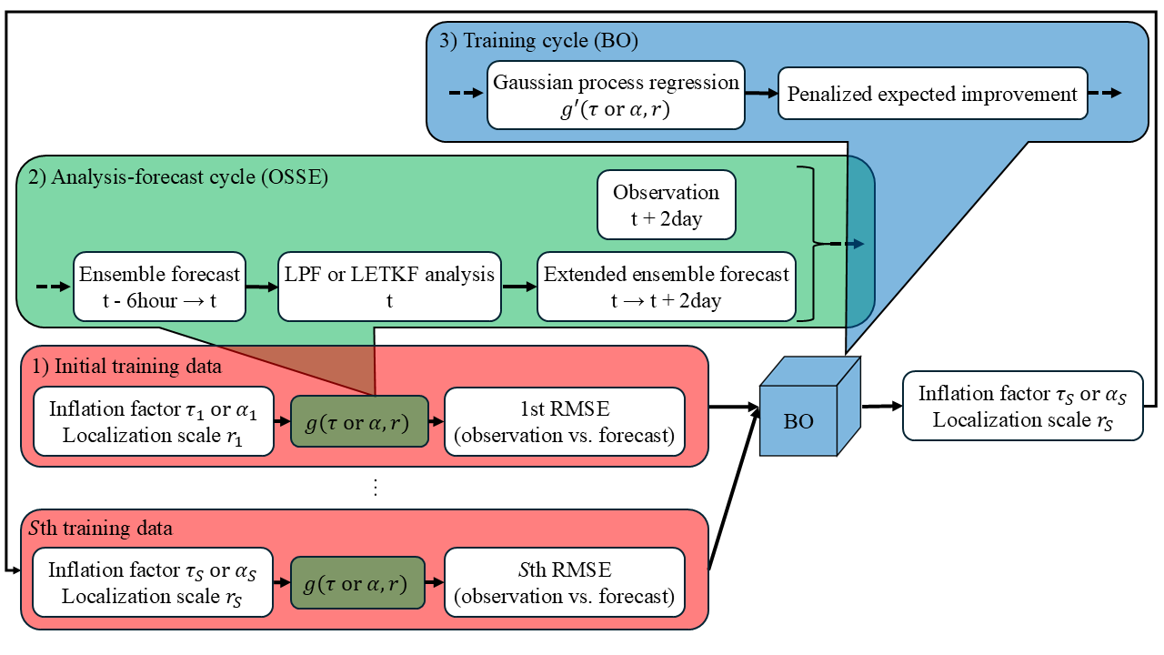
Fig. 1. Flowchart of the Bayesian optimization (BO) in the local particle filter (LPF) framework. Since the data assimilation system and the BO are implemented independently, it is possible to replace the LPF with the local ensemble transform Kalman filter. Here, $t (t=1, …, T)$ is time, $g$ is the objective function, $s (s=1, …, S)$ is the input data (inflation factor $τ$, $α$, and localization scale $r$), and the number of output data (root mean square error between the observations and the forecasts (RMSE(o vs. f)) ). In the observing system simulation experiment (OSSE), the observations are assimilated by the LPF every 6 Earth hours, and the RMSE(o vs. f) at the same time is calculated after the 2 Earth days extended forecast. Through this process in the objective function, the input data are converted to the output data. In the BO, the input data that minimizes the objective function is estimated through response surface modeling using Gaussian process regression and evaluation using an acquisition function (penalized expected improvement). The training cycle of conducting the OSSE using the estimated input data is repeated. Note that the BO optimizes $τ$ and $r$ offline.

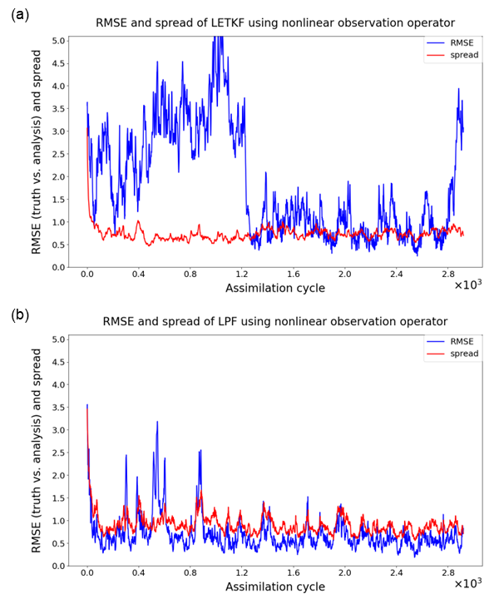
Fig. 2. Time series of the root mean square error and ensemble spread between the truth and the analysis (RMSE(t vs. a)) (a) for the local ensemble transform Kalman filter (LETKF) and (b) for the local particle filter (LPF) using 64 ensemble members (particles) and the nonlinear observation operators. The vertical axis shows the RMSE(t vs. a) (blue line) and the ensemble spread (red line), while the horizontal axis indicates the assimilation cycle.

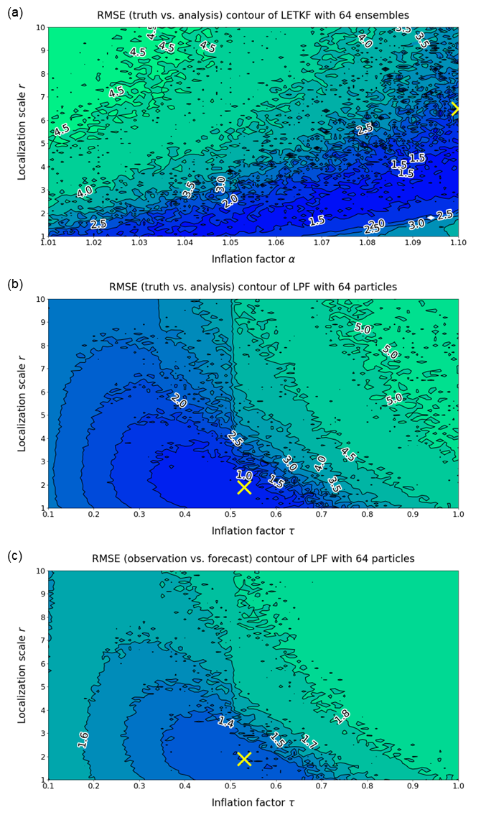
Fig. 3. Response surface of root mean square error between the truth and the analysis (RMSE(t vs. a)) in the local ensemble transform Kalman filter (LETKF) and the local particle filter (LPF) using 64 ensemble members (particles) and the nonlinear observation operator. The closer the color is to green, the larger the RMSE(t vs. a), and the closer the color is to blue, the smaller the RMSE(t vs. a). The vertical axis shows the localization scale $r$, and the horizontal axis shows the inflation factor $α$ and $τ$. The minimum error of 1.024 in the LETKF was obtained when $r$ = 6.5 and $α$ = 1.100 (cross mark). In addition, the minimum error of 0.586 in the LPF was obtained when $r$ = 1.9 and $τ$ = 0.53 (cross mark).

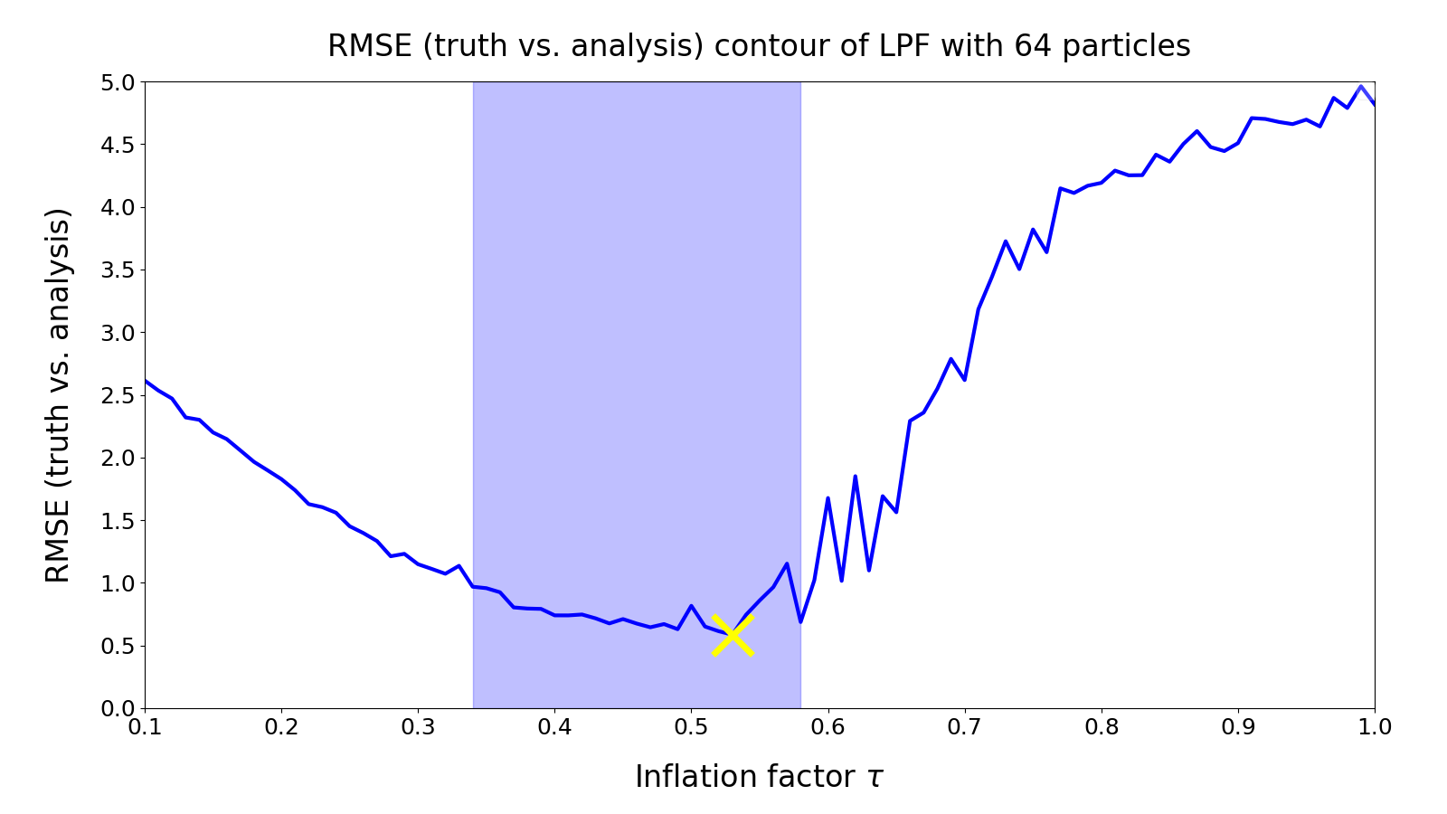
Fig. 4. Response surface of the root mean square error between the truth and the analysis (RMSE(t vs. a)) in the local particle filter using 64 ensemble members (particles) and the nonlinear observation operator. The vertical axis shows the RMSE(t vs. a), and the horizontal axis shows the inflation factor $τ$. The localization scale was fixed at $r$ = 1.9, and the minimum error of 0.586 was obtained when $τ$ = 0.53 (cross mark). In addition, the light blue shaded area indicates the optimal inflation factor range ($τ$ = 0.34-0.58) where the RMSE(t vs. a) of the LPF is 1.0 or less (the filter operates stably).

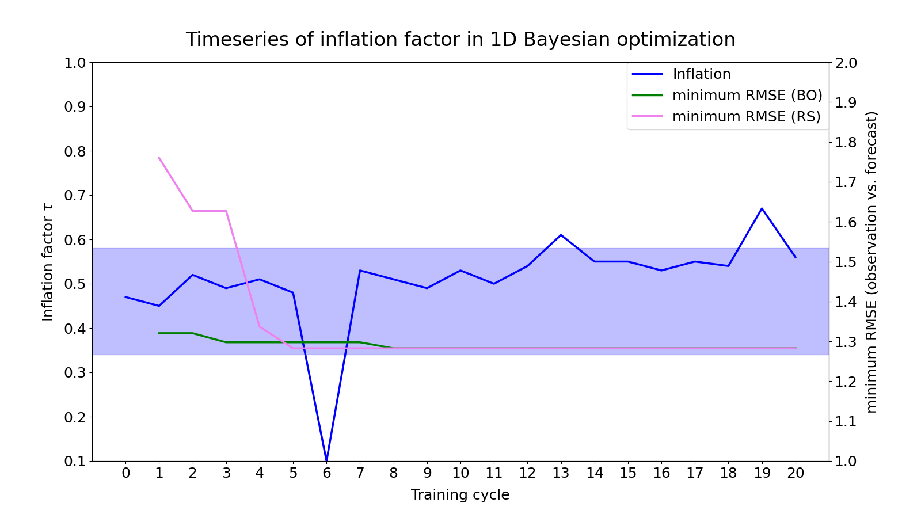
Fig. 5. Time series of the estimation by the 1-dimensional Bayesian optimization (BO). The blue line shows the inflation factor $τ$, the green line shows the minimum root mean square error between the observations and the forecasts (RMSE(o vs. f)) in the previous training cycle estimated by the BO, and the purple line shows the minimum RMSE(o vs. f) in the previous training cycle estimated by the random sampling. In addition, the light blue shaded area indicates the optimal inflation factor range ($τ$ = 0.34-0.58) for which the root mean square error between the truth and the analysis in the local particle filter is 1.0 or less (the filter operates stably). The horizontal axis shows the training cycle, the first vertical axis shows $τ$, and the second vertical axis shows the minimum RMSE(o vs. f) in the previous training cycle. Note that, due to the convenience of conducting the OSSE using the BO estimation, the training cycles of $τ$ and the RMSE(o vs. f) are shifted by one cycle.

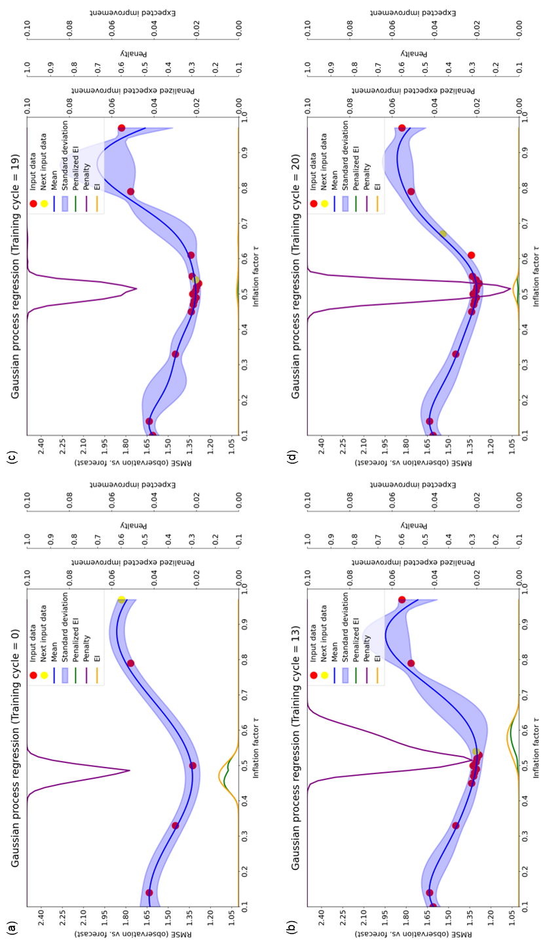
Fig. 6. Prediction distribution of Gaussian process regression (GPR) using the inflation factor $τ$ and the root mean square error between the observations and the forecasts (RMSE(o vs. f)) in the local particle filter as input and output data. The green line indicates the penalized expected improvement (EI), the purple line indicates the penalty, the yellow line indicates the EI, the red dots indicate the input data that has been explored, and the yellow dots indicate the input data explored in that training cycle. The horizontal axis is $τ$, the first vertical axis is the RMSE(o vs. f), the second vertical axis is the penalized EI, the third vertical axis is the penalty, and the fourth vertical axis is the EI. (a)-(d) are the prediction distributions for the 0th (i.e., when only the initial input data were given), 13th, 19th, and 20th training cycles, respectively.

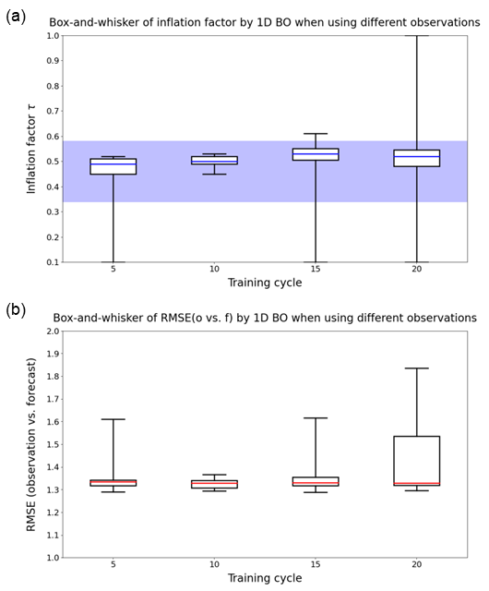
Fig. 7. Variation in the estimation by 1-dimensional Bayesian optimization for different observations. (a) Box plot of inflation factor $τ$. The blue line is the median, the lower edge of the box is the first quartile, the upper edge of the box is the third quartile, the lower edge of the whiskers is the minimum, and the upper edge of the whiskers is the maximum. In addition, the light blue shaded area indicates the optimum inflation factor range ($τ$ = 0.34-0.58) for which the root mean square error between the observations and forecasts (RMSE(o vs. f)) in the local particle filter is less than 1.0 (the filter operates stably). (b) Box plot of the RMSE(o vs. f). The red line is the median, and the other plots are the same as in (a). The vertical axes in (a) and (b) indicate $τ$ and the RMSE(o vs. f), respectively. The horizontal axes indicate the number of training cycles.

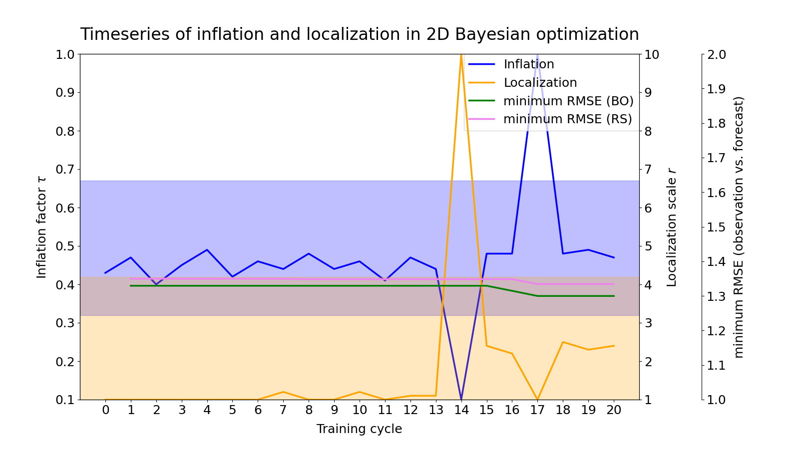
Fig. 8. Time series plot of the estimations by the 2-dimensional Bayesian optimization (BO). The blue line shows the inflation factor $τ$, the orange line shows the localization scale $r$, the green line shows the minimum root mean square error between the observations and the forecasts (RMSE(o vs. f)) in the previous training cycle estimated by the BO, and the purple line shows the minimum RMSE(o vs. f) in the previous training cycle estimated by the random sampling. The light blue shaded area indicates the optimal inflation factor range ($τ$ = 0.32-0.67) for which the root mean square error between the truth and the analysis in the local particle filter is less than 1.0 (the filter operates stably). In addition, the light orange shaded area indicates the optimal localization scale range ($r$ = 1.0-4.2). The light beige shaded area indicates the range that satisfies both the optimal inflation factor and localization scale. The horizontal axis represents the training cycle, the first vertical axis represents $τ$, the second vertical axis represents $r$, and the third vertical axis represents the minimum RMSE(o vs. f). Note that due to the convenience of conducting the OSSE using the BO estimations, the training cycles of $τ$, $r$, and the RMSE (o vs. f) are shifted by one cycle.

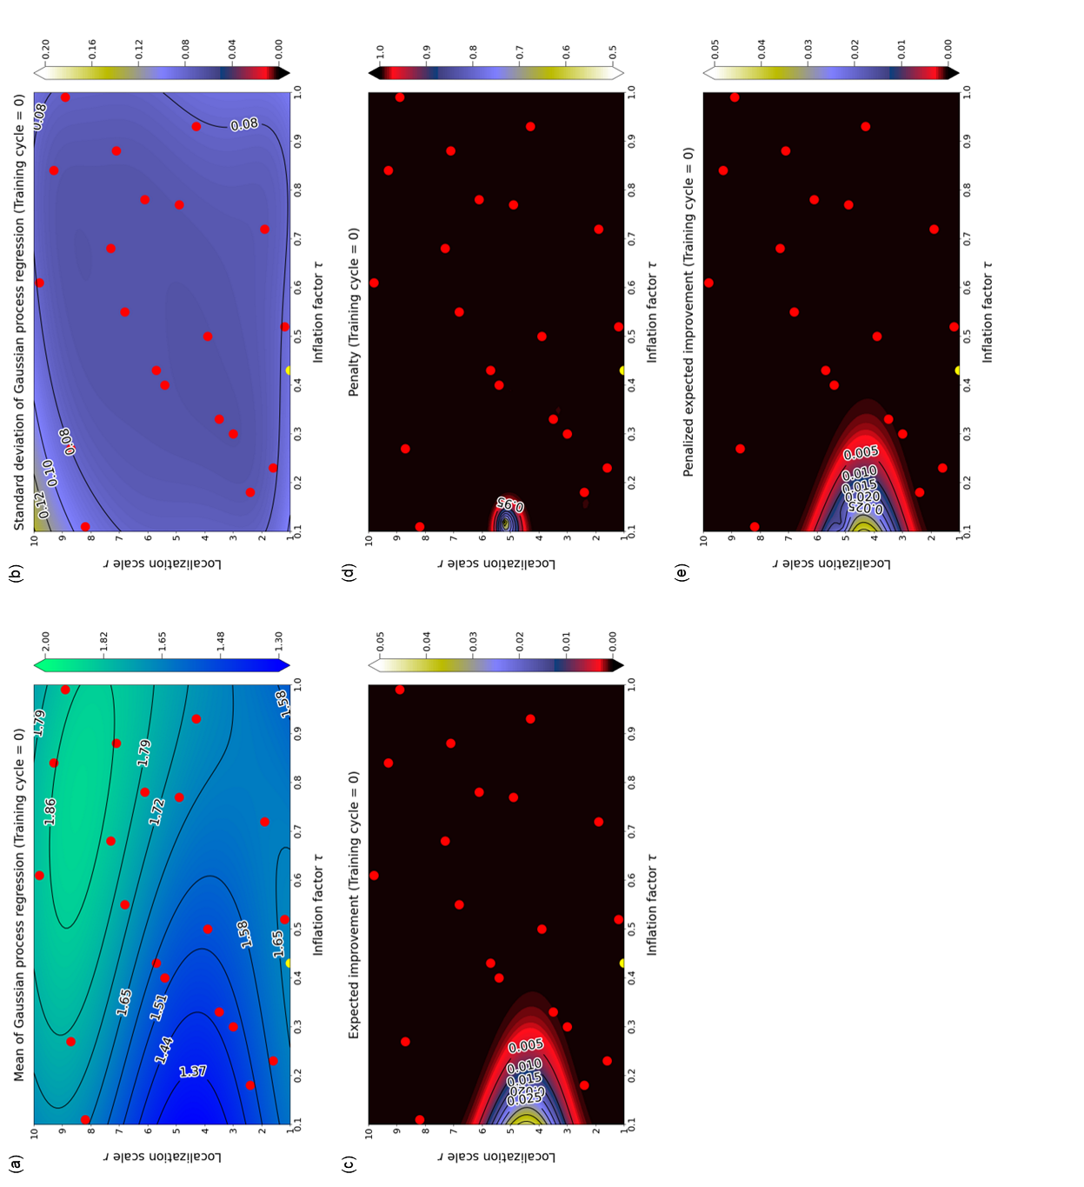
Fig. 9. Prediction distribution of Gaussian process regression (GPR) using the inflation factor $τ$ and the localization scale $r$ in the 0th training cycle (i.e., when only initial input data were given) and the root mean square error between observations and forecasts (RMSE(o vs. f)) in the local particle filter as input and output data. (a) is the GPR mean, (b) is the GPR standard deviation, (c) is the expected improvement (EI), (d) is the penalty, and (e) is the penalized EI prediction distribution. The red dots are input data obtained in advance using the LHS, and the yellow dots indicate the input data explored in that training cycle. The horizontal axis indicates $τ$, and the vertical axis indicates $r$.

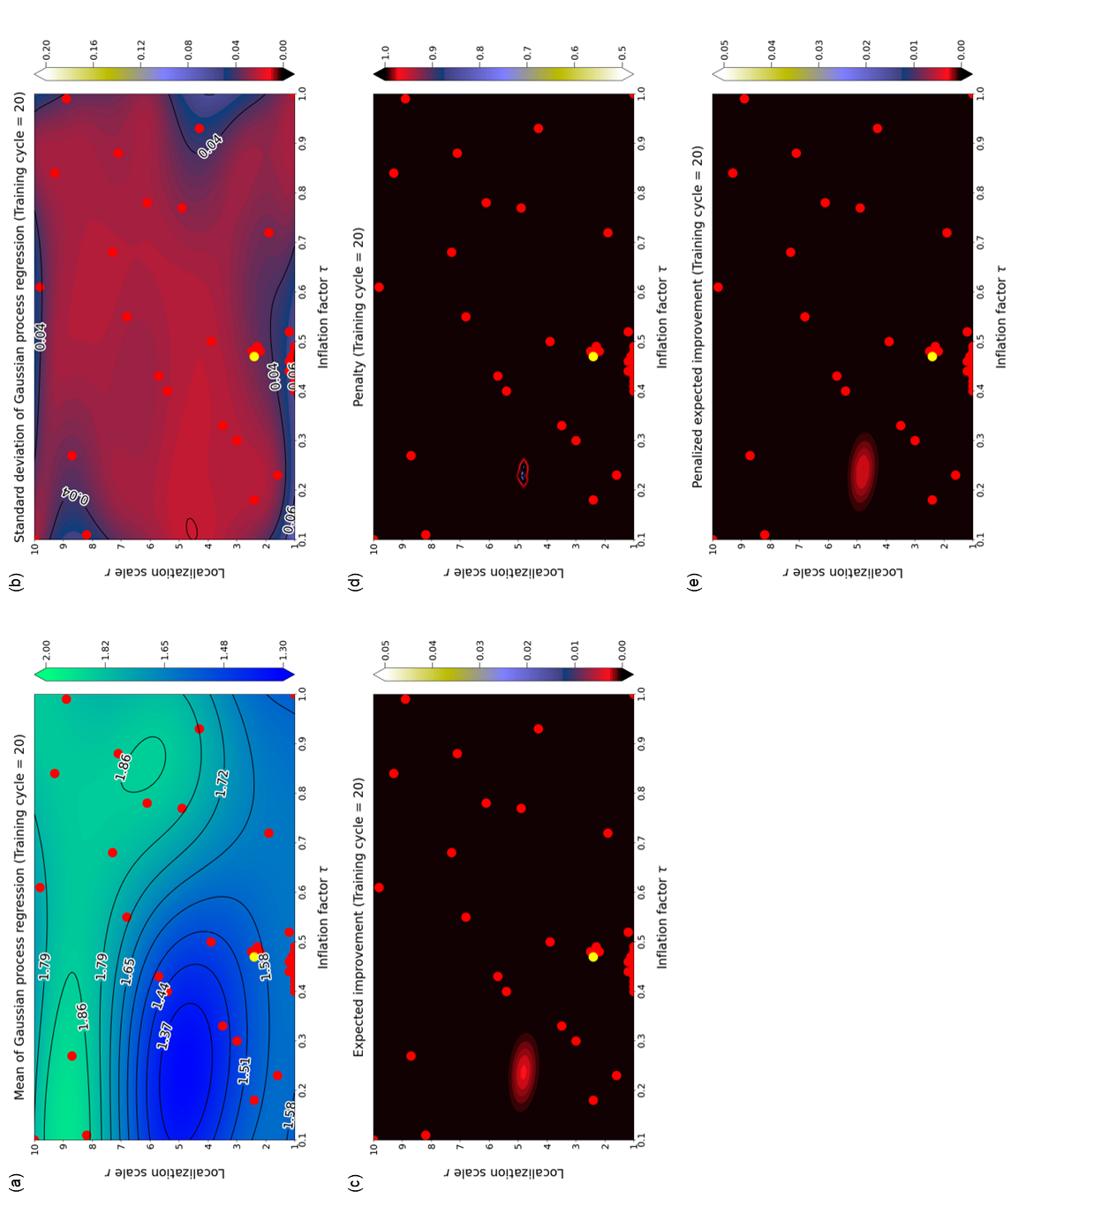
Fig. 10. Prediction distribution of Gaussian process regression (GPR) using the inflation factor $τ$ and the localization scale $r$ at the 20th training cycle, and the root mean square error between the observations and the forecasts (RMSE(o vs. f)) in the local particle filter as input and output data. (a) is the GPR mean, (b) is the GPR standard deviation, (c) is the expected improvement (EI), (d) is the penalty, and (e) is the penalized EI prediction distribution. The training cycle in this figure corresponds to that in Fig. 8. The expected value and uncertainty of the RMSE(o vs. f) are obtained as the mean and standard deviation of the GPR. Red dots indicate input data that has been explored, and yellow dots indicate input data explored in that training cycle. The horizontal axis indicates $τ$, and the vertical axis indicates $r$.

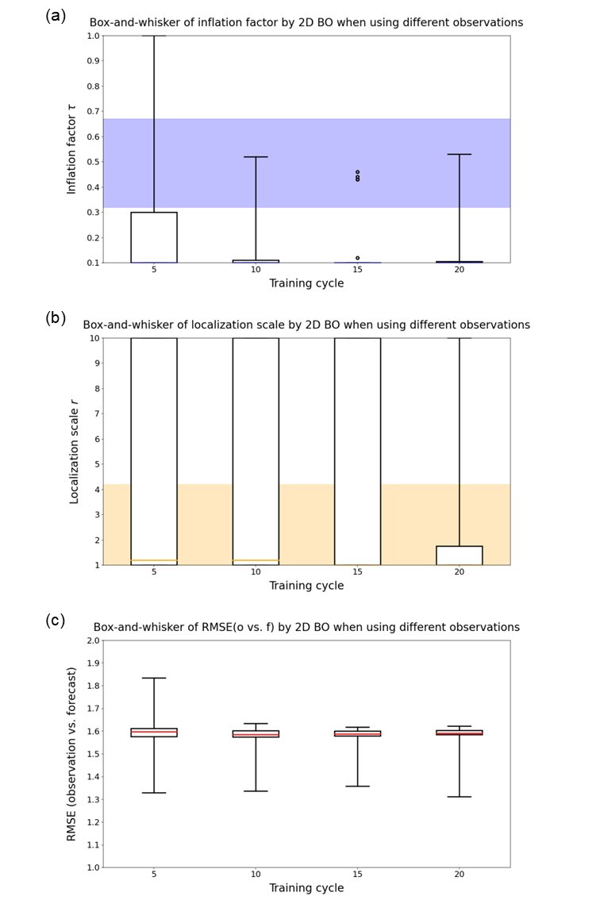
Fig. 11. Variation in the estimation by the 2-dimensional Bayesian optimization for the different observation sets. (a) Box plot of inflation factor $τ$. The blue line is the median, the lower edge of the box is the first quartile, the upper edge of the box is the third quartile, the lower edge of the whiskers is the minimum, the upper edge of the whiskers is the maximum, and the dots indicate outliers. In addition, the light blue shade indicates the optimal inflation factor range ($τ$ = 0.34-0.58) for which the root mean square error between the truth and the analysis (RMSE(t vs. a)) in the local particle filter is less than 1.0 (the filter operates stably). (b) Box plot of localization scale $r$. The orange line is the median, and the other plots are the same as in (a). In addition, the light orange shade indicates the optimal localization scale range ($r$ = 1.0-4.2). (c) Box plot of the RMSE(o vs. f). The red line is the median, and the other plots are the same as in (a). The vertical axes in (a), (b), and (c) indicate $τ$, $r$, and the RMSE(o vs. f), respectively. The horizontal axes indicate the number of training cycles.

List of Tables
Table 1 Variation in the estimation by the Bayesian optimization with respect to the dimension of the response surface, the Lipschitz constant, and the number of initial input data. The rightmost column shows the minimum root mean square error between the observations and the forecasts for 20 training cycles, with the best cases for each dimension of the response surface highlighted in bold.

Table 1 Variation in the estimation by the Bayesian optimization with respect to the dimension of the response surface, the Lipschitz constant, and the number of initial input data. The rightmost column shows the minimum root mean square error between the observations and the forecasts for 20 training cycles, with the best cases for each dimension of the response surface highlighted in bold.
2-dimension (91 * 91)
Lipschitz constant | Number of initial input data | minimum RMSE
0.1 | 10 | 1.319
 | 20 | 1.302
 | 30 | 1.312
 | 40 | 1.319
0.5 | 10 | 1.319
 | 20 | 1.304
 | 30 | 1.316
 | 40 | 1.315
2.0 | 10 | 1.319
 | 20 | 1.300
 | 30 | 1.323
 | 40 | 1.332
10.0 | 10 | 1.319
 | 20 | 1.329
 | 30 | 1.354
 | 40 | 1.352
1-dimension (91)
Lipschitz constant | Number of initial input data | minimum RMSE
0.1 | 5 | 1.282
 | 10 | 1.282
 | 15 | 1.304
 | 20 | 1.282
0.5 | 5 | 1.282
 | 10 | 1.301
 | 15 | 1.298
 | 20 | 1.282
2.0 | 5 | 1.298
 | 10 | 1.301
 | 15 | 1.301
 | 20 | 1.282
10.0 | 5 | 1.301
 | 10 | 1.301
 | 15 | 1.301
 | 20 | 1.282

