Bayesian optimization in parameter estimation for a local particle filter

Shoichi AKAMI¹

Graduate School of Life and Environmental Sciences, University of Tsukuba, Tsukuba, Japan

Meteorological Research Institute, Japan Meteorological Agency, Tsukuba, Japan

and

Keiichi KONDO

Meteorological Research Institute, Japan Meteorological Agency, Tsukuba, Japan

and

Hiroshi L. TANAKA

Organization of Volcanic Disaster Mitigation, Shinjuku, Japan

and

Mizuo KAJINO

Meteorological Research Institute, Japan Meteorological Agency, Tsukuba, Japan

Faculty of Life and Environmental Sciences, University of Tsukuba, Tsukuba, Japan

June 16th, 2026

------------------------------------
1) Corresponding author: Shoichi AKAMI, Graduate School of Life and Environmental Sciences, University of Tsukuba, 1-1, Tennoudai, Tsukuba, Ibaraki, Japan, 305-8572.
Email: s2330311@u.tsukuba.ac.jp
Tel: +81-29-853-8695

Abstract
The particle filter (PF) is a powerful data assimilation method that assumes neither linearity in the time evolution of errors nor Gaussian error distributions. However, the number of required particles, which increases exponentially with the dimensionality of a dynamical system, becomes a bottleneck when the PF is applied to numerical weather prediction (NWP) models. The local particle filter (LPF) realizes the PF method in high-dimensional systems through localization, but it has high parameter sensitivity and is difficult to operate stably. However, when a nonlinear observation operator is used, it is possible to estimate the analysis with higher accuracy than is possible with the local ensemble transformation Kalman filter by setting the weight inflation factor $τ$, which smooths the weights among the particles, and the localization scale $r$ to their optimal values. Therefore, an efficient parameter estimation method is required.
The Bayesian optimization (BO) is a method that efficiently optimizes black-box functions with high computational costs. In this study, the BO was used to estimate the values of $τ$ and $r$ that minimize the root mean square error between the observation and the forecast in the Lorenz-96 40-variable model. As a result, the one-dimensional BO could estimate the optimal weight inflation factor with all observation sets. However, the observation sets that could estimate the optimal weight inflation factor stayed at 34% and the ones that could estimate the localization scale stayed at 97% in the two-dimensional BO. An investigation into the cause of this performance degradation revealed that excessive exploration near the boundary, which became significant as the dimension of the parameter space increased, was the cause. Additionally, a need to adequately set the Lipschitz constant depending on the problem formulation was identified.
This study is one of precious study solving systematically a limit of the BO performance and that cause in data assimilation. The obtained insight suggests two improvement methods in applying the LPF to the practical NWP system: (1) preventing excessive exploration near the boundary with the virtual derivative sign observation method, and (2) estimating the Lipschitz constant with the GP-LCA method. This study clarified problems and the applicability of the BO in data assimilation and provided a direction for future research.
Keywords: Local particle filter; Parameter estimation; Bayesian optimization; Gaussian process regression

Introduction
In high-dimensional chaotic dynamical systems, such as numerical weather prediction (NWP) models, even small errors in the initial conditions can develop into large errors over time. Data assimilation is a technique that estimates the state closest to the truth by combining the forecast and the observation. Conducting a forecast with an accurate initial state can reduce forecast error. The ensemble Kalman filter (EnKF; Evensen, 1994) and the four-dimensional variational data assimilation (4D-Var; Dimet and Talagrand, 1986), which are currently mainstream data assimilation methods, can estimate the optimal analyses when errors develop linearly over time and the error distribution follows a Gaussian distribution. The ensemble variational data assimilation (EnVar; Liu et al., 2008) does not require a tangent or adjoint model. However, the EnVar assumes linearity and Gaussianity, like the EnKF and the 4D-Var, to minimize efficiently quadratic cost function. If these assumptions are not satisfied—e.g., about cumulus convection and storm tracks—the appropriate analysis should not be estimated (e.g., Kondo and Miyoshi, 2019).
The particle filter (PF; Gordon et al., 1993) does not assume linearity or Gaussianity, and thus it may be an appropriate data assimilation method for dynamical systems that have strong nonlinearity. The PF obtains the analyses by resampling ensembles (particles) based on weights derived from the likelihood of a given observation. However, in high-dimensional systems, only a small number of particles possess a high likelihood. Consequently, the weights become concentrated on these particles, which leads to a phenomenon known as "weight collapse." The PF requires an exponential increase in the number of particles with an increase of the dimensionality of the dynamical system (Snyder et al., 2008), and this problem becomes a bottleneck when the PF is applied to the NWP systems.
The local particle filter (LPF; Penny and Miyoshi, 2016; Potthast et al., 2019; Kotsuki et al., 2022) is a method for realizing the PF in high-dimensional systems by reducing the dimensionality of the dynamical system through localization. The spatial localization is justified by the following two facts: (1) spurious long-range correlation arises from sampling error with finite ensemble size, and (2) long-range correlation is weaker than local correlation due to local low dimensionality of atmospheric dynamics (Hamil et al., 2001). In fact, the LPF can estimate the accurate analyses than the EnKF in cases of non-Gaussian observation errors, nonlinear observation operators, and networks having sparse observations (Poterjoy and Anderson, 2016; Poterjoy, 2016; Penny and Miyoshi, 2016). This advantage of the LPF is extremely important in improving the forecast accuracy of heavy rainfall. This is because, for example, radar reflectivity and precipitation intensity have a nonlinear relationship, and when radar reflectivity is assimilated, it is necessary to introduce a nonlinear observation operator.
However, for the LPF, the localization scale and the weight inflation factor (which smooths the weights among the particles) must be set to their optimal values. Moreover, excessive resampling causes "weight collapse," which means the resampling frequency is another parameter that should be optimized in the LPF. Furthermore, a method approximates the prior distribution using a combination of Gaussian kernels centered on value of each particle, as one of the methods for implementing the PF has been proposed. In this method, the bandwidth of the Gaussian kernel is an important parameter (Stordal et al., 2011). In the LPF, the filter diverges unless these parameters are optimized (Kotsuki et al., 2022).
With the improvement of methods and the advancement of models that are applied in the practical implementation of the LPF, the number of parameters to be optimized can be expected to increase, and the computational cost of numerical experiments is expected to increase considerably. The simplest way to search for the optima of these parameters is by grid search (GS), which divides the parameter space into equal parts and comprehensively searches all combinations. Although the GS can be sure to obtain the optima in the grid, experiments that increase exponentially with the number of estimated parameters must be performed. Random sampling (RS) is a method that randomly selects combinations from the parameter space. It works more efficiently than does the GS in high-dimensional spaces (Bergstra and Bengio, 2012), but if the number of samples is insufficient, it may not obtain the optima. Therefore, a more efficient optimization method is required.
One method for reducing the computational cost of parameter optimization is to replace response of the system to parameters with a surrogate model derived from the actual system (e.g., Sawada, 2020). The Bayesian optimization (BO; Mockus, 1989) is one such optimization technique. The BO is a method for estimating parameters that minimize an objective function, and it is used for tasks such as parameter optimization in neural networks (Snoek et al., 2012). A feature of the BO is generally emulating the objective function using Gaussian process regression (GPR). Therefore, the BO can efficiently explore a global optimum even when the shape of the response surface of input and output data is unknown, or when the function is non-differentiable and multimodal. Moreover, the BO is a black-box optimization method that does not require knowledge of structure of the objective function or its gradient. Therefore, the BO can be applied to various systems, which is an advantage.
The effectiveness of using the BO for parameter estimation within the EnKF framework has been demonstrated (Lunderman et al., 2021; hereafter L21). Therefore, the present study builds on this existing line of research to investigate whether parameter estimation using the BO can improve the practicality of the LPF. Moreover, the BO has been used as a mere tool in previous studies, and detailed investigations of the GPR predictive distributions or the Lipschitz constant have not been conducted. We conducted investigations into these components, with an eye toward future technique development. This survey was conducted using a data assimilation experiment with the Lorenz-96 40-variable model (L96; Lorenz and Emanuel, 1998).
The organization of this manuscript is as follows. Section 2 introduces the methodology, and Section 3 describes the experimental setup. Section 4 compares the LETKF and the LPF, investigates the estimates of the BO in view of the GPR predictive distributions, and the Lipschitz constant thoroughly. Section 5 discusses the results, and Section 6 presents the conclusions of the study and future prospects.

Method
- LPF
The PF sequentially estimates the posterior distribution using Bayes' theorem based on the sequential Monte Carlo method:
$$\begin{aligned}p\left(x_{t} | y_{1:t}\right) = \frac{p\left(y_{t} | x_{t}\right) p\left(x_{t} | y_{1:t-1}\right)}{p\left(y_{t} | y_{1:t-1}\right)}, \#\left(1\right)\end{aligned}$$
where $p$ represents the probability distribution; $p\left(x_{t} | y_{1:t}\right)$ denotes the posterior distribution of state variable $x$ at time $t (t = 1, …, T)$ given all observations $y$ up to time $t;$ $p\left(y_{t} | x_{t}\right)$ is the conditional distribution of $y$ when given $x$, which functions as the likelihood function; $p(x_{t}|y_{1:t-1})$ is the prior distribution given all $y$ up to one time step before the analysis time; and $p(y_{t}|y_{1:t-1})$ is the forecast likelihood, which functions as the normalization constant in the Bayes update. The prior distribution can be approximated using the particles (or ensemble members) for the numerical forecast:
$$\begin{aligned}p\left(x_{t} | y_{1:t-1}\right)≈\frac{1}{M}\sum_{m = 1}^{M}{δ\left(x_{t}-F\left(x_{t-1}^{m}\right)\right)}, \#\left(2\right)\end{aligned}$$
where the superscripts $m (m = 1, …, M)$ denote the indices of the particles; $δ$ is the Dirac delta function; and $F$ is the numerical model. This study assumes a Gaussian likelihood function, which is given by
$$\begin{aligned}p\left(y_{t} | x_{t}\right) = \frac{1}{\sqrt{{\left(2π\right)}^{o}\left|R\right|}}\exp\left[-\frac{1}{2}{\left(y_{t}-h\left(x_{t}\right)\right)}^{⊤}R^{-1}\left(y_{t}-h\left(x_{t}\right)\right)\right] ,\#\left(3\right)\end{aligned}$$
where $o$ represents the dimension of $y_{t}$. In addition, $R$ denotes the observation error covariance matrix, and $|R|$ is its determinant; $h$ denotes the observation operator. The weight of each particle is the normalized likelihood, computed for all particles as follows:
$$\begin{aligned}w_{t}^{m} = \frac{p\left(y_{t} | x_{t}^{m}\right)}{\sum_{m^{'} = 1}^{M}{p\left(y_{t} | x_{t}^{m^{'}}\right)}}, \#\left(4\right)\end{aligned}$$
where the superscript $m^{'}$ denotes the indices of the particles in the summation. The posterior distribution is approximated by resampling the particles in proportion to the weights:
$$\begin{aligned}p\left(x_{t} | y_{1:t}\right)≈\sum_{m = 1}^{M}{w_{t}^{m}δ\left(x_{t}-F\left(x_{t-1}^{m}\right)\right)}. \#\left(5\right)\end{aligned}$$
Various resampling methods have been proposed. In this study, the analysis particles are defined as the sum of the mean of forecast particles and the perturbation of forecast particles applied to the transformation matrix, using deterministic resampling:
$$\begin{aligned}X^{a} = {\overline{X}}^{f} + δX^{f} T. \#\left(6\right)\end{aligned}$$
Here, $X^{a} (∈R^{M*N}$) denotes the analysis particles; ${\overline{X}}^{f} (∈R^{M*N}$) denotes the mean of the forecast particles; $δX^{f} (∈R^{M*N}$) denotes the perturbation of the forecast particles; $N$ represents the dimension of the NWP; and $T$ denotes the ensemble transform matrix, defined as a square matrix of order $M$. In the LPF, deterministic resampling is performed via the ensemble transformation matrix. Therefore, the ensemble transformation significantly affects filter performance (Farchi and Bocquet, 2018; Kotsuki et al., 2022). Furthermore, the ensemble spread tends to be underestimated when the insufficient number of particles is used.
Moreover, the weights differ among the grid points because different observations are assimilated at each grid point through localization. As a pronounced weight difference should cause spatial discontinuity, the ensemble transform matrix should ensure a spatially smooth transition. The smoothing issue presents an interesting challenge. For example, Kotsuki et al. (2022) addressed this issue by averaging the resampling matrices generated from multiple uniform random numbers to create an ensemble transform matrix that was similar to an identity matrix (see also Potthast et al. (2019)). Our resampling method is based on Algorithm 1 in Kotsuki et al. (2022). Additionally, we adopted stochastic universal resampling (SUR) rather than Monte Carlo resampling to reduce sampling error. The SUR is implemented as follows: we create the cumulative distribution function, split by the magnitudes of weight of each particle, and select the random starting point in the range of $[0, 1/M]$. We set $M$ pointers at equal intervals of $1/M$ starting from the position of the first pointer, and we sample the particles corresponding to the cumulative probabilities pointed to by each pointer.
Furthermore, we use localization to limit the impact of the observations within the local domain to avoid "weight collapse" (Penny and Miyoshi, 2016; Kotsuki et al., 2022). With this localization method, the analysis is computed independently at every grid point, similar to the local ensemble transform Kalman filter (LETKF; Hunt et al., 2007). In this study, we adopted the Gaussian function with a cut-off distance as the localization function (Gaspari and Cohn, 1999),
$$\begin{aligned}L\left(q;r\right) = \left\{\begin{aligned}\exp\left(-\frac{q^{2}}{2r^{2}}\right) if q < 2\sqrt{\frac{10}{3}} r \\ 0 else\end{aligned}\right.. \#\left(7\right)\end{aligned}$$
At each analysis grid point, we calculated the distance $q$ (unit: grid interval) between the grid point and the observation point and the localization function $L(q;r)$ based on the localization scale $r$. Additionally, we constructed the localization matrix $L(q;r)$, whose elements are the localization functions. Specifically, the $(i, j)$ element of the localization matrix $L(q;r)$ is given as $L_{ij}=L(q_{ij};r)$ using the distance $q_{ij}$ between the $i$-th observation point and the $j$-th observation point. The following equation represents the localization implementation method,
$$\begin{aligned}\exp\left[-\frac{1}{2}{\left(y_{t}-h\left(x_{t}\right)\right)}^{⊤}\left(R^{-1}∘L\left(q;r\right)\right)\left(y_{t}-h\left(x_{t}\right)\right)\right]. \#\left(8\right)\end{aligned}$$
The localization is implemented by computing the Schur product of the inverse of the observation error covariance matrix $R^{-1}$ and the localization matrix $L(q;r)$. Specifically, the observations beyond the cut-off distance are not assimilated; those within it are weighted by distance. We should set the localization scale to the appropriate value to adequately assimilate the observations while suppressing sampling error.
Moreover, to prevent filter divergence, it is necessary to maintain particle diversity. If a few particles account for most of the weight, the diversity of particles after resampling is likely to be lost, potentially to filter divergence. Therefore, we smoothed the weights of the particles to prevent excessive concentration of weight. We refer to this approach as weight inflation in this study:
$$\begin{aligned}w_{t}^{m}←τw_{t}^{m} + \frac{1-τ}{M}, \left(0 ≤ τ ≤ 1\right), \#\left(9\right)\end{aligned}$$
where $τ$ represents the weight inflation factor in the LPF. If $τ$ is not one, the weights $w_{t}^{m}$ are smoothed, and all particles have equal weights when $τ$ equals zero. However, if the original weights are used without introducing weight inflation, the LPF tends to diverge due to "weight collapse". Introducing weight inflation stabilizes the LPF, although it causes the filter to deviate from the theoretical PF as $τ$ becomes smaller. Thus, mathematical rigor and stability are in a trade-off relationship in the weight inflation factor $τ$. Note that this approach is mathematically equivalent to Eq. (23) in Kotsuki et al. (2022). However, whereas Kotsuki et al. (2022) smoothed the weights in the time direction, we smoothed the weights of the particles.

- LETKF
The LETKF is a computationally efficient data assimilation method that combines the local ensemble Kalman filter (Ott et al., 2004) and the ensemble transform Kalman filter (Bishop et al., 2001). The analysis ensembles are obtained using the following equation:
$$\begin{aligned}X^{a} = {\overline{X}}^{f} + δX^{f}\left[{\tilde{P}}^{a}{\left(δh\left(X^{f}\right)\right)}^{T}R^{-1}\left(y-h\left({\overline{X}}^{f}\right)\right) + \sqrt{M-1}{\left({\tilde{P}}^{a}\right)}^{\frac{1}{2}}\right]. \#\left(10\right)\end{aligned}$$
Here, ${\tilde{P}}^{a}$ is the analysis error covariance matrix in the ensemble space. It is given by the following equation:
$$\begin{aligned}{\tilde{P}}^{a} = {\left[\frac{\left(M-1\right)}{α}I + {\left(δh\left(X^{f}\right)\right)}^{T}R^{-1}\left(δh\left(X^{f}\right)\right)\right]}^{-1}. \#\left(11\right)\end{aligned}$$
Here, $α$ represents the covariance inflation factor in the LETKF, and $I$ is the identity matrix. The forecast error covariance matrix tends to be underestimated due to finite ensemble size, model error, and nonlinear dynamics. The underestimation leads to filter divergence by reducing the ensemble spread. In multiplicative inflation, the underestimation is prevented by inflating the forecast error covariance matrix with the covariance inflation factor $α$.

- BO
The BO estimates input data that minimize the objective function by modeling the response surface using the GPR and then evaluating using an acquisition function. The GPR assumes that a conditional distribution $p\left(g \right| z)$ of the output data $g = \{g\left(z_{1}\right), g\left(z_{2}\right), …, g(z_{S})\}$ at the input data $z = \{z_{1}, z_{2}, …, z_{S}\}$ follows a multivariate Gaussian distribution $N\left(μ, K\right)$. Here, the subscripts of input and output data $s (s = 1, …, S)$ denote the indices for the data. This assumption is written as follows:
$$\begin{aligned}g\sim GP\left(μ\left(z\right), K\left(z, z^{‘}\right)\right). \#\left(12\right)\end{aligned}$$
Here, each input data $z=(τ, r)$ is a two-dimensional vector, which has the inflation factor $τ$ and the localization scale $r$ as its elements; $z^{‘}$ denotes another input data in the dataset, i.e., a different combination of the inflation factor $τ^{'}$ and the localization scale $r^{'}$; $GP$ represents the Gaussian process with mean $μ$, and $K$ represents the covariance matrix, defined as an $S×S$ square matrix. An element $(i, j)$ of $K$ is given by $K_{ij}$ = $k\left(z, z^{‘} \right| θ)$. In this study, a commonly used Gaussian kernel with added white noise was adopted. Note that the following equation is for two-dimensional BO:
$$\begin{aligned}k\left(z, z^{‘} | θ\right) = θ_{1}\exp\left(-\frac{{\left(τ-τ^{'}\right)}^{2}}{θ_{2}}-\frac{{\left(r-r^{'}\right)}^{2}}{θ_{3}}\right) + θ_{4}δ\left(z, z^{‘}\right). \#\left(13\right)\end{aligned}$$
Here, the kernel function $k\left(z, z^{‘} | θ\right)$ defines the covariance between any two points $z$ and $z^{‘}$ in input space. In addition, $θ = (θ_{1}, θ_{2}, θ_{3}, θ_{4})$ denotes the positive hyperparameters that define the kernel function; and $δ$ represents the Kronecker delta function. Incidentally, the minimum and maximum of the hyperparameters were set based on the physical meaning of each hyperparameter and the statistics of input and output data. For the length scale parameters $θ_{2}$ and $θ_{3}$, the minimum and maximum were set to 0.1 and 3 times the median distance between input points, respectively. This setting allows $GP$ to model correlations ranging from local to global scales. Incidentally, the minimum and maximum differ among training cycles because these values change depending on the input data.
When the amplitude parameter $θ_{1}$ is small, the variation in the GPR predictive distribution is small. The GPR predictive distribution becomes smoother when the length scale parameters $θ_{2}$ and $θ_{3}$ are large. When the noise parameter $θ_{4}$ is small, the uncertainty in the GPR predictive distribution near the input data are small. Incidentally, for two-dimensional input data, more flexible modeling that accounts for the features of each input can be achieved using the two length-scale parameters $θ_{2}$ and $θ_{3}$.
Furthermore, as $τ$ and $r$ have scales that differ by a factor of ten, we normalized them to the same scale. In the Gaussian kernel, since the distance-based calculation is performed, it can help avoid a specific input variable from becoming dominant through the normalization. This approach improved the BO performance in our system.
When new input data $z^{*}$ is given, the conditional distribution $p\left(g^{*} | z^{*}, D\right)$ of corresponding output data is written as follows:
$$\begin{aligned}p\left(g^{*} | z^{*}, D\right) = N\left(k_{*}^{⊤}K^{-1}g, k_{**}-k_{*}^{⊤}K^{-1}k_{*}\right). \#\left(14\right)\end{aligned}$$
Here, $D = (z, g)$ denotes the training data set; $k_{*}$ denotes the covariance vector between the new input data $z^{*}$ and the training input data $z$; and $k_{**}$ denotes the prior covariance at the new input data $z^{*}$:
$$\begin{aligned}k_{*} = {\left(k\left(z^{*}, z_{1}\right), k\left(z^{*}, z_{2}\right), …, k\left(z^{*}, z_{S}\right)\right)}^{⊤}, \#\left(15\right)\end{aligned}$$
$$\begin{aligned}k_{**} = k(z^{*}, z^{*}). \#\left(16\right)\end{aligned}$$
When the covariance matrix $K$ becomes similar to a singular matrix due to redundant exploration of the same input data, it may become impossible to calculate the inverse matrix stably (Rasmussen and Nickisch, 2010). Several techniques are available to improve the numerical stability of inverse matrix calculation: we followed Rasmussen and Williams (2006) by adding jitter to the diagonal components of the covariance matrix. Although this approach successfully prevented errors associated with singular matrices in our experiments, it was unable to prevent the redundant exploration.
The hyperparameter $θ$ is optimized by maximizing the log-marginal likelihood defined as:
$$\begin{aligned}\log{p\left(g | z, θ\right)} = -\frac{S}{2}\log\left(2π\right)-\frac{1}{2}\log\left|K_{θ}\right|-\frac{1}{2}g^{⊤}K_{θ}^{-1}g, \#\left(17\right)\end{aligned}$$
where $K_{θ}$ denotes the covariance matrix that depends on $θ$ and that has elements determined by the kernel function $k\left(z, z^{‘} \right| θ)$; and $\left|K_{θ}\right|$ represents the determinant. The gradient of log-marginal likelihood [Eq. (17)] is written as follows:
$$\begin{aligned}\frac{∂\log{p\left(g | z, θ\right)}}{∂θ} = -\frac{1}{2}tr\left(K_{θ}^{-1}\frac{∂K_{θ}}{∂θ}\right) + {\left(K_{θ}^{-1}g\right)}^{⊤}\frac{∂K_{θ}}{∂θ}\left(K_{θ}^{-1}g\right), \#\left(18\right)\end{aligned}$$
where $\frac{∂K_{θ}}{∂θ}$ denotes the matrix of the same shape as the covariance matrix $K_{θ}$; the elements of the matrix are $\frac{∂}{∂θ}k\left(z, z^{‘} \right| θ)$, which represents each element of the covariance matrix $K_{θ}$ differentiated by the hyperparameter $θ$. Note that Eq. (17) and Eq. (18) are the equations for one element $θ$ in $θ$ that summarizes multiple hyperparameters as a vector. More accurate modeling and evaluation can be expected by re-optimizing the hyperparameters at each training cycle, as new input data $z^{*}$ are added to the training data. Note that Eqs. (14), (17), and (18) are derived under the assumption that the mean $μ\left(z\right)$ is zero in Eq. (12). In terms of implementation, mathematical rigor can be satisfied by subtracting the mean from the output data.
We employed multi-start optimization using the multiple initial values generated by the Latin hypercubic sampling (LHS; McKay et al., 1979) and the hyperparameters obtained one training cycle ago. This objective is to prevent convergence to local optimum during optimization. Moreover, we adopted the L-BFGS-B algorithm (Byrd et al., 1995) as the optimization method.
The modeling of the response surfaces using the GPR has been described above. Next, we describe the evaluation by the acquisition function. The acquisition function is defined as the combination of the mean $μ\left(z\right)$ and the standard deviation $σ\left(z\right)$ obtained by the GPR. Initially, we followed Lunderman et al. (2021) in adopting the expected improvement (EI), which is defined by the following equation, as the acquisition function:
$$\begin{aligned}EI\left(z\right) = \left(\hat{g}-μ\left(z\right)\right)Φ\left(\frac{\hat{g}-μ\left(z\right)}{σ\left(z\right)}\right) + σ\left(z\right)ϕ\left(\frac{\hat{g}-μ\left(z\right)}{σ\left(z\right)}\right). \#\left(19\right)\end{aligned}$$
Here, $\hat{g}$ denotes the provisional optimum, i.e., the minimum of the objective function in all previous training cycles; $σ\left(z\right)$ denotes the GPR standard deviation, which is the square root of the GPR variance. In addition, $Φ$ and $ϕ$ represent the cumulative distribution function and probability distribution function of the standard normal distribution, respectively. The EI increases when the GPR mean is small or the GPR standard deviation is large.
However, the inverse matrix in Eqs. (14), (17), and (18) could not be calculated stably using the EI due to the redundant exploration of the input data. Therefore, we adopted the penalized EI. The local penalization method proposed by González et al. (2016) is an approach that smoothly reduces the acquisition function near the input data points. This approach assumes the objective function is Lipschitz continuous; this approach prevents the redundant exploration by smoothly reducing the acquisition function as the distance from the input data increases.
The acquisition function is often non-convex and has multiple local optima, a general problem in the BO (Shahriari et al., 2016). The acquisition function should be optimized to determine the next input data. If the optimization algorithm falls into a local optimum, the adequate input data may not be obtained. Therefore, we also employed multi-start optimization to optimize the acquisition function. The penalized EI at the input data point is written as follows:
$$\begin{aligned}\ln{\tilde{EI}} = \ln{EI} + \sum_{s = 1}^{S}{\ln{φ\left(z^{*}, z_{s}\right)}}, \#\left(20\right)\end{aligned}$$
where $\tilde{EI}$ denotes the penalized EI. The local penalization method maximizes the product of the acquisition function and the penalty function to select the next input data point. In Eq. (20), the sum is calculated by applying a logarithmic characteristic. Furthermore, the derivative of the penalized EI is written as follows:
$$\begin{aligned}∇\ln{\tilde{EI}} = EI^{-1}∇EI + \sum_{s = 1}^{S}{φ{\left(z^{*}, z_{s}\right)}^{-1}∇φ\left(z^{*}, z_{s}\right).} \#\left(21\right)\end{aligned}$$
The next input data point is explored after the total penalty for all input data points are calculated. The penalty function takes the following form:
$$\begin{aligned}φ\left(z^{*}, z_{s}\right) = \frac{1}{2}erfc\left(-u\right), \#\left(22\right)\end{aligned}$$
with
$$\begin{aligned}u = \frac{1}{\sqrt{2σ^{2}}}\left(L\left\|z^{*}-z_{s}\right\|-\hat{g} + μ\right), \#\left(23\right)\end{aligned}$$
where $erfc$ is the complementary error function; $L$ is the Lipschitz constant. The penalty approaches zero when the GPR mean is small; the penalty approaches one when the Lipschitz constant is large. The higher spatial uniformity of the GPR standard deviation, the clearer trend that the penalty is small in the region where the GPR mean is small. The reason is that the redundant exploration should be avoided, as it is unlikely that another optimum exists near the current input data point in a region where the GPR mean is low. In the BO using the penalized EI, changing the ratio of "exploration and exploitation" can be done by adjusting the Lipschitz constant. Exploration is prioritized as the Lipschitz constant is small; Exploitation is prioritized as the Lipschitz constant is large. In this study, $L$ = 0.1, 0.5, 2.0, and 10.0 are selected as the settings for the sensitivity experiment, spanning the Lipschitz constant by two orders of magnitude. Note that, depending on the problem formulation, setting $L$ to 10.0 or higher may result in exploration being confined to only the vicinity of the provisional optimum, which markedly increases the probability of failing to obtain the global optimum. The derivative of the penalty function takes the following form:
$$\begin{aligned}∇φ\left(z^{*}, z_{s}\right) = \frac{e^{-u^{2}}}{\sqrt{2πσ^{2}}}\frac{L}{\left\|z^{*}-z_{s}\right\|}\left(z^{*}-z_{s}\right). \#\left(24\right)\end{aligned}$$
The derivative of the EI can be described as follows:
$$\begin{aligned}∇EI\left(z\right) = -Φ\left(\frac{\hat{g}-μ\left(z\right)}{σ\left(z\right)}\right)∇μ\left(z\right) + \left\{ϕ\left(\frac{\hat{g}-μ\left(z\right)}{σ\left(z\right)}\right) + 2\hat{g}μ\left(z\right)-2μ^{2}\left(z\right)\right\}∇σ\left(z\right).\#\left(25\right)\end{aligned}$$

Experimental Setup
- L96
We conducted an observing system simulation experiment (OSSE) using the L96 to investigate whether the BO improves the practicality of the LPF. The L96 is a toy model that mimics atmospheric variables placed at regular intervals along a circle of latitude. The time evolution of the atmospheric variables is expressed as follows:
$$\begin{aligned}\frac{dx_{n}}{dt} = \left(x_{n + 1}-x_{n-2}\right)x_{n-1}-x_{n} + F, \#\left(26\right)\end{aligned}$$
where $x$ and $t$ denote the state variables and time, respectively, as described in Section 2a; the subscripts $n (n = 1, …, N)$ denote the indices of the grid points. Because the L96 has a periodic boundary condition, the following relationship with respect to the state variables at each grid point, $x_{-1}= x_{39}, x_{0}=x_{40}, and x_{41}=x_{1},$ are satisfied. The right side of each term represents the advection in the first term, the diffusion in the second term, and the forcing in the third term, respectively. The advection term introduces nonlinearity and mimics the chaotic behavior of the atmosphere through the products of state variables at adjacent grid points. The model consists of 40 grid points, each carrying a single state variable. The fourth-order Runge–Kutta scheme is used for the time integration, where the forecast time step $Δt = 0.01$.

- Data assimilation method
The LETKF can estimate the optimal analysis when the forecast error and the observation error follow a Gaussian distribution and when the observation operator is linear. However, the LPF does not require the forecast error to follow a Gaussian distribution. Therefore, the LETKF cannot estimate the optimal analysis because the assumptions of linearity and Gaussianity are violated by the nonlinear observation operator, leading to the posterior distribution deviating from Gaussianity. On the other hand, the LPF may provide the more accurate analysis by adequately handling the observational information. To demonstrate this theoretical advantage and to further investigate how the accuracy of the LPF analysis depends on the weight inflation factor $τ$ and the localization scale $r$, we performed controlled experiment using the nonlinear observation operator that takes the logarithm of the absolute values of the state variables, following Poterjoy (2016),
$$\begin{aligned}h\left(x\right) = \ln\left(\left|x\right|\right).\#\left(27\right)\end{aligned}$$
Specifically, the root mean square error (RMSE) between the truth and the analysis (RMSE (t vs. a)) was compared, and the ensemble spread for the LETKF was compared with that for the LPF. Moreover, we investigated how the RMSE (t vs. a) changed when the inflation factors $α$ and $τ$ and the localization scale $r$ were varied. Through these experiments, we confirmed the superiority and the parameter sensitivity of the LPF. This characteristic of the LPF motivated the proposal of parameter estimation using the BO in this study. In the LETKF, the covariance inflation factor $α$ was varied in increments of 0.001 over the range of 1.01–1.10, and in the LPF, the weight inflation factor $τ$ was varied in increments of 0.01 over the range of 0.1–1.0. In addition, the localization scale $r$ was varied in increments of 0.1 over the range of 1–10 for both the LETKF and the LPF (i.e., 91 $×$ 91 parameter combinations). Moreover, the observations are generated by adding Gaussian noise $N(0, 1)$ to what applies the observation operator to the truths as nature runs of the L96. The observations were collected at all grid points at intervals of 0.05 time units. Incidentally, 0.4 time units correspond to two Earth days in terms of error doubling time in synoptic weather. The observation errors at different grid points are mutually independent, so the observation error covariance matrix $R$ is diagonal. Furthermore, as a gross error check, if the difference between the forecast and the observation exceeds ten times the observation error, the observation is rejected.
All the observations are assimilated using the LETKF and the LPF for 64 particles over two years. The initial particles are generated by long-term integration of the L96 initialized with a random state.

- Parameter estimation
To confirm basic performance of the BO, we first estimated a single parameter (the weight inflation factor $τ$) using the one-dimensional BO, and then performed the two-dimensional BO experiment to estimate the optima of two parameters (the weight inflation factor $τ$ and the localization scale $r$). In this study, we used the RMSE between the observation and the forecast (RMSE (o vs. f)) in the BO as the objective function as follows,
$$\begin{aligned}g\left(z\right) = -\frac{1}{T}\sum_{t = 1}^{T}{\sqrt{\frac{1}{N}\sum_{n = 1}^{N}{{\left(y_{n,t}-h\left({\overline{x}}_{n, t}^{f}\left(z\right)\right)\right)}^{2}}}.}\#\left(28\right)\end{aligned}$$
Here, $g$ and $z$ denote the RMSE (o vs. f) and the input data, respectively, as described in Section 2c; $y$ and $h$ represent the observation and observation operator, respectively, as outlined in Section 2a; and ${\overline{x}}_{n, t}^{f}$ is the mean of the forecast particles at the $n$th grid point and at the $t$th time. The BO estimates $τ$ and $r$ that minimize this objective function.
Additionally, the RMSE (t vs. a) was used as an indicator for comparing the analysis accuracy of the LPF with that of the LETKF. This indicator is expressed by the following equation:
$$\begin{aligned}g^{'}\left(z\right) = -\frac{1}{T}\sum_{t = 1}^{T}{\sqrt{\frac{1}{N}\sum_{n = 1}^{N}{{\left(x_{n,t}^{t}-{\overline{x}}_{n, t}^{a}\left(z\right)\right)}^{2}}}}, \#\left(29\right)\end{aligned}$$
where $g^{'}$ denotes the RMSE (t vs. a); $x_{n,t}^{t}$ and ${\overline{x}}_{n, t}^{a}$ represent the truth and the mean of the analysis particle at the $n$th grid point and at the $t$th time, respectively.
The RMSE (o vs. f) was used in the BO because the truth cannot be obtained in the real world. On the other hand, the observation perturbs around the truth; the forecast error is smaller than the observation error in short lead time immediately after the analysis, and it is expected that the forecast error becomes larger than the observation error as time progresses (Otsuka and Miyoshi, 2015). Therefore, we evaluated the forecast accuracy by comparing the future observation with the extended forecast. This method is equivalent to indirectly assessing the analysis accuracy. This is because, in data assimilation systems, the extended forecast is generated using the analysis as the initial condition. Consequently, if the analysis is accurate, the extended forecast will also be accurate. In other words, the parameters that reduce the RMSE (o vs. f) are likely to generate the more accurate analysis, ultimately yielding the more accurate forecast. In this study, the extended forecast is performed for all particles. The above assumption regarding relationship between the forecast error and the observation error holds if the optimal analysis is estimated and the outliers of the observations are rejected. Although this assumption is valid for the experimental settings of this study, it may not always hold.
Unlike an online system, an offline system executes assimilation cycles and training cycles separately, which allows for the use of the future observation. Furthermore, since forecasting in operational NWP systems is performed using the parameters optimized in the past, our offline system is consistent with the actual operational environment. Incidentally, the length of the extended forecast was set to two Earth days.
The offline system in the two-dimensional BO experiment was performed as follows:
1) we executed the OSSE using the weight inflation factor $τ$ and the localization scale $r$ generated by the LHS,
2) we calculated the RMSE (o vs. f) values and provided them as the initial input data for the BO,
3) we estimated the weight inflation factor $τ$ and the localization scale $r$ that minimize the RMSE (o vs. f) using the BO.
We show the flowchart for the offline system in Fig. 1. The numbers in Fig. 1 correspond to the number of each procedure.
Fig. 1
We provided the initial input data generated by the LHS to the BO, performed the OSSE with the estimated weight inflation factor $τ$ and the localization scale $r$, and repeated the training cycle that estimates $τ$ and $r$ that minimize the RMSE (o vs. f) using the BO. In this experiment, the system was stopped after 20 training cycles because the GPR predictive distribution changed only marginally beyond this cycle, even when additional input data were added. The weight inflation factor $τ$ and the localization scale $r$ that minimize the RMSE (o vs. f) were then selected as the optimal parameters estimated by the BO. We considered that $τ$ and $r$ minimize the RMSE (o vs. f) during these training cycles as the estimate of the BO. In general, the BO stopping criterion is often set according to the amount of computational resources to be invested in advance and the variation in the estimate.
Then, we describe the experimental details in order. To evaluate the estimation accuracy and the convergence rate of the BO, our study followed Snoek et al. (2012) in comparing the estimate of the BO and the RS. Furthermore, when the RMSE (o vs. f) is defined as the objective function, the BO estimates depend on the seed of Gaussian noise used to generate the observation error. To assess robustness of the BO estimates across the different observation sets, we performed the 35 experiments, each using different Gaussian observation noise generated with a distinct random seed. Figures 2-4 are results for a single observation set and Fig. 5-11 and Table. 1 are results for the 35 observation sets.
Moreover, we investigated how the estimation accuracy changes as the number of parameters estimated by the BO increases from one (the weight inflation factor $τ$ only) to two (the weight inflation factor $τ$ and the localization scale $r$). We performed sensitivity experiments with respect to the Lipschitz constant [Eq. (23)], which determines the balance between exploration and exploitation, and the number of the initial input data. Based on these results, we set $L$ = 10.0 with 5 initial input data for the one-dimensional BO, and $L$ = 0.1 with 10 initial input data for the two-dimensional BO.

Result
- Comparison of the LETKF and the LPF
Initially, we investigated the conditions under which the LPF could estimate the more accurate analysis than the LETKF. The optimal parameters were obtained by the GS. Figure 2a shows the time series of the RMSE (t vs. a) and the ensemble spread in the LETKF. The localization scale $r$ was set to 6.5; the covariance inflation factor $α$ was set to 1.100. Focusing on the second year and excluding the first year that corresponds to the spin-up period, we observed the RMSE (t vs. a) fluctuated within the range of 0.5 to 1.5, increasing to 3.5 particularly toward the end of experimental period. The period average RMSE (t vs. a) was 1.024. This result suggested that the LETKF has a potential problem about filter stability using the nonlinear observation operator. In addition, the ensemble spread fluctuated within the range of 0.5–1.0. The period average ensemble spread was 0.751. Figure 2b shows the time series for the RMSE (t vs. a) and the ensemble spread in the LPF. The localization scale $r$ was set to 1.9; the weight inflation factor $τ$ was set to 0.53. Focusing on the second year and excluding the first year corresponding to the spin-up period, we observed the RMSE (t vs. a) fluctuated within the range of 0.5 to 1.0. The period average RMSE (t vs. a) was 0.586. In addition, the ensemble spread fluctuated within the range of 0.75 to 1.25. The period average ensemble spread was 0.830. These results suggested that the period average RMSE (t vs. a) of the LPF was smaller than that of the LETKF using the nonlinear observation operator. Moreover, the ratio of the ensemble spread to the RMSE (t vs. a) was 0.733 in the LETKF and the RMSE (t vs. a) was 1.416 in the LPF, indicating variance underestimation and variance overestimation, respectively. Because variance underestimation can lead to filter divergence, the LPF operated more stably than the LETKF in this problem setting.
Fig. 2
Subsequently, we investigated how the RMSE (t vs. a) changes when the inflation factors $α$ and $τ$, and the localization scale $r$ are varied. Figure 3a shows the response surface of the RMSE (t vs. a) in the LETKF, where the minimum RMSE (t vs. a) of 1.024 was observed for $r$ = 6.5 and $α$ = 1.100. The region of optimal parameters exhibited a diagonal distribution within the range of $r$ = 2–4 for the localization scale and the range of $α$ = 1.04–1.10 for the covariance inflation factor. In addition, except for the region where $r$ = 1–2 and $α$ = 1.07–1.10, the RMSE (t vs. a) generally tended to increase as $α$ decreased.
Fig. 3
On the other hand, the RMSE (t vs. a) tended to increase with $r$ increased, except in the region where $r$ = 1–2 and $α$ = 1.07–1.10. A region of the consistently low RMSE (t vs. a) was observed at $r$ = 2–4 and $α$ = 1.04–1.10, but this region did not include the global minimum, which observed at $r$ = 6.5 and $α$ = 1.100. Moreover, as the resolution of the response surface increased, the contour lines exhibited fine-scale fluctuations, making it difficult to clearly delineated the boundary of the region of optimal parameters.
Figure 3b shows the response surface of the RMSE (t vs. a) in the LPF, where the minimum RMSE (t vs. a) of 0.586 was observed at $r$ = 1.9 and $τ$ = 0.53. The region of optimal parameters was elliptically distributed within the range of $r$ = 1–3 for the localization scale and within $τ$ = 0.4–0.6 for the weight inflation factor. $τ$ that was either too large or too small resulted in the large RMSE (t vs. a) values. This is because the observation is not assimilated when $τ$ is inadequate; "weight collapse" occurs easily when $τ$ is excessive. Basically, the RMSE (t vs. a) decreased as $r$ decreased. Moreover, the discontinuous region existed near $τ$ = 0.5, where the RMSE (t vs. a) changed abruptly. This result suggested that if $τ$ is too large, the analysis accuracy of the LPF deteriorates sharply due to "weight collapse." The response to changes in $τ$ is more complex than the response to changes in $r$, suggesting that $τ$ is the more important parameter for stabilizing the LPF.
Figure 3c shows the response surface of the RMSE (o vs. f) in the LPF, where the minimum RMSE (o vs. f) of 1.282 was observed at $r$ = 1.9 and $τ$ = 0.53. From this result, it can be seen that the optima for these parameters can be efficiently explored by estimating $τ$ and $r$ that minimize the RMSE (o vs. f) using the BO. Compared with the response surface of the RMSE (t vs. a), the overall trend of distribution was consistent; however, the RMSE (o vs. f) exhibited the larger minimum and the smaller maximum.

- One-dimensional BO
Figure 4a shows a cross-sectional view of the response surface (Fig. 3b) at the localization scale $r$ = 1.9. Figure 4b shows the GPR predictive distribution of the one-dimensional BO at the 20th training cycle. Because both were obtained for a single observation set. We compared the two to determine whether the GPR predictive distribution of the one-dimensional BO was appropriate. Focusing on the outlines of the GPR mean and the GPR standard deviation, both show U-shaped distributions, and the GPR could adequately model the shape of the response surface. The input data were densely distributed around $τ$ = 0.4–0.6 in the GPR mean (Fig. 4b).
Fig. 4
The localization scale was fixed at $r$ = 1.9, and only $τ$ was estimated using the BO. Five input data points obtained by the LHS were used as the initial input data. Figure 5 shows the time series of the minimum RMSE (o vs. f) obtained until each training cycle for the BO and the RS, along with the estimated $τ$. Note that, because the OSSE is performed using the parameters estimated by the BO, the RMSE (o vs. f) is shifted by one training cycle later than $τ$. The minimum RMSE (o vs. f) was not updated after the 15th training cycle in the RS and after the 16th training cycle in the BO. The minimum RMSE (o vs. f) (mean ± standard deviation: 1.302 ± 0.012) in the BO is slightly lower than the minimum RMSE (o vs. f) (mean ± standard deviation: 1.327 ± 0.021) in the RS, suggested that the BO can estimate $τ$ with greater accuracy. The estimate of the BO always fluctuated within the range ($τ$ = 0.34-0.59) of the optimal weight inflation factor $τ$, which yields the RMSE (o vs. f) lower than 1.0 (the light blue shade in Fig. 5). This result suggested that the BO stably estimated the practically acceptable $τ$.
Fig. 5
The parameter that minimizes the RMSE (o vs. f) was $τ$ = 0.51 (14th training cycle) in Fig 5. On the other hand, the parameter that minimizes the RMSE (t vs. a) was $τ$ = 0.53 in Fig 4. The difference between the optima by the GS and the optima by the one-dimensional BO was 0.02, and the increase of the RMSE (t vs. a) caused by the difference is small, approximately 0.065. This result suggested that the one-dimensional BO accurately estimated the optimum of $τ$.
The estimate by the one-dimensional BO were investigated from the perspective of the GPR predictive distribution. Figure 6 shows the GPR predictive distribution at the zeroth, 6th, 13th, and 20th training cycles, respectively. Each panel shows the variation of the GPR mean (the expected value of the RMSE (o vs. f)), the GPR standard deviation (the uncertainty of the RMSE (o vs. f); shows ±2$σ$ in the figure), the EI, the penalty, the penalized EI, and the input data, respectively. The GPR mean, the GPR standard deviation, the penalized EI, the penalty, and the EI were the averages of the 35 observation sets; the variation in the input data were plotted for the 35 observation sets. Note that the GPR standard deviation is not statistic of the 35 observation sets.
Fig. 6
At the zeroth training cycle (Fig. 6a), the RMSE (o vs. f) at $τ$ = 0.14, 0.33, 0.5, 0.79, and 0.97 obtained by the LHS were given as the initial input data. The GPR mean showed a U-shaped distribution with a minimum at $τ$ = 0.5, suggested that the GPR captured the overall shape of the response surface at this training cycle. Recall from Section 2c that, when the GPR standard deviation is comparable, regions with a smaller GPR mean yield a larger EI over the provisional optimum; the EI was therefore higher in such regions. Therefore, the EI showed a bell-shaped distribution with a maximum around $τ$ = 0.5, where the GPR mean was small. The penalty showed a thin V-shaped distribution at each initial input data. Because the penalized EI is calculated as the product of the EI and the penalty, it showed a bell-shaped distribution, with small values at small penalties.
The GPR mean increased from 1.70 to 1.80 around $τ$ = 0.9; the shape of the GPR predictive distribution became closer to the response surface at the 6th training cycle (Fig. 6b). The GPR standard deviation decreased from 1.70 to 1.60 around $τ$ = 0.5 and increased from 1.95 to 2.10 around $τ$ = 0.8. Since the GPR mean decreased from 1.50 to 1.35 around $τ$ = 0.5, the EI increased from 1.70 to 2.25. The minimum penalty decreased from 0.75 to 0.55; the penalty showed a thick V-shaped distribution because the input data were dense around $τ$ = 0.4-0.5.
At the 13th training cycle (Fig. 6c), the GPR mean increased from 1.80 to 1.90 around $τ$ = 0.9. The GPR standard deviation increased from 2.10 to 2.20 around $τ$ = 0.85 and increased from 1.80 to 1.90 around $τ$ = 0.25. The EI almost did not change, suggested that the BO had already determined the optimum. The minimum penalty decreased from 0.55 to 0.45, and the penalty showed a U-shaped distribution because the input data increased around $τ$ = 0.5-0.6. As a result, the penalized EI showed high values at $τ$ = 0.45 and $τ$ = 0.6; the penalized EI showed the bimodal distribution, which showed low values around $τ$ = 0.5, where the input data were dense.
The GPR mean, GPR standard deviation, and EI did not change much from the 13th training cycle to the 20th training cycle (Fig. 6d). The U-shaped distribution of the penalty became wider because the input data increased around $τ$ = 0.6, and the minimum penalty decreased from 0.45 to 0.4. As a result, the penalized EI exhibited the trapezoidal distribution, with high values at $τ$ = 0.4-0.6. Moreover, between the zeroth and 20th training cycles, the average $θ_{2}$ of the 35 observation sets in Eq. (13) decreased from 1.113 (average minimum and maximum: 0.002 and 1.868) to 0.096 (average minimum and maximum: 1.067×10⁻⁴ and 0.096). As the length scale along $τ$ became shorter, the GPR came to capture the local variation, and the GPR predictive distribution became more variable.
To assess whether the BO provides the practical estimates, we examined the stability of the estimate across the different observation sets. Figure 7a shows the box plot of $τ$ for each observation set. The box from the first quartile (Q1) to the third quartile (Q3) and the whiskers fell within the range $τ$ = 0.34–0.59 of the optimal weight inflation factor, which yields the RMSE (o vs. f) lower than 1.0. No outliers were observed across all the 35 observation sets.
Fig. 7
Figure 7b shows the box plots of the RMSE (o vs. f) for each observation set. The box from Q1 to Q3 and the whiskers fell within the range of 1.3–1.4 across all 35 the observation sets. The outlier tended to shift upward in the box plot of the RMSE (o vs. f). This trend arose because the BO also explored points outside the optimal parameter region during exploration. In this region, the RMSE (o vs. f) increased.
In summary, the BO estimates fell within the optimal parameter range for the weight inflation factor across all the 35 observation sets, and high robustness was observed for the observation sets.

- Two-dimensional BO
We estimated $τ$ and $r$ using the BO. Ten input data points obtained by the LHS were used as the initial input data. Figure 8 shows the estimate of $τ$, the estimate of $r$, and the time series of the minimum RMSE (o vs. f) that was obtained until each training cycle for the BO and the RS, respectively. Note that, because the OSSE is performed using the parameters estimated by the BO, the RMSE (o vs. f) is shifted by one training cycle later than $τ$ and $r$. These estimates are the averages of results from the 35 observation sets. Although the update in the minimum RMSE (o vs. f) was not observed after the 11th training cycle in the RS, the update continued until the 20th training cycle in the BO. The minimum RMSE (o vs. f) (mean ± standard deviation: 1.325 ± 0.015) in the BO was slightly lower than in the RS (mean ± standard deviation: 1.349 ± 0.038), suggested that the BO could estimate $τ$ and $r$ with greater accuracy. However, the minimum RMSE (o vs. f) in the RS was slightly lower than in the BO when the training cycle was extended to 40 cycles. Here, the optimal parameter range was defined as the range that the RMSE (o vs. f) was lower than 1.0 (0.32 ≤ $τ$ ≤ 0.66, 1.0 ≤ $r$ ≤ 4.1). As the training cycles progressed, the estimate of $τ$ and $r$ converged within this range. As a result, the BO could stably estimate the practically acceptable $τ$ and $r$.
Fig. 8
The parameters that minimize the RMSE (o vs. f) were $τ$ = 0.49 and $r$ = 1.7 at 19th training cycle in Fig. 8. On the other hand, the parameters that minimize the RMSE (t vs. a) were $τ$ = 0.53 and $r$ = 1.9 in Fig. 3b. The difference between the two was 0.04 in $τ$ and 0.2 in $r$. The resulting increase in the RMSE (t vs. a) was small, approximately 0.097. As a result, the two-dimensional BO could accurately estimate the optima of $τ$ and $r$.
The estimate by the two-dimensional BO was investigated in terms of the GPR predictive distribution. Figure 9 shows the GPR predictive distributions at the zeroth training cycle: (a) the GPR mean, representing the expected value of the RMSE (o vs. f); (b) the GPR standard deviation, representing the uncertainty of the RMSE (o vs. f), with ±2 $σ$ shown in the figure; (c) the EI; (d) the penalty; and (e) the penalized EI. The GPR mean, the GPR standard deviation, the EI, the penalty, and the penalized EI were the averages of the 35 observation sets; the variation in the input data were plotted for the 35 observation sets. Note that the GPR standard deviation is not statistic of the 35 observation sets.
Fig. 9
At the zeroth training cycle, the GPR predictive distribution was obtained from the ten initial input data. The GPR mean (Fig. 9a) showed the maximum at $τ$ = 1.0 and $r$ = 9, with the bell-shaped distribution centered on the maximum. Compared with the response surface (Fig. 3b), the overall trend was similar, with the RMSE (o vs. f) increased as $τ$ and $r$ increased. The GPR standard deviation (Fig. 9b) was large around $τ$ = 0.1, $r$ = 10 and $τ$ = 1.0, $r$ = 1, suggested that the uncertainty was high in the regions where the input data were sparse. Although the input data were also sparse in the center of the parameter space, the GPR standard deviation there remained relatively low. This is because the center region can draw information from multiple directions, whereas the region near the boundary can draw information from only one direction. Consequently, the GPR standard deviation tended to be higher near the boundary than in the center, even when the input data density is comparable. At the zeroth training cycle, the average $θ_{2}$ and $θ_{3}$ of the 35 observation sets in Eq. (13) reached the maxima of their setting range (average minima and maxima: 0.004 and 3.218). The long length scales along $τ$ and $r$ yielded a smooth GPR mean that varied gradually with both $τ$ and $r$, reflected that the GPR did not capture the local variation owing to the insufficient input data.
Because the GPR standard deviation was comparable throughout the entire region, the EI (Fig. 9c) showed high values in the region of $τ$ = 0.1–1.0 and $r$ = 1–2, where the GPR mean was small. Moreover, the penalty (Fig. 9d) also showed low values in the region of $τ$ = 0.1–1.0 and $r$ = 1–2, where the GPR mean was small. The penalized EI (Fig. 9e) is calculated as the product of the EI and the penalty and therefore showed high values in the regions of $τ$ = 0.1-1.0, $r$ = 1-3, and $τ$ = 0.1-0.2, $r$ = 1-10. The current input data points were dense around $τ$ = 0.1, $r$ = 10 and $τ$ = 1.0, $r$ = 1-3.
Following Fig. 9, we investigated how the estimate by the two-dimensional BO change as the input data increases, from the perspective of the GPR predictive distribution. Figure 10 shows the GPR predictive distributions at the 20th training cycle (panels as in Fig. 9).
Fig. 10
At the 20th training cycle, the GPR predictive distribution was obtained from the 30 input data points. The GPR mean (Fig. 10a) showed the maximum at $τ$ = 0.8, $r$ = 10 and the minimum at $τ$ = 0.5, $r$ = 1. In addition, the GPR mean generally showed the shape that overlaps two bell-shaped distributions centered on these extrema. Compared with the response surface (Fig. 3b), the GPR mean at the 20th training cycle reproduced the elliptical shape of the low-RMSE region better than at the zeroth training cycle. At the 20th training cycle, the average $θ_{2}$ was 0.369 (average minimum and maximum: 0.003 and 2.561) and the average $θ_{3}$ was 1.923 (average minimum and maximum: 0.003 and 2.561). The longer length scale along $r$ relative to $τ$ yielded a GPR mean that varied more gradually with $r$ than with $τ$.
Owing to the sufficient increase in the input data, the GPR standard deviation decreased from the zeroth training cycle. A smaller GPR standard deviation yields a smaller EI, so the EI (Fig. 10c) approached zero throughout the entire region. This result suggested that the BO has converged. The penalty (Fig. 10d) showed its minimum at $τ$ = 0.5 and $r$ = 1, where the GPR mean was smallest while the GPR standard deviation was nearly uniform. Since the penalized EI is calculated as the product of the EI and the penalty, unlike the maximum EI was observed at $τ$ = 0.5 and $r$ = 1, the maximum penalized EI was observed at $τ$ = 0.5 and $r$ = 2.5. The input data were dense in the regions of $τ$ = 0.4–0.6, $r$ = 1–3; $τ$ = 0.2–0.8, $r$ = 1; $τ$ = 0.1, $r$ = 1–5; and near the boundary at $τ$ = 1.0, $r$ = 1–3. The region of $τ$ = 0.4–0.6, $r$ = 1–3 coincides with the optimal parameter region in the response surface (Fig. 3b). The BO has converged, and the region of dense input data coincides with the optimal parameter region. These results suggested that the two-dimensional BO correctly identified the optima.
To assess whether the BO provides the practical estimates, we examined the stability of the estimate across the different observation sets. Figure 11a shows the box plot of $τ$ for each observation set. The box from Q1 to Q3 fell within the range $τ$ = 0.32–0.67 of the optimal weight inflation factor for 12 of the 35 observation sets (34%). On the other hand, the box from Q1 to Q3 did not fall within the range of the optimal weight inflation factor for the remaining 23 observation sets (66%). The GPR standard deviation showed high values in the region of $τ$ = 0.4-0.6 and $r$ = 1-3 and the input data tended to be dense in this region for the observation sets fell within the optimal parameter range. However, the GPR standard deviation showed high values around the region of $τ$ = 0.1 and the input data tended to be slightly dense in this region for the observation sets did not fall within the optimal parameter range. Moreover, the upper and lower edges of the whiskers tended to extend to the maximum and minimum, respectively, for the observation sets did not fall within the optimal parameter range. This is because the input data were dense near the boundary.
Fig. 11
Figure 11b shows the box plot of $r$ for each observation set. The box from Q1 to Q3 fell within the range of $r$ = 1.0–4.1 of the optimal localization scale for 34 of the 35 observation sets (97%). This is because the BO focused on exploring the region of $r$ = 1-5. The top side whisker tended to extend far, and the outliers to shift upward in the box plot of $r$. This is because the BO rarely explored the region of $r$ = 6-10.
Figure 11c shows the box plot of the RMSE (o vs. f). The box from Q1 to Q3 fell within the range of RMSE (o vs. f) = 1.3–1.6 for all the 35 observation sets. The top side whisker tended to extend to the RMSE (o vs. f) = 1.8. This is because the RMSE (o vs. f) increased as $r$ increased in the main exploration regions of the BO, namely around $τ$ = 0.4–0.6 and $r$ = 1–3 and near the boundary.
In summary, the BO achieved stable estimation of the weight inflation factor for only 34% of the observation sets, suggested that consistently stable estimation remained challenging. In addition, the BO could achieve stable estimation with respect to the localization scale for 97% of the observation sets. This difference was attributable to the more complex response when $τ$ was changed than when $r$ was changed.

- Sensitivity experiment for BO setting changes
Furthermore, we investigated the influence of changes in the number of estimated parameters, the Lipschitz constant, and the number of the initial input data on the estimate of the BO. Table 1 summarizes the results of the sensitivity experiment. Incidentally, it is considered that the appropriate number of the initial input data is approximately ten times the number of estimated parameters (Loeppky et al., 2009). We changed the Lipschitz constant $L$ to 0.1, 0.5, 2.0, and 10.0; we changed the initial input data from 5 to 20 with 5 intervals in the one-dimensional BO and from 10 to 40 with 10 intervals in the two-dimensional BO to set the number of cases to 16.
Table. 1
Recall that the Lipschitz constant controls the trade-off between exploration and exploitation (Section 2c): a larger Lipschitz constant prioritizes exploitation (sampling near the provisional optimum), whereas a smaller Lipschitz constant prioritizes exploration (sampling broadly throughout the entire region). In the one-dimensional BO, the minimum RMSE (o vs. f) decreased as the Lipschitz constant increased, suggested that exploitation was favorable in this case. In the two-dimensional BO, the minimum RMSE (o vs. f) decreased as the Lipschitz constant decreased, suggested that exploration was favorable.
In the one-dimensional BO, the minimum RMSE (o vs. f) changed little as the number of the initial input data increased. In contrast, in the two-dimensional BO, the minimum RMSE (o vs. f) decreased and the BO estimates tended to approach the optimal parameters as the number of the initial input data increased, particularly for $L$ = 0.5, 2.0, and 10.0. In some cases, the minimum RMSE (o vs. f) differed even when the weight inflation factor $τ$ and the localization scale $r$ were the same.
Moreover, the difference in the minimum RMSE (o vs. f) between the best one-parameter case (estimating only the inflation factor $τ$) and the best two-parameter case (estimating both the weight inflation factor $τ$ and the localization scale $r$) was small, 1.325 versus 1.303. This result suggested that the estimation accuracy did not exacerbate markedly when the number of estimated parameters increased from one to two.

Discussion
Initially, the RMSE (t vs. a) in the LPF was less than that in the LETKF when using the nonlinear observation operator and setting $τ$ and $r$ to the optima. The LETKF assumes a Gaussian distribution in the analysis update and approximates the posterior distribution using the first-order moment (mean) and the second-order moment (variance). Therefore, the LETKF cannot account for higher-order moments, such as the third-order moment (skewness) and the fourth-order moment (kurtosis). In contrast, the LPF does not rely on the Gaussian assumption and can therefore leverage higher-order moments, allowing it to use the observational information more effectively. The nonlinear observation operator used in this study calculates the logarithm of the absolute value of the state variables and produces an observation distribution with high skewness. Therefore, the LPF could estimate a more accurate analysis than the LETKF.
In Fig. 3a, the RMSE (t vs. a) generally increased as $α$ decreased. This trend reflects the underestimation of the forecast error covariance in nonlinear dynamics: a larger $α$ mitigates this underestimation, allowing the observational information to be incorporated into the analysis more effectively through the Kalman gain. The RMSE (t vs. a) generally increased as $r$ increased. This is because observations far from an analysis grid point have a true correlation signal that is small relative to the sampling error in the ensemble-based covariance, and therefore cannot be effectively assimilated. The RMSE (t vs. a) was large in the region where $r$ = 1–2 and $α$ = 1.07–1.10. This is because a small localization scale reduces the number of assimilated observations, whereas a large covariance inflation factor overestimates the forecast error, assigning excessive weight to the observations through the Kalman gain.
The global minimum of the RMSE (t vs. a) appeared outside the region of optimal parameters. As the resolution of the response surface increased, the contour lines exhibited fine-scale fluctuations, the feature that was not observed when $α$ was varied in increments of 0.01 and $r$ was varied in increments of 1 (not shown). Because the RMSE (t vs. a) responds nonlinearly to changes in the localization scale and the inflation factor in in nonlinear dynamics, increasing the resolution of the response surface can cause the global minimum to appear outside the region where the RMSE (t vs. a) values are consistently low.
The discontinuous region existed near $τ$ = 0.5 in the response surface of the RMSE (t vs. a) in the LPF (Fig. 3b). However, the discontinuous region was not observed in the region where $τ$ = 0.1-0.4. This is because the weights among the particles remain similar in magnitude, so that "weight collapse" rarely occurs. Moreover, compared with the response surface of the RMSE (t vs. a) (Fig. 3b), that of the RMSE (o vs. f) (Fig. 3c) had the larger minimum and the smaller maximum. The larger minimum reflected contribution of the observation error included in the RMSE (o vs. f), while the smaller maximum reflected the compressive effect of the log-observation operator, which suppressed large forecast errors when mapped into the observation space.
The input data were densely distributed around $τ$ = 0.4–0.6 in the GPR mean (Fig. 4b). This concentration reflected the exploitation behavior of the acquisition function, which preferentially explored regions where the GPR mean was small. This region corresponded to the region of the optimal parameters on the response surface (Fig. 4a), suggested that the one-dimensional BO correctly identified the optimal parameter.
Subsequently, comparing the one-dimensional BO and the RS revealed that the estimate of the RS converged faster than that of the one-dimensional BO. The estimate of the RS sometimes converged faster than that of the BO by chance because the RS explored the input data randomly. However, the estimate of the BO tended to converge more stably than that of the RS, because the BO learns the structure of the objective function (see also Turner et al. (2021) for a general consideration) given sufficient training cycles in wide parameter space. Moreover, the BO can evaluate prospects for improvement quantitatively using the acquisition function and the GPR standard deviation. Therefore, the BO can determine the convergence based on statistics compared with the RS. In this study, we examined robustness of the one-dimensional BO estimates across the different observation sets, and confirmed that the BO produced the stable estimates for all of them.
Investigating the estimates of the BO from the perspective of the GPR predictive distribution revealed the following: the one-dimensional BO explored the region intensively with the small GPR mean, and the two-dimensional BO explored intensively near the boundary. It is thought because the excessive exploration near the boundary becomes apparent as the number of estimated parameters increases due to the following reasons: the area ratio of the boundary increases, the GPR standard deviation on the boundary increases, the algorithm is more likely to get stuck in the local optima in optimizing the acquisition function, and the number of data covering the parameter space increases. Excessive exploration near the boundary is a general problem in the BO (Siivola et al., 2018). Because the GPR standard deviation tends to be large near the boundary, the EI increases there, and the input data concentrate near the boundary during the exploration phase. This effect becomes more pronounced as the number of estimated parameters increases, since the relative volume occupied by the boundary grows with the number of estimated parameters. In this study, the number of estimated parameters increased from one to two, and the resulting boundary over-exploration is therefore expected.
Furthermore, we examined robustness of the two-dimensional BO estimates across the different observation sets. The stable estimates were obtained for $τ$ in 34% of the observation sets and for $r$ in 97% of the observation sets. For the observation sets whose the estimates fell outside the optimal parameter range, the input data tended to concentrate near the boundary of the parameter space. To investigate whether additional training cycle could improve the estimation accuracy in these cases, we extended the training cycle to 40 cycles for some of these observation sets. Although exploration extended beyond the boundary region, it rarely explored the region of optimal parameters. Consequently, the proportion of the observation sets that achieved stable estimation in the two-dimensional BO was lower than that in the one-dimensional BO.
Moreover, investigating the influence on the estimate of the BO brought about by the following factors: the number of estimated parameters, the Lipschitz constant, and the changes in the number of the initial input data, revealed that it is necessary to set the Lipschitz constant adequately depending on problem settings. The estimation accuracy depended differently on the Lipschitz constant between the one-dimensional BO and two-dimensional BO. This difference was attributable to the size of the parameter space. Because the parameter space of the two-dimensional BO is 91 times larger than that of the one-dimensional BO, the input data density is relatively low with a similar amount of the input data. Therefore, when prioritized exploitation, the input data concentrated near the local optimum, and the majority of the parameter space was not explored. Thus, the accuracy of the GPR predictive distribution deteriorated, and it was difficult to estimate the global optimum. On the other hand, in setting prioritized exploration, the input data covered the parameter space, and it was easy to estimate the global optimum.
In the one-dimensional BO, the RMSE (o vs. f) showed little change as the number of the initial input data increased. This is because a GPR predictive distribution with sufficient accuracy could be obtained from a small number of the input data for the simple one-dimensional response surface. In contrast, in the two-dimensional BO, the RMSE (o vs. f) decreased as the number of the initial input data increased. This result is consistent with the finding by Furuuchi and Yamada (2024) that the required number of the initial input data grows with the number of estimated parameters. In the two-dimensional BO, the BO estimates also tended to approach the optimal parameters as the number of the initial input data increased, particularly for $L$ = 0.5, 2.0, and 10.0. This is because an exploitation-oriented strategy does not fully explore the parameter space, so the result depends strongly on the initial input data; increasing the number of the initial input data therefore improves the coverage of the parameter space and brings the estimates closer to the optimal parameters. Therefore, in high-dimensional BO, increasing the number of the initial input data is expected to improve the parameter estimation accuracy.
In some cases, the minimum RMSE (o vs. f) differed even when the weight inflation factor $τ$ and the localization scale $r$ were the same. This is because the RMSE (o vs. f) depends not only on these parameters but also on the observation. Table 1 reports the average of the 35 observation sets; therefore, it is not unusual that the same parameters yield different minimum RMSE (o vs. f) values.
Furthermore, two findings were consistent with previous studies. First, it is necessary to increase the number of the initial input data in high-dimensional BO. Second, the one-dimensional BO achieves the estimation accuracy comparable to that of the two-dimensional BO. The parameter estimation accuracy did not degrade markedly as the number of estimated parameters increased from one to two. This result was attributable to the fact that the number of estimated parameters considered in this study was so few that the curse of dimensionality had not yet become apparent. Because the number of the required input data needed to maintain the accuracy of the GPR predictive distribution increases exponentially in the BO, the performance deteriorates with increasing the number of estimated parameters (Binois and Wycoff, 2022). Empirically, vanilla BO performs well up to approximately 15 dimensions, after which the curse of dimensionality becomes apparent (Santoni et al., 2024). Although the setting in these previous studies differs from that of this study, the behavior that the GPR exhibits as the number of estimated parameters increases is common to both. The number of estimated parameters considered in this study falls well below the dimension at which the BO performance begins to deteriorate. This fact was consistent with the estimation accuracy being equivalent between the one-dimensional BO and the two-dimensional BO.
In L21, the equivalent forecast error to the augmented state EnKF was obtained by estimating the inflation factor, the localization scale, and a model parameter using the BO. However, the influence of the response surface feature on the parameter estimation accuracy has not been discussed. Moreover, L21 reported that the estimate of the inflation factor fluctuates slightly across experiments, whereas the localization scale fluctuates markedly. L21 pointed out that the cost function in the direction along the localization scale is 'flat' as this causes. The response surface of the LPF in this study also showed anisotropy: flat for the localization scale $r$ and sharp for the weight inflation factor $τ$, the feature was consistent with L21. Furthermore, the GPR captured the feature of the response surface adequately.
The anisotropy suggested that the LPF performance was insensitive to $r$ and sensitive to $τ$. In this study, the GPR predictive distribution changed with the change in the observation sets because the RMSE (o vs. f) was used as the objective function. The BO could consistently estimate the optimum across the observation sets because $r$ has a slight influence on the RMSE (o vs. f); it was difficult to consistently estimate because $τ$ has a marked influence on the RMSE (o vs. f).
Therefore, computational resources should be allocated preferentially to estimating $τ$ rather than $r$. Moreover, the anisotropy of the response surface is an interesting finding, and it is desirable to accumulate new insights with different data assimilation methods and estimated parameters.

Conclusion
The PF is a powerful data assimilation method that does not assume linearity in the time evolution of errors or Gaussian error distributions. However, the number of required particles increases exponentially with the dimensionality of dynamical systems, which is a bottleneck when applying the PF to the NWP systems. The LPF is a method that realizes the PF in high-dimensional systems by localization. Moreover, when the nonlinear observation operator was used, the LPF could estimate the more accurate analysis than the LETKF. However, this result was limited to cases where the weight inflation factor $τ$ and the localization scale $r$ were set to their optima. Furthermore, the burden and the computational resources required for optimization increase as the resolution of the response surface increases and the number of estimated parameters increases (e.g., thee resampling frequency; the band width of the Gaussian kernel). Therefore, efficient parameter estimation method is required.
Therefore, we estimated $τ$ and $r$ minimize the RMSE (o vs. f) using the BO and analyzed the behavior of the BO. We found that, in the one-dimensional BO, the GPR could capture the overall shape of the response surface and estimate the weight inflation factor more accurately than the RS. Moreover, these results were robust to changes in the observation sets. In the two-dimensional BO, the BO could capture the main features of the response surface and estimate $τ$ and $r$ with higher accuracy than the RS, although its accuracy was lower than for the one-dimensional BO. The results with respect to $r$ were robust across changes in the observation sets. On the other hand, the results with respect to $τ$ varied substantially across changes in the observation sets.
Moreover, as the number of particles decreased, the region of the response surface where the LPF operated stably became narrower (not shown), making it more difficult for the BO to identify the optimal parameters. In this case, an effective approach is to first explore a wide region to identify promising areas in the initial stage, and then narrow exploration to the surrounding region. Multi-stage BO (Yu et al., 2026), proposed recently, indicates a promising direction for future BO development.
Furthermore, in models that are more advanced than the L96, it is expected that the optima of the inflation factor and the localization scale will not be uniform throughout the model. In fact, in the LETKF system using the SPEEDY (Simplified Parameterizations, Primitive Equation Dynamics; Molteni, 2003) model, the optimal localization scale is not uniform throughout the entire domain, and it is desirable to set the larger (smaller) localization scale in region with the sparse (dense) observations (Kotsuki et al., 2020). As the optimum of the covariance inflation factor in the LETKF also depends on the localization scale, it is unlikely to be uniform throughout the entire domain. In this case, it would be appropriate to divide the domain based on the observation density and perform parameter estimation by the BO.
The BO can also estimate parameters that account for the model error, which develops over time. However, this analysis was not performed in this study because the BO uses the extended forecast as an argument of the objective function. Additionally, offline optimization performs the OSSE multiple times during the same period to estimate parameters that minimize the period-average RMSE (o vs. f). Thus, extending the experiment period allows for the estimation of parameters that lead to the long-term stable operation of the LPF. However, online optimization that executes the assimilation cycle and the training cycle in parallel is also a promising system. As the optimal parameters in the LPF change moment by moment, the development of this system would enable further stabilization of the LPF and yield a more accurate analysis.
Unlike gradient methods, the BO is advantageous in that it can efficiently explore the global optimum even when the shape of the response surface for the input and output data is unknown or when the response surface is a multi-peaked function that cannot be differentiated. In recent years, libraries such as GPyOpt (GPyOpt authors, 2016) have become widely available, enabling rapid adoption of these advanced methods. However, it is insufficient to use the BO merely as a tool without understanding principles of the BO to make the BO widespread within the framework of data assimilation. Therefore, it is important to perform analyses focused on the GPR predictive distribution or the Lipschitz constant, as in this study, and to systematically accumulate insights that contribute to a fundamental understanding of the BO.
Finally, we summarize the academic significances and practical implications of this study. This study is one of the few that elucidate the limit of the BO performance and its cause in the field of data assimilation. Two contributions of this study provide important insights that deepen the fundamental understanding of the BO application to data assimilation: (1) the quantitative evaluation of performance degradation associated with the increase in the number of estimated parameters, and (2) the demonstration of the importance of setting the Lipschitz constant to an appropriate value. Regarding (1), the one-dimensional BO successfully estimated the optimal weight inflation factor for all the observation sets, whereas the two-dimensional BO succeeded for only 34% of the observation sets for the weight inflation factor and 97% for the localization scale.
These findings suggested practical strategies for applying the LPF to the NWP. For example, due to the nonlinear relationship between radar reflectivity and precipitation intensity, the LPF is effective for improving the prediction accuracy of heavy rainfall. However, as shown in this study, the BO performance deteriorated as the number of estimated parameters increased. When the number of estimated parameters is large, as in the operational NWP models, applying the BO becomes difficult. This study revealed the importance of following: (1) preventing excessive exploration near the boundary, and (2) setting the Lipschitz constant to the appropriate value. Regarding (1), the virtual derivative sign observation method proposed by Siivola et al. (2018) is an effective solution. This method refines the GPR predictive distribution by giving prior knowledge that the optimum does not exist near the boundary, as data without performing experiments, and prevents excessive exploration near the boundary. Regarding (2), we may realize that to apply the method that estimates the Lipschitz constant directly from the GP, such as the GP-LCA method proposed in González et al. (2016). In this method, the Lipschitz constant is estimated as the maximum norm of the GP posterior mean of the gradient throughout the parameter space. Integrating these improvement methods is expected to markedly enhance the LPF performance in the practical NWP systems.
It is important to apply the method of this study to more realistic models, such as SPEEDY, and to verify effectiveness of the method in future studies. This study clarifies the applicability and problems of the BO in data assimilation and provides the guideline for future research.

Data Availability Statement
The source code used in this study is available upon request to the corresponding author.

Acknowledgments
We would like to express our sincere gratitude to the two reviewers and the editor, Professor Shunji Kozuki (Chiba University), for their honest review. Part of this research was supported by JST SPRING, Grant Number JPMJSP2124. This research was also supported by the Fundamental Technology Research of MRI (M5 and P5), a Grant-in-Aid for Scientific Research (KAKENHI) (Grant Numbers JP23H05494, JP23K17465, and JP21K13995) from the Japan Society for the Promotion of Science, and the Environmental Research and Technology Development Fund (Grant Numbers JPMEERF20245004) of the Environmental Restoration and Conservation Agency of Japan (ERCA).

References
Alvi, A., B. Ru, J. Calliess, S. Roberts, M. A. Osborne, 2019: Asynchronous Batch Bayesian Optimisation with Improved Local Penalisation. Proceedings of the 36th International Conference on Machine Learning, PMLR 97, 253-262, http://proceedings.mlr.press/v97/alvi19a.html.
Bergstra, J., and Y. Bengio, 2012: Random Search for Hyper-Parameter Optimization. J. Mach. Learn. Res., 13(10), 281-305, https://jmlr.org/papers/volume13/bergstra12a/bergstra12a.pdf.
Binois, M., and N. Wycoff, 2022: A Survey on High-dimensional Gaussian Process Modeling with Application to Bayesian Optimization. ACM Trans. Evol. Learn. Optim., 2, 8, https://doi.org/10.1145/3545611.
Bishop, C. H., B. J. Etherton, and S. J. Majumdar, 2001: Adaptive sampling with the ensemble transform Kalman filter. Part I: Theoretical aspects. Mon. Wea. Rev., 129, 420–436, https://doi.org/10.1175/1520-0493(2001)129%3C0420:ASWTET%3E2.0.CO;2.
Byrd, R. H., and P. Lu, J. Nocedal, C. Zhu, 1995: A Limited Memory Algorithm for Bound Constrained Optimization. SIAM J. Sci. Comput., 16(5), 1190-1208, https://doi.org/10.1137/0916069.
Le Dimet, F. X., and O. Talagrand, 1986: Variational algorithms for analysis and assimilation of meteorological observations: theoretical aspects. Tellus A, 38(2), 97–110, https://doi.org/10.3402/tellusa.v38i2.11706.
Evensen, G., 1994: Sequential data assimilation with a nonlinear quasi-geostrophic model using Monte Carlo methods to forecast error statistics. J. Geophys. Res., 99, 10143–10162, https://doi.org/10.1029/94JC00572.
Farchi, A., and M. Bocquet, 2018: Review article: Comparison of local particle filters and new implementations. Nonlinear Processes Geophys., 25, 765-807, https://doi.org/10.5194/npg-25-765-2018.
Gaspari, G., and S. E. Cohn, 1999: Construction of correlation functions in two and three dimensions. Quart. J. Roy. Meteor. Soc., 125, 723-757, https://doi.org/10.1002/qj.49712555417.
González, J., and Z. Dai, P. Hennig, N. D. Lawrence, 2015: Batch Bayesian Optimization via Local Penalization. arXiv, https://arxiv.org/abs/1505.08052.
Gordon, N. J., D. J. Salmond, and A. F. M. Smith, 1993: Novel approach to nonlinear/non-Gaussian Bayesian state estimation. IEE Proceedings F (Radar and Signal Processing), 140:2, 107–113, https://doi.org/10.1049/ip-f-2.1993.0015.
GPyOpt authors, 2016: GPyOpt: a Bayesian optimization framework in python. http://github.com/SheffieldML/GPyOpt.
Hunt, B. R., E. J. Kostelich, and I. Szunyogh, 2007: Efficient data assimilation for spatiotemporal chaos: A local ensemble transform Kalman filter. Phys. D, 230, 112–126, https://doi.org/10.1016/j.physd.2006.11.008.
Kondo, K., and T. Miyoshi, 2019: Non-Gaussian statistics in global atmospheric dynamics: a study with a 10 240-member ensemble Kalman filter using an intermediate atmospheric general circulation model. Nonlinear Processes Geophys., 26, 211–225, https://doi.org/10.5194/npg-26-211-2019.
Kotsuki, S., T. Miyoshi, K. Kondo, and R. Potthast, 2022: A local particle filter and its Gaussian mixture extension implemented with minor modifications to the LETKF, Geosci. Model Dev., 15, 8325–8348, https://doi.org/10.5194/gmd-15-8325-2022.
Loeppky, J. L., J. Sacks, and W. J. Welch, 2009: Choosing the Sample Size of a Computer Experiment: A Practical Guide. Technometrics, 51(4), 366–376, https://doi.org/10.1198/TECH.2009.08040.
Lorenz, E. N., and K. A. Emanuel, 1998: Optimal Sites for Supplementary Weather Observations: Simulation with a Small Model. J. Atmos. Sci., 55, 399–414, https://doi.org/10.1175/1520-0469(1998)055<0399:OSFSWO>2.0.CO;2.
Lunderman, S., M. Morzfeld, and D. J. Posselt, 2021: Using global Bayesian optimization in ensemble data assimilation: parameter estimation, tuning localization and inflation, or all of the above. Tellus A, 73(1), p. 1924952, https://doi.org/10.1080/16000870.2021.1924952.
Mckay, M. D., R. J. Beckman, and W. J. Conover, 1979: A Comparison of Three Methods for Selecting Values of Input Variables in the Analysis of Output From a Computer Code. Technometrics, 21(2), 239-245, https://doi.org/10.1080/00401706.1979.10489755.
Mockus, J., 1989: Mathematics and its Applications: Bayesian Approach to Global Optimization: Theory and Applications. Kluwer Academic Publishers, 270pp. https://doi.org/10.1007/978-94-009-0909-0.
Molteni, F., 2003: Atmospheric simulations using a GCM with simplified physical parametrizations. I: model climatology and variability in multi-decadal experiments. Climate Dynamics, 20, 175–191, https://doi.org/10.1007/s00382-002-0268-2.
Otsuka, S., and T. Miyoshi, 2015: A Bayesian Optimization Approach to Multimodel Ensemble Kalman Filter with a Low-Order Model. Mon. Wea. Rev., 143, 2001–2012, https://doi.org/10.1175/MWR-D-14-00148.1.
Ott, E., B. R. Hunt, I. Szunyogh, A. V. Zimin, E. J. Kostelich, M. Corazza, E. Kalnay, D. J. Patil, and J. A. Yorke, 2004: A local ensemble Kalman filter for atmospheric data assimilation. Tellus, 56, 415–428, https://doi.org/10.1111/j.1600-0870.2004.00076.x.
Penny, S. G., and T. Miyoshi, 2016: A local particle filter for high-dimensional geophysical systems. Nonlinear Processes Geophys., 23, 391–405, https://doi.org/10.5194/npg-23-391-2016.
Poterjoy, J., 2016: A Localized Particle Filter for High-Dimensional Nonlinear Systems. Mon. Wea. Rev., 144, 59–76, https://doi.org/10.1175/MWR-D-15-0163.1.
Poterjoy, J., and J. L. Anderson, 2016: Efficient Assimilation of Simulated Observations in a High-Dimensional Geophysical System Using a Localized Particle Filter. Mon. Wea. Rev., 144, 2007–2020, https://doi.org/10.1175/MWR-D-15-0322.1.
Potthast, R., A. Walter, and A. Rhodin, 2019: A Localized Adaptive Particle Filter within an Operational NWP Framework. Mon. Wea. Rev., 147, 345–362, https://doi.org/10.1175/MWR-D-18-0028.1.
Rasmussen, C. E., and H. Nickisch, 2010: Gaussian Processes for Machine Learning (GPML) Toolbox. J. Mach. Learn. Res, 11, 3011–3015, https://dl.acm.org/doi/abs/10.5555/1756006.1953029.
Rasmussen, C. E., and C. K. I. Williams, 2006: Gaussian Processes for Machine Learning. the MIT Press, 266pp.
Sawada, Y., 2020: Machine learning accelerates parameter optimization and uncertainty assessment of a land surface model. J. Geophys. Res.: Atmos., 125, e2020JD032688, https://doi.org/10.1029/2020JD032688.
Shahriari, B., and K. Swersky, Z. Wang, R. P. Adams, N. de Freitas, 2016: Taking the Human Out of the Loop: A Review of Bayesian Optimization. Proc. IEEE, 104(1), 148-175, https://doi.org/10.1109/JPROC.2015.2494218.
Snoek, J., H. Larochelle, and R. P. Adams, 2012: Practical Bayesian Optimization of Machine Learning Algorithms, https://doi.org/10.48550/arXiv.1206.2944.
Snyder, C., T. Bengtsson, P. Bickel, and J. Anderson, 2008: Obstacles to High-Dimensional Particle Filtering. Mon. Wea. Rev., 136, 4629–4640, https://doi.org/10.1175/2008MWR2529.1.
Stordal, A. S., H. A. Karlsen, G. Nævdal, H. J. Skaug, and B. Vallès, 2011: Bridging the ensemble Kalman filter and particle filters: the adaptive Gaussian mixture filter. Comput. Geosci., 15, 293–305. https://doi.org/10.1007/s10596-010-9207-1.
Turner, R., D. Eriksson, M. McCourt, J. Kiili, E. Laaksonen, Z. Xu, and I. Guyon, 2021: Bayesian Optimization is Superior to Random Search for Machine Learning Hyperparameter Tuning: Analysis of the Black-Box Optimization Challenge 2020. arXiv, https://doi.org/10.48550/arXiv.2104.10201.

List of Figures
Fig. 1. Flowchart for the Bayesian optimization (BO) in the local particle filter (LPF) framework. Because the data assimilation system and the BO are implemented independently, it is possible to replace the LPF with the local ensemble transform Kalman filter (LETKF). Here, $t (t=1, …, T)$ denote the time; $g$ denotes the objective function; and $s (s=1, …, S)$ denote the indices of input data (the inflation factor $τ$, $α$, and the localization scale $r$) and output data (root mean square error between the observation and the forecast (RMSE (o vs. f)). In the observing system simulation experiment (OSSE), the LPF assimilates the observations every six Earth hours, and the RMSE (o vs. f) at the forecast end time is calculated after two Earth days extended forecast. Through this sequence of operations in the objective function (the data assimilation every six Earth hours and the two Earth days extended forecast), the input data ($τ$, $r$) is transformed into the output data (the RMSE (o vs. f)). In the BO, the input data that minimizes the objective function are estimated through the response surface modeling using the Gaussian process regression (GPR) and the evaluation using the acquisition function (penalized expected improvement). The training cycle for performing the OSSE using the estimated input data is repeated. Note that the BO optimizes $τ$ and $r$ offline.

Fig. 2. (a) Time series plot of the RMSE between the truth and the analysis (RMSE (t vs. a)) and the ensemble spread in the LETKF using 64 ensemble members (particles) and the nonlinear observation operator. (b) Same plot in the LPF. The vertical axis shows the RMSE (t vs. a) (blue line) and the ensemble spread (red line); the horizontal axis shows the assimilation cycle. In the LETKF, the localization scale was set to $r$ = 6.5; the covariance inflation factor was set to $α$ = 1.100 (the optimum in Fig. 3a). In the LPF, the localization scale was set to $r$ = 1.9; the weight inflation factor was set to $τ$ = 0.53 (the optimum in Fig. 3b). Incidentally, these results were obtained for a single observation set.

Fig. 3. (a) Response surface of the RMSE (t vs. a) in the LETKF using 64 ensemble members (particles) and the nonlinear observation operator. (b) The RMSE (t vs. a) in the LPF, and (c) the RMSE (o vs. f) in the LPF. The closer the color is to green, the larger the RMSE; the closer the color is to blue, the smaller the RMSE. The vertical axis shows the localization scale $r$; the horizontal axis shows the inflation factor $α$, $τ$. The minimum RMSE (t vs. a) of 1.024 in the LETKF was observed when $r$ = 6.5 and $α$ = 1.100 (marked by an "x"); the minimum RMSE (t vs. a) of 0.586 in the LPF was observed when $r$ = 1.9 and $α$ = 0.53 (marked by an "x"). In addition, the minimum RMSE (o vs. f) of 1.282 was observed when $r$ = 1.9 and $α$ = 0.53 (marked by an "x"). Incidentally, these results were obtained for a single observation set.

Fig. 4. (a) Response surface of the RMSE (t vs. a) in the LPF with 64 particles and the nonlinear observation operator. The vertical axis shows the RMSE (t vs. a), and the horizontal axis shows the weight inflation factor $τ$. The yellow cross mark represents the minimum error of 0.586 with the localization scale $r$ = 1.9 and $τ$ = 0.53. Moreover, the light blue shade represents the range of the optimal weight inflation factor, which achieves the RMSE (t vs. a) of the LPF at most 1.0—the filter operates stably. The response surface is obtained for the single observation set. (b) The GPR predictive distribution using the weight inflation factor $τ$ and the RMSE (o vs. f) in the LPF as the input and output data, respectively, at the 20th training cycle. The blue line represents the GPR mean; the blue shaded area represents the GPR standard deviation; the green line represents the penalized expected improvement (EI); the purple line represents the penalty; the yellow line represents the EI; the red dots represent the input data points that have been explored; and the yellow dots represent the input data points that were explored at that training cycle. The horizontal axis represents $τ$; the first vertical axis represents the RMSE (o vs. f); the second vertical axis represents the penalized EI; the third vertical axis represents the penalty; and the fourth vertical axis represents the EI. The predictive distribution is obtained for the single observation set.

Fig. 5. Time series for the estimate by one-dimensional BO. The blue line represents the weight inflation factor $τ$; the green line represents the minimum RMSE (o vs. f) across all previous training cycles estimated by the BO; and the violet line represents the one estimated by the random sampling (RS). In addition, the light blue shade represents the range of the optimal weight inflation factor $τ$, which achieves the RMSE (t vs. a) of the LPF at most 1.0—the filter operates stably. In this case, the range is $τ$ = 0.34-0.59. All values are the average of the 35 observation sets. The horizontal axis represents the training cycle; the first vertical axis represents $τ$; and the second vertical axis represents the minimum RMSE (o vs. f) across all previous training cycles.

Fig. 6. The GPR predictive distribution using the weight inflation factor $τ$ and the RMSE (o vs. f) in the LPF as the input and output data, respectively. The blue line represents the GPR mean; the blue shaded area represents the GPR standard deviation; the green line represents the penalized EI; the purple line represents the penalty; the yellow line represents the EI; the red dots represent the input data points that have been explored; and the yellow dots represent the input data points that were explored at that training cycle. The GPR mean, GPR standard deviation, EI, penalty, and penalized EI are the averages of the 35 observation sets; the previously explored input data and the explored input data at the current training cycle are plotted for the 35 observation sets. Note that the GPR standard deviation is not statistic of the 35 observation sets. The training cycle in this figure corresponds to that in Fig. 5. The expected value and uncertainty of the RMSE (o vs. f) are obtained as the GPR mean and the GPR standard deviation. The horizontal axis represents $τ$; the first vertical axis represents the RMSE (o vs. f); the second vertical axis represents the penalized EI; the third vertical axis represents the penalty; and the fourth vertical axis represents the EI. (a)-(d) are the predictive distributions at zeroth—the GPR trains only five initial input data—, 6th, 13th, and 20th, respectively

Fig. 7. The distribution of the estimate by the one-dimensional BO for each observation set. Each box plot shows the distribution of the estimate across 1-20th training cycles for a single observation set. (a) Box plot of the weight inflation factor $τ$. The blue line in the box represents the median; the lower edge of the box represents the first quartile (Q1); the upper edge of the box represents the third quartile (Q3); the lower edge of the whisker represents the minimum among values at least Q1 – 1.5 × interquartile range (IQR); the upper edge of the whisker represents the maximum among values at most Q3 + 1.5 × IQR; and the data outside this range were plotted as the outliers. In addition, the light blue shade represents the range of the optimal weight inflation factor $τ$, which achieves the RMSE (t vs. a) of the LPF at most 1.0—the filter operates stably. In this case, the range is $τ$ = 0.34-0.59. (b) Box plot of the RMSE (o vs. f). The red line in the box represents the median; the other plots represent the same as in (a). The vertical axes of (a) and (b) represent $τ$ and the RMSE (o vs. f), respectively. The horizontal axis represents the observation set.

Fig. 8. Time series plot of the estimates by the two-dimensional BO. The blue line represents the weight inflation factor $τ$; the orange line represents the localization scale $r$; the green line represents the minimum RMSE (o vs. f) across all previous training cycles estimated by the BO; and the violet line represents the one estimated by the RS. In addition, the light blue shade represents the range of the optimal weight inflation factor $τ$, which achieves the RMSE (t vs. a) of the LPF at most 1.0—the filter operates stably. In this case, the range is $τ$ = 0.32-0.66. Moreover, the light orange shade represents the range of the optimal localization scale (stable $r$ = 1.0-4.1). The light beige shade represents the region that overlaps the light blue and the light orange. All values are the averages of the 35 observation sets. The horizon axis represents the training cycle; the first vertical axis represents $τ$; the second vertical axis represents $r$; the third vertical axis represents the minimum RMSE (o vs. f) across all previous training cycles.

Fig. 9. The GPR predictive distribution that use the weight inflation factor $τ$, the localization scale $r$, and the RMSE (o vs. f) in the LPF as the input and output data in the zeroth—the GPR trains only ten initial input data—training cycle. (a) shows the GPR mean; (b) shows the GPR standard deviation; (c) shows the EI; (d) shows the penalty; (e) shows the penalized EI. The red points represent the previously explored input data; the yellow points represent the explored input data at the current training cycle. The GPR mean, GPR standard deviation, EI, penalty, and penalized EI are the averages of the 35 observation sets; the previously explored input data and the explored input data at the current training cycle were plotted for the 35 observation sets. Note that the GPR standard deviation is not statistic of the 35 observation sets. The horizontal axis represents $τ$, and the vertical axis represents $r$.

Fig. 10. The GPR predictive distribution using the weight inflation factor $τ$ and the localization scale $r$ at the 20th training cycle, and the RMSE (o vs. f) in the LPF as the input and output data, respectively. (a) shows the GPR mean; (b) shows the GPR standard deviation; (c) shows the EI; (d) shows the penalty; (e) shows the penalized EI. The training cycle in this figure corresponds to that in Fig. 8. The expected value and uncertainty of the RMSE (o vs. f) are obtained as the mean and standard deviation of the GPR. The red dots indicate input data points that have been explored, and the yellow dots indicate input data points explored at that training cycle. The GPR mean, GPR standard deviation, EI, penalty, and penalized EI are the averages of the 35 observation sets; the previously explored input data and the explored input data at the current training cycle were plotted for the 35 observation sets. Note that the GPR standard deviation is not statistic of the 35 observation sets. The horizontal axis represents $τ$, and the vertical axis represents $r$.

Fig. 11. The distribution of the estimate by the two-dimensional BO for each observation set. Each box plot shows the distribution of the estimate across 1-20th training cycles for a single observation set. (a) Box plot of the weight inflation factor $τ$. The blue line in the box represents the median; the lower edge of the box represents the Q1; the upper edge of the box represents the Q3; the lower edge of the whisker represents the minimum among values at least Q1 – 1.5 × IQR; the upper edge of the whisker represents the maximum among values at most Q3 + 1.5 × IQR; and the data outside this range were plotted as the outliers. In addition, the light blue shade represents the range of the optimal weight inflation factor $τ$, which achieves the RMSE (t vs. a) of the LPF at most 1.0—the filter operates stably. In this case, the range is $τ$ = 0.32-0.66. (b) Box plot of the localization scale $r$. The orange line in the box represents the median; the other plots represent the same as in (a). In addition, the light orange shade represents the range of the optimal localization scale $r$, which achieves the RMSE (t vs. a) of the LPF at most 1.0—the filter operates stably. In this case, the range is $r$ = 1.0-4.1. (c) Box plot of the RMSE (o vs. f). The red line in the box represents the median; the other plots represent the same as in (a). The vertical axes of (a), (b), and (c) represent $τ$, $r$, and the RMSE (o vs. f), respectively. The horizontal axis represents the observation set.

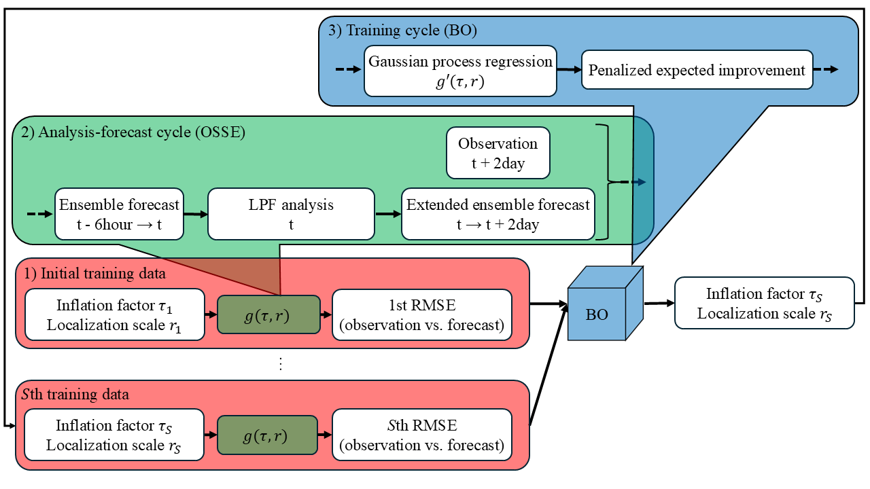
Fig. 1. Flowchart for the Bayesian optimization (BO) in the local particle filter (LPF) framework. Because the data assimilation system and the BO are implemented independently, it is possible to replace the LPF with the local ensemble transform Kalman filter (LETKF). Here, $t (t=1, …, T)$ denote the time; $g$ denotes the objective function; and $s (s=1, …, S)$ denote the indices of input data (the inflation factor $τ$, $α$, and the localization scale $r$) and output data (root mean square error between the observation and the forecast (RMSE (o vs. f)). In the observing system simulation experiment (OSSE), the LPF assimilates the observations every six Earth hours, and the RMSE (o vs. f) at the forecast end time is calculated after two Earth days extended forecast. Through this sequence of operations in the objective function (the data assimilation every six Earth hours and the two Earth days extended forecast), the input data ($τ$, $r$) is transformed into the output data (the RMSE (o vs. f)). In the BO, the input data that minimizes the objective function are estimated through the response surface modeling using the Gaussian process regression (GPR) and the evaluation using the acquisition function (penalized expected improvement). The training cycle for performing the OSSE using the estimated input data is repeated. Note that the BO optimizes $τ$ and $r$ offline.
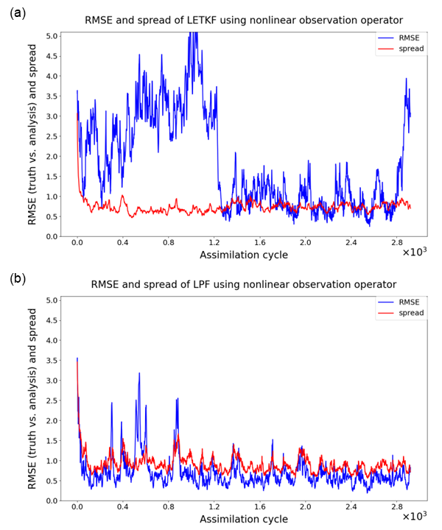
Fig. 2. (a) Time series plot of the RMSE between the truth and the analysis (RMSE (t vs. a)) and the ensemble spread in the LETKF using 64 ensemble members (particles) and the nonlinear observation operator. (b) Same plot in the LPF. The vertical axis shows the RMSE (t vs. a) (blue line) and the ensemble spread (red line); the horizontal axis shows the assimilation cycle. In the LETKF, the localization scale was set to $r$ = 6.5; the covariance inflation factor was set to $α$ = 1.100 (the optimum in Fig. 3a). In the LPF, the localization scale was set to $r$ = 1.9; the weight inflation factor was set to $τ$ = 0.53 (the optimum in Fig. 3b). Incidentally, these results were obtained for a single observation set.
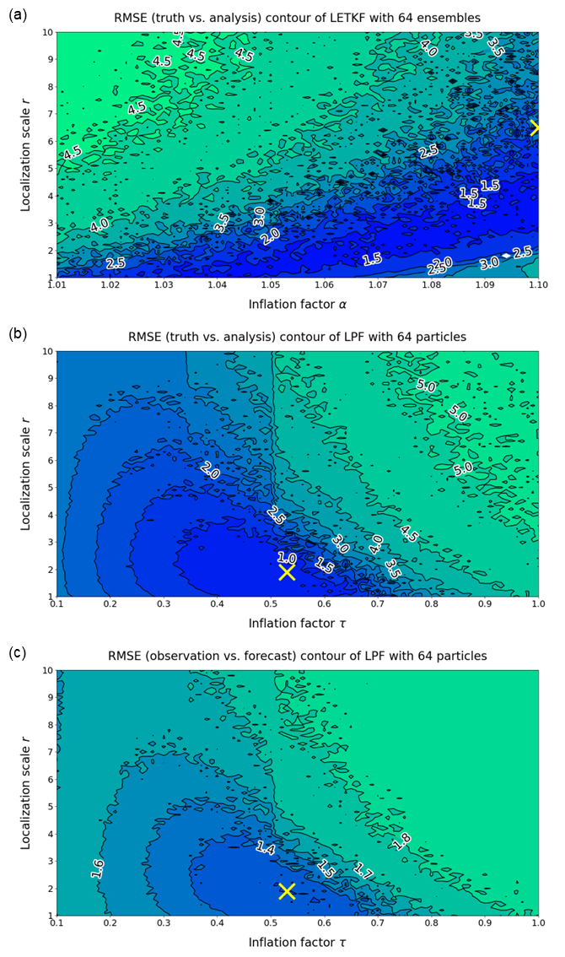
Fig. 3. (a) Response surface of the RMSE (t vs. a) in the LETKF using 64 ensemble members (particles) and the nonlinear observation operator. (b) The RMSE (t vs. a) in the LPF, and (c) the RMSE (o vs. f) in the LPF. The closer the color is to green, the larger the RMSE; the closer the color is to blue, the smaller the RMSE. The vertical axis shows the localization scale $r$; the horizontal axis shows the inflation factor $α$, $τ$. The minimum RMSE (t vs. a) of 1.024 in the LETKF was observed when $r$ = 6.5 and $α$ = 1.100 (marked by an "x"); the minimum RMSE (t vs. a) of 0.586 in the LPF was observed when $r$ = 1.9 and $α$ = 0.53 (marked by an "x"). In addition, the minimum RMSE (o vs. f) of 1.282 was observed when $r$ = 1.9 and $α$ = 0.53 (marked by an "x"). Incidentally, these results were obtained for a single observation set.
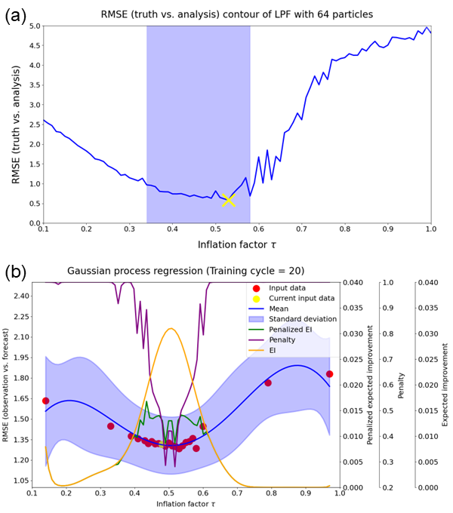
Fig. 4. (a) Response surface of the RMSE (t vs. a) in the LPF with 64 particles and the nonlinear observation operator. The vertical axis shows the RMSE (t vs. a), and the horizontal axis shows the weight inflation factor $τ$. The yellow cross mark represents the minimum error of 0.586 with the localization scale $r$ = 1.9 and $τ$ = 0.53. Moreover, the light blue shade represents the range of the optimal weight inflation factor, which achieves the RMSE (t vs. a) of the LPF at most 1.0—the filter operates stably. The response surface is obtained for the single observation set. (b) The GPR predictive distribution using the weight inflation factor $τ$ and the RMSE (o vs. f) in the LPF as the input and output data, respectively, at the 20th training cycle. The blue line represents the GPR mean; the blue shaded area represents the GPR standard deviation; the green line represents the penalized expected improvement (EI); the purple line represents the penalty; the yellow line represents the EI; the red dots represent the input data points that have been explored; and the yellow dots represent the input data points that were explored at that training cycle. The horizontal axis represents $τ$; the first vertical axis represents the RMSE (o vs. f); the second vertical axis represents the penalized EI; the third vertical axis represents the penalty; and the fourth vertical axis represents the EI. The predictive distribution is obtained for the single observation set.
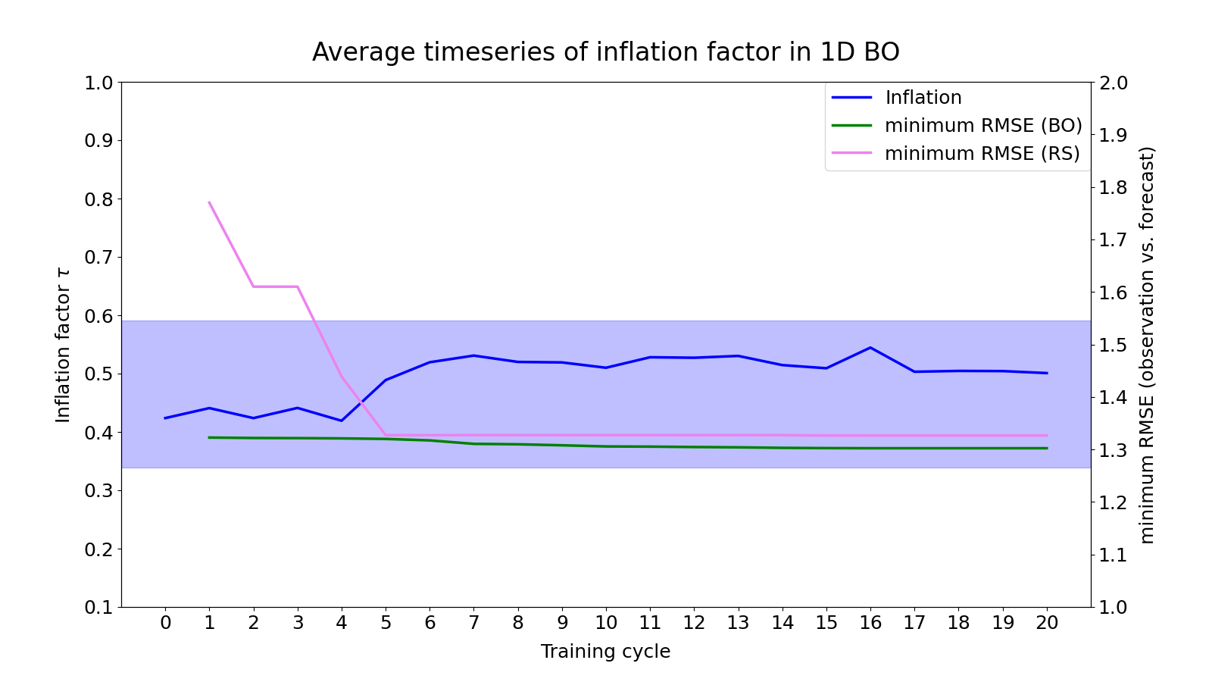
Fig. 5. Time series for the estimate by one-dimensional BO. The blue line represents the weight inflation factor $τ$; the green line represents the minimum RMSE (o vs. f) across all previous training cycles estimated by the BO; and the violet line represents the one estimated by the random sampling (RS). In addition, the light blue shade represents the range of the optimal weight inflation factor $τ$, which achieves the RMSE (t vs. a) of the LPF at most 1.0—the filter operates stably. In this case, the range is $τ$ = 0.34-0.59. All values are the average of the 35 observation sets. The horizontal axis represents the training cycle; the first vertical axis represents $τ$; and the second vertical axis represents the minimum RMSE (o vs. f) across all previous training cycles.
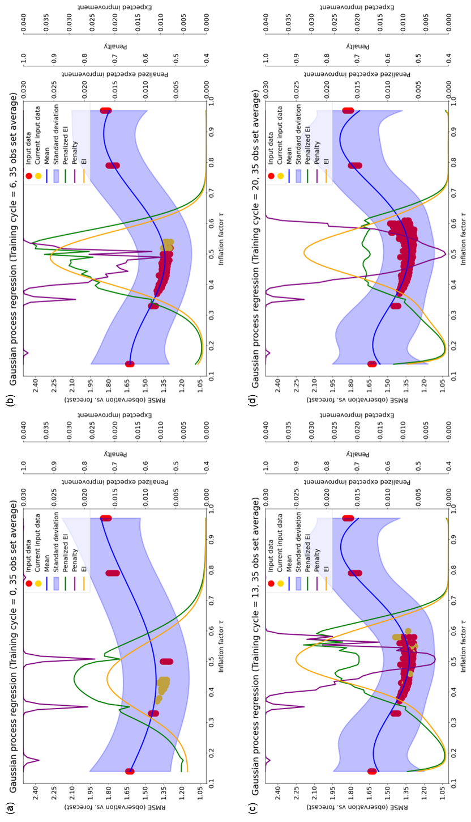
Fig. 6. The GPR predictive distribution using the weight inflation factor $τ$ and the RMSE (o vs. f) in the LPF as the input and output data, respectively. The blue line represents the GPR mean; the blue shaded area represents the GPR standard deviation; the green line represents the penalized EI; the purple line represents the penalty; the yellow line represents the EI; the red dots represent the input data points that have been explored; and the yellow dots represent the input data points that were explored at that training cycle. The GPR mean, GPR standard deviation, EI, penalty, and penalized EI are the averages of the 35 observation sets; the previously explored input data and the explored input data at the current training cycle are plotted for the 35 observation sets. Note that the GPR standard deviation is not statistic of the 35 observation sets. The training cycle in this figure corresponds to that in Fig. 5. The expected value and uncertainty of the RMSE (o vs. f) are obtained as the GPR mean and the GPR standard deviation. The horizontal axis represents $τ$; the first vertical axis represents the RMSE (o vs. f); the second vertical axis represents the penalized EI; the third vertical axis represents the penalty; and the fourth vertical axis represents the EI. (a)-(d) are the predictive distributions at zeroth—the GPR trains only five initial input data—, 6th, 13th, and 20th, respectively.
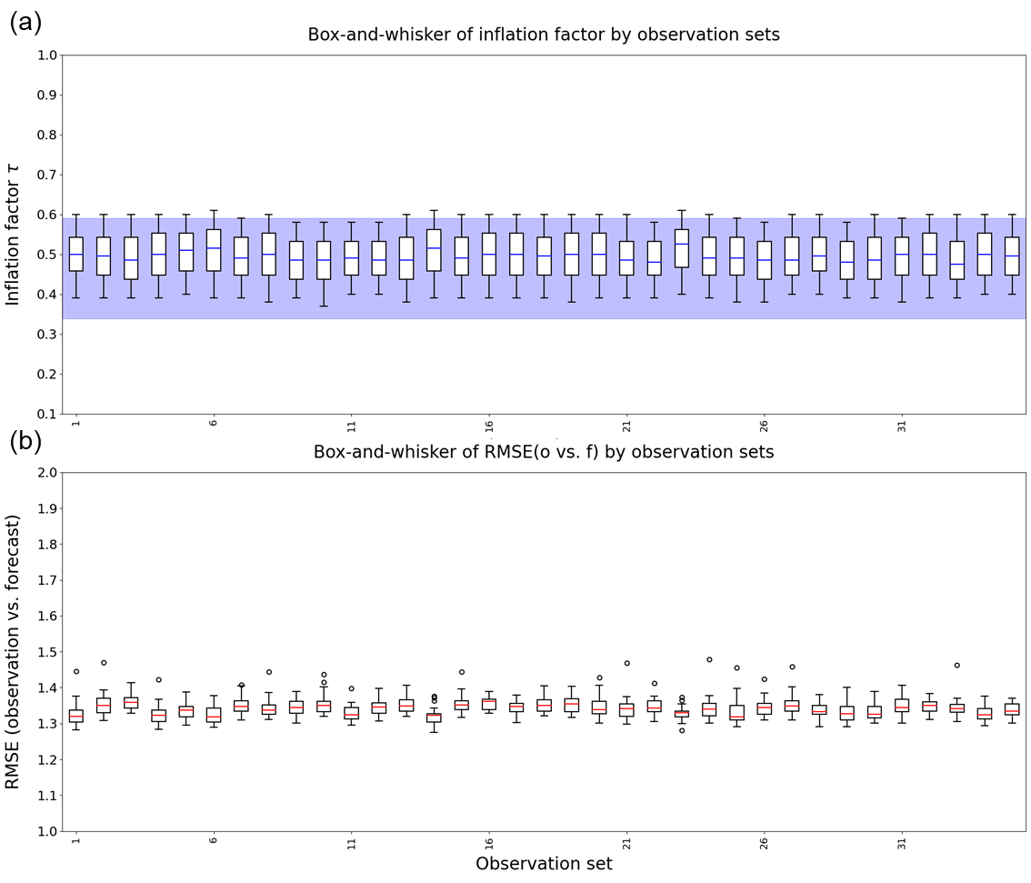
Fig. 7. The distribution of the estimate by the one-dimensional BO for each observation set. Each box plot shows the distribution of the estimate across 1-20th training cycles for a single observation set. (a) Box plot of the weight inflation factor $τ$. The blue line in the box represents the median; the lower edge of the box represents the first quartile (Q1); the upper edge of the box represents the third quartile (Q3); the lower edge of the whisker represents the minimum among values at least Q1 – 1.5 × interquartile range (IQR); the upper edge of the whisker represents the maximum among values at most Q3 + 1.5 × IQR; and the data outside this range were plotted as the outliers. In addition, the light blue shade represents the range of the optimal weight inflation factor $τ$, which achieves the RMSE (t vs. a) of the LPF at most 1.0—the filter operates stably. In this case, the range is $τ$ = 0.34-0.59. (b) Box plot of the RMSE (o vs. f). The red line in the box represents the median; the other plots represent the same as in (a). The vertical axes of (a) and (b) represent $τ$ and the RMSE (o vs. f), respectively. The horizontal axis represents the observation set.
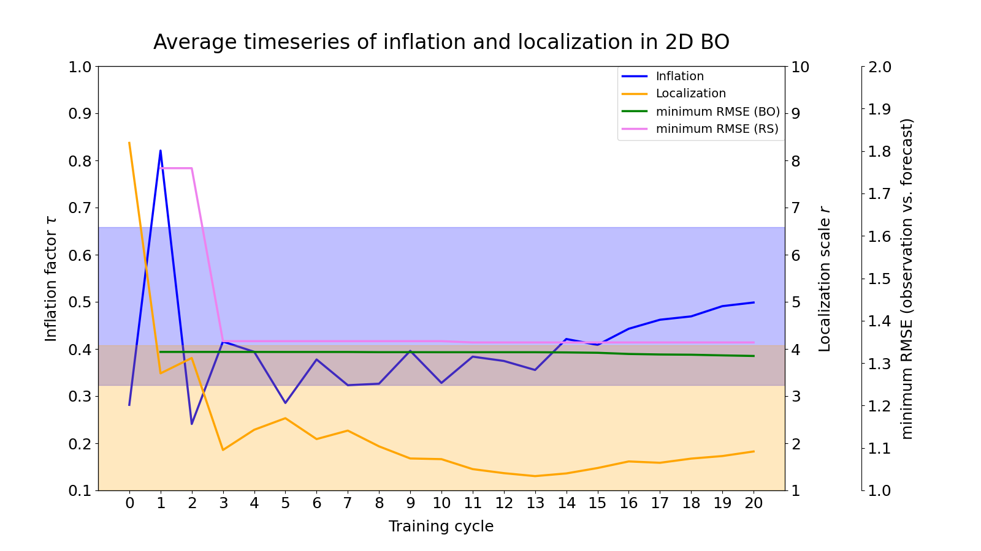
Fig. 8. Time series plot of the estimates by the two-dimensional BO. The blue line represents the weight inflation factor $τ$; the orange line represents the localization scale $r$; the green line represents the minimum RMSE (o vs. f) across all previous training cycles estimated by the BO; and the violet line represents the one estimated by the RS. In addition, the light blue shade represents the range of the optimal weight inflation factor $τ$, which achieves the RMSE (t vs. a) of the LPF at most 1.0—the filter operates stably. In this case, the range is $τ$ = 0.32-0.66. Moreover, the light orange shade represents the range of the optimal localization scale (stable $r$ = 1.0-4.1). The light beige shade represents the region that overlaps the light blue and the light orange. All values are the averages of the 35 observation sets. The horizon axis represents the training cycle; the first vertical axis represents $τ$; the second vertical axis represents $r$; the third vertical axis represents the minimum RMSE (o vs. f) across all previous training cycles.
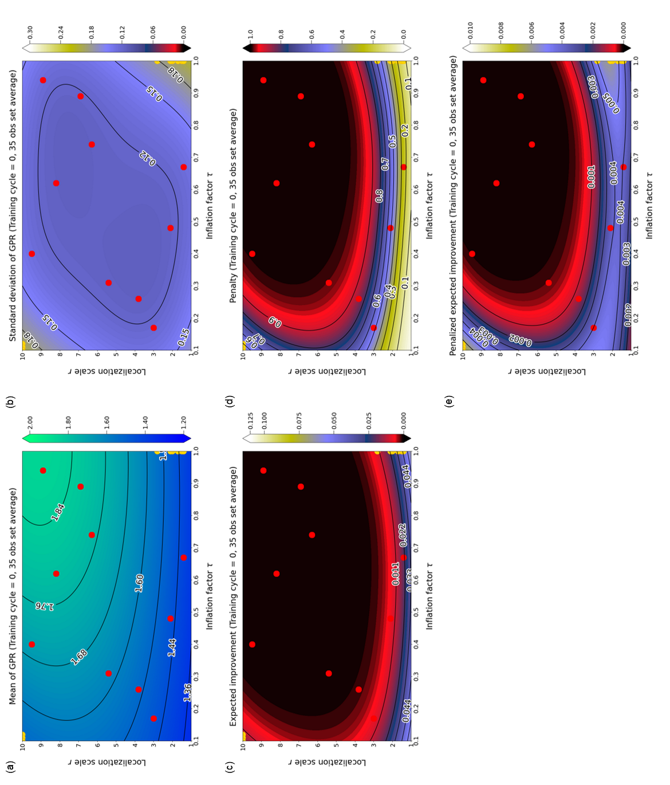
Fig. 9. The GPR predictive distribution that use the weight inflation factor $τ$, the localization scale $r$, and the RMSE (o vs. f) in the LPF as the input and output data in the zeroth—the GPR trains only ten initial input data—training cycle. (a) shows the GPR mean; (b) shows the GPR standard deviation; (c) shows the EI; (d) shows the penalty; (e) shows the penalized EI. The red points represent the previously explored input data; the yellow points represent the explored input data at the current training cycle. The GPR mean, GPR standard deviation, EI, penalty, and penalized EI are the averages of the 35 observation sets; the previously explored input data and the explored input data at the current training cycle were plotted for the 35 observation sets. Note that the GPR standard deviation is not statistic of the 35 observation sets. The horizontal axis represents $τ$, and the vertical axis represents $r$.
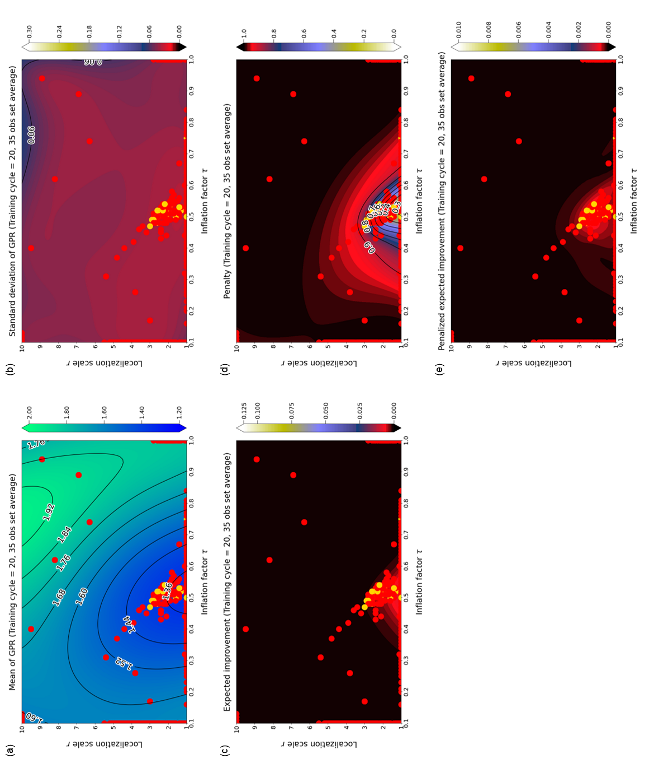
Fig. 10. The GPR predictive distribution using the weight inflation factor $τ$ and the localization scale $r$ at the 20th training cycle, and the RMSE (o vs. f) in the LPF as the input and output data, respectively. (a) shows the GPR mean; (b) shows the GPR standard deviation; (c) shows the EI; (d) shows the penalty; (e) shows the penalized EI. The training cycle in this figure corresponds to that in Fig. 8. The expected value and uncertainty of the RMSE (o vs. f) are obtained as the GPR mean and the GPR standard deviation. The red dots indicate input data points that have been explored, and the yellow dots indicate input data points explored at that training cycle. The GPR mean, GPR standard deviation, EI, penalty, and penalized EI are the averages of the 35 observation sets; the previously explored input data and the explored input data at the current training cycle were plotted for the 35 observation sets. Note that the GPR standard deviation is not statistic of the 35 observation sets. The horizontal axis represents $τ$, and the vertical axis represents $r$.
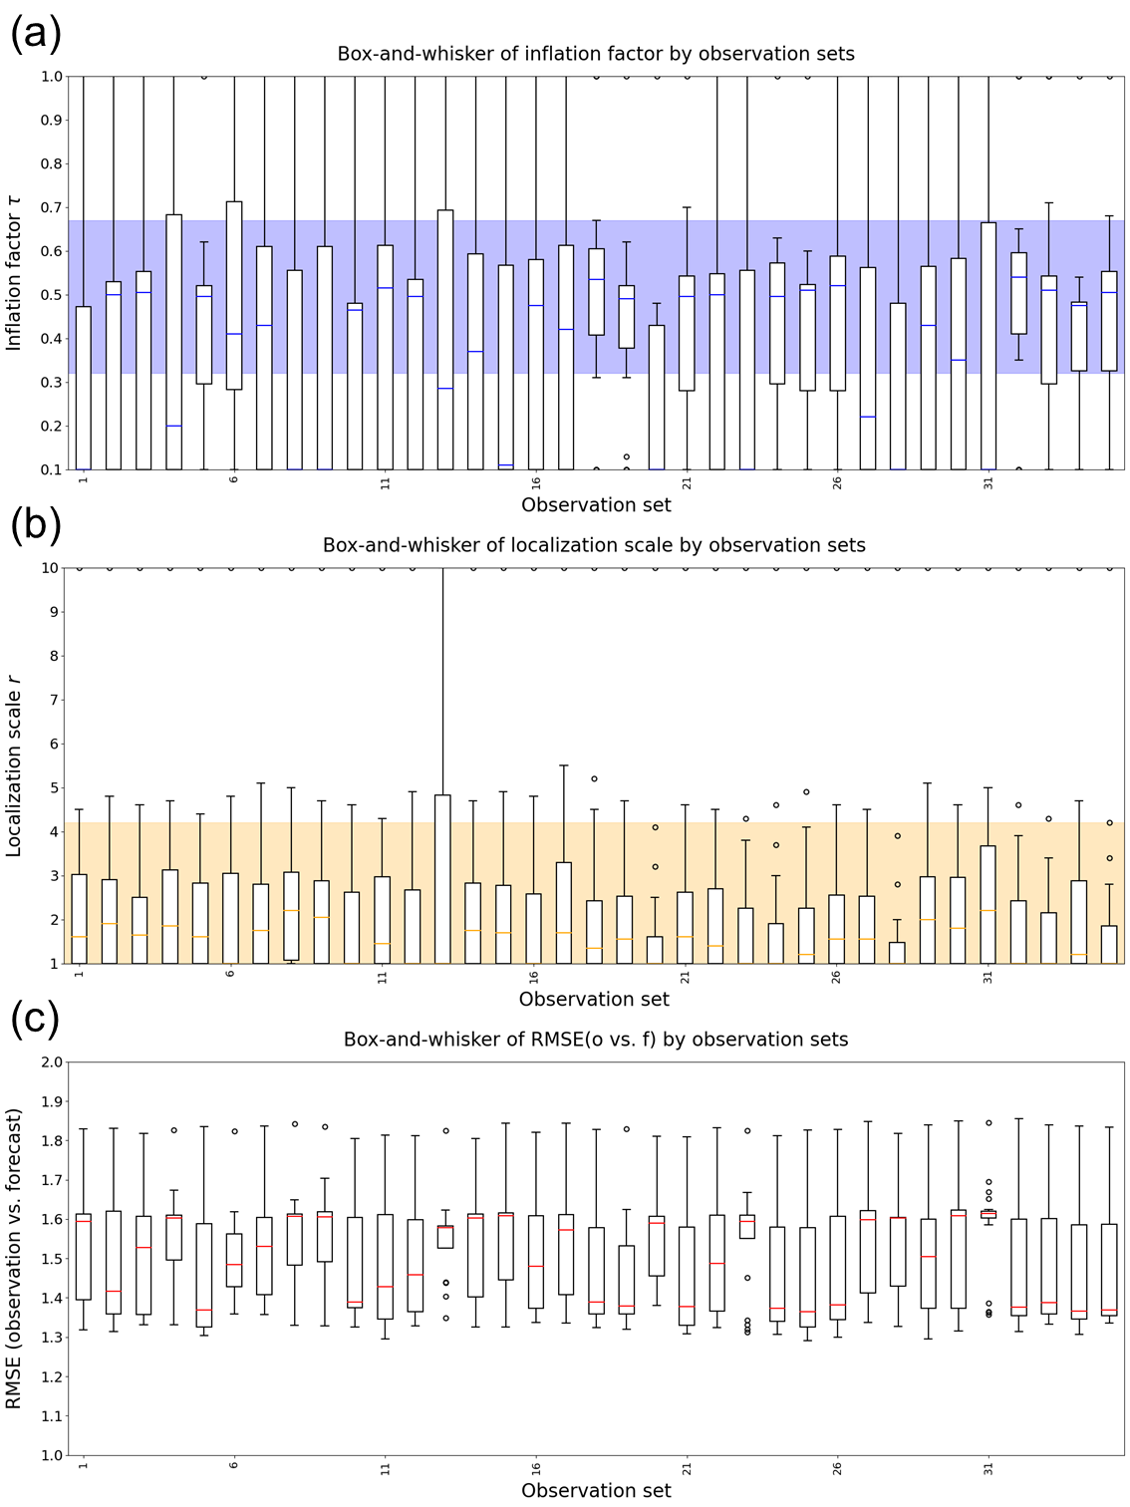
Fig. 11. The distribution of the estimate by the two-dimensional BO for each observation set. Each box plot shows the distribution of the estimate across 1-20th training cycles for a single observation set. (a) Box plot of the weight inflation factor $τ$. The blue line in the box represents the median; the lower edge of the box represents the Q1; the upper edge of the box represents the Q3; the lower edge of the whisker represents the minimum among values at least Q1 – 1.5 × IQR; the upper edge of the whisker represents the maximum among values at most Q3 + 1.5 × IQR; and the data outside this range were plotted as the outliers. In addition, the light blue shade represents the range of the optimal weight inflation factor $τ$, which achieves the RMSE (t vs. a) of the LPF at most 1.0—the filter operates stably. In this case, the range is $τ$ = 0.32-0.66. (b) Box plot of the localization scale $r$. The orange line in the box represents the median; the other plots represent the same as in (a). In addition, the light orange shade represents the range of the optimal localization scale $r$, which achieves the RMSE (t vs. a) of the LPF at most 1.0—the filter operates stably. In this case, the range is $r$ = 1.0-4.1. (c) Box plot of the RMSE (o vs. f). The red line in the box represents the median; the other plots represent the same as in (a). The vertical axes of (a), (b), and (c) represent $τ$, $r$, and the RMSE (o vs. f), respectively. The horizontal axis represents the observation set.

List of Tables
Table 1 Variation of the BO estimates with the number of estimated parameters, the Lipschitz constant, and the number of the initial input data. The first column represents the Lipschitz constant; the second column represents the number of the initial input data; the third column represents the minimum RMSE (o vs. f) across 1-20th training cycles; the fourth and the fifth columns represent the weight inflation factor $τ$ and the localization scale $r$ in the training cycle, which obtained the minimum RMSE (o vs. f), respectively. The column of the localization scale $r$ is not listed because we fixed $r$ to 1.9 in the one-dimensional BO. Incidentally, the minimum RMSE, $τ$, and $r$ are the average of the 35 observation sets. The best cases for each dimension of the parameter space were emphasized in bold.

Table 1 Variation of the BO estimates with the number of estimated parameters, the Lipschitz constant, and the number of the initial input data. The first column represents the Lipschitz constant; the second column represents the number of the initial input data; the third column represents the minimum RMSE (o vs. f) across 1-20th training cycles; the fourth and the fifth columns represent the weight inflation factor $τ$ and the localization scale $r$ in the training cycle, which obtained the minimum RMSE (o vs. f), respectively. The column of the localization scale $r$ is not listed because we fixed $r$ to 1.9 in the one-dimensional BO. Incidentally, the minimum RMSE (o vs. f), $τ$, and $r$ are the average of the 35 observation sets. The best cases for each dimension of the parameter space were emphasized in bold.
1-dimension (91)
Lipschitz constant | Number of initial input data | minimum RMSE (o vs. f) | Weight inflation factor
0.1 | 5 | 1.323 | 0.46
0.1 | 10 | 1.345 | 0.40
0.1 | 15 | 1.403 | 0.50
0.1 | 20 | 1.356 | 0.52
0.5 | 5 | 1.305 | 0.51
0.5 | 10 | 1.314 | 0.42
0.5 | 15 | 1.328 | 0.43
0.5 | 20 | 1.324 | 0.43
2.0 | 5 | 1.306 | 0.51
2.0 | 10 | 1.309 | 0.42
2.0 | 15 | 1.306 | 0.48
2.0 | 20 | 1.306 | 0.44
10.0 | 5 | 1.303 | 0.54
10.0 | 10 | 1.304 | 0.49
10.0 | 15 | 1.304 | 0.46
10.0 | 20 | 1.305 | 0.47
2-dimension (91 * 91)
Lipschitz constant | Number of initial input data | minimum RMSE (o vs. f) | Weight inflation factor | Localization scale
0.1 | 10 | 1.325 | 0.49 | 1.7
0.1 | 20 | 1.334 | 0.44 | 1.6
0.1 | 30 | 1.367 | 0.46 | 2.4
0.1 | 40 | 1.333 | 0.43 | 1.1
0.5 | 10 | 1.568 | 0.12 | 2.8
0.5 | 20 | 1.380 | 0.54 | 1.7
0.5 | 30 | 1.370 | 0.45 | 1.5
0.5 | 40 | 1.334 | 0.47 | 1.1
2.0 | 10 | 1.582 | 0.10 | 4.3
2.0 | 20 | 1.391 | 0.43 | 1.4
2.0 | 30 | 1.374 | 0.43 | 1.3
2.0 | 40 | 1.347 | 0.47 | 1.1
10.0 | 10 | 1.573 | 0.12 | 1.8
10.0 | 20 | 1.403 | 0.43 | 1.3
10.0 | 30 | 1.368 | 0.44 | 1.0
10.0 | 40 | 1.364 | 0.45 | 1.0

